Chapter 1: Nutrition in plants
Class :VII Subject : Science
WORKSHEET SOLUTION
A.1. c)Pitcher plant
2. b) glucose
3. a) symbiosis
4. a) stem
5. c) leaves
6. c) mushroom
7. d) sunlight,
chlorophyll,water &
carbon dioxide
8. a) guard cells
9. c) destarch
10. a) turns blue-black
B.1.
Parasitic plants | Insectivorous plants
1.These plants obtain nutrition from living green plants on which they live | 1.These plants obtain nutrition by trapping and digesting insects.
2.Parasitic plants get readymade food from the host plant and simply absorbs it by special sucking roots.  e.g.cuscuta | 2.These plants are modified to trap the insects and digest them by enzymes.Digested nitrogen compounds are absorbed.  e.g.pitcher plants.
2.
A leaf can be decolourised by removing the green- coloured chlorophyll from the leaf by boiling it first in water and then in alcohol.
3.The bodies of living organism are made up of tiny units called cells.Cells are enclosed by a cell membrane.It contains a nucleus, which is surrounded by jelly- like substances called cytoplasm
4.Stomata are minute openings present on the undersurface of the leaf for gaseous exchange.
Each tiny pore or stoma is surrounded by a pair of guard cells.The opening and closing of stomata is controlled by guard cells.

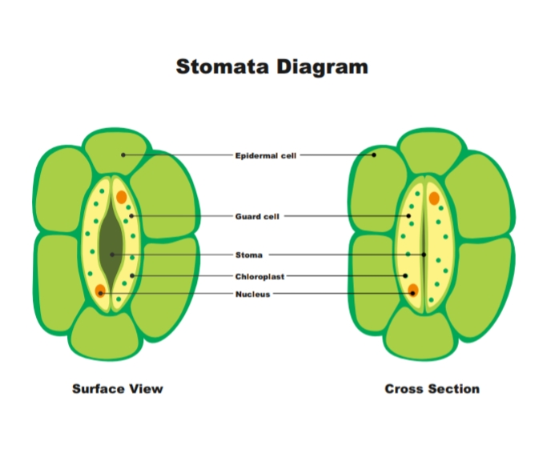
5.Schematic diagram of photosynthesis
