MAP WORK WORKSHEET
ON AN OUTLINE MAP OF INDIA SHOW ALL THE IMPORTANT CITIES AND KINGDOMS .
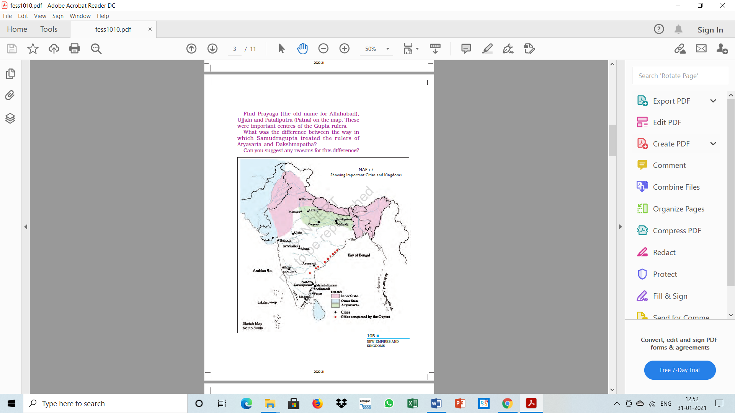
FOLLOW YOUR HISTORY TEXT BOOK
CHAPTER – NEW EMPIRES AND KINGDOMS
ON AN OUTLINE MAP OF INDIA SHOW THE PHYSIOGRAPHIC DIVISIONS OF INDIA WITH THE STATES SHOWN ON THE MAP.

