Nouns Worksheet
What is this ?--------------

What is the name of this fruit?---------
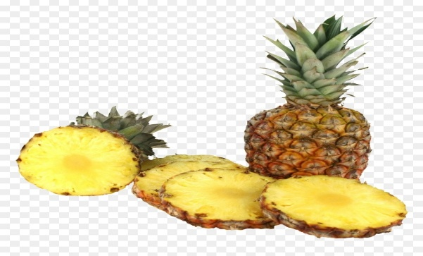

What is this?------------

Name five vegetables which you like.

Name the countries where you want to go.( Any 4)

