SATISH CHANDRA MEMORIAL SCHOOL
ENGLISH WORKSHEET
Name: …………………………… Class: ……. Sec: …….. ROLL: ………..
Q1. Circle the letters that matches with the given letter:-
G - B D G K
P - B N T P
R - Q R S M
S - J P T S
Q2. Match the pictures with letters:-
P 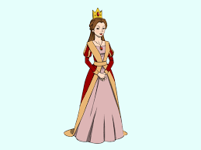
Q
R
Z 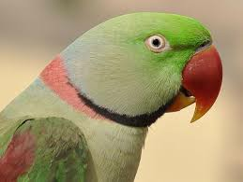

Q3. Trace the picture and colour it: -

