Contents

- NETWORKING CONCEPTS 1
Need for Computer Networks Types of Computer Networks Network Topologies Transmission Media Network Devices
Protocols
Packet Switching in Networks Network Security
- INTRODUCTION TO MICROSOFT
ACCESS 2013 20
Database and DBMS Advantages of a Database Starting Microsoft Access Creating a Database in Access Tables in Access
Components of a Table in Access
Different Views of a Table—Design View and Database View
Add and Delete Records in a Table
Set and Remove a Primary Key in a Table Modify the Table Design
- ADVANCED FEATURES OF
ACCESS 2013 43
Query Form Report
- IMAGES AND LISTS IN HTML 60
<IMG> Tag in HTML
Creating Lists Nested Lists
- TABLES AND HYPERLINKS IN HTML 73
<TABLE> Tag and its Attributes
<A> Tag and its Attributes
- INTRODUCTION TO VISUAL BASIC 88
Starting Visual Basic
Elements of Visual Basic Integrated Development Environment (IDE)
Properties, Methods and Events of Form Object
Uses of Common Controls Adding Controls on the Form
Creating a Calculator in Visual Basic
- INTRODUCTION TO ADOBE
PHOTOSHOP CC 2015 110
Starting Adobe Photoshop CC 2015 Components of Photoshop Workspace Selection Tools
Drawing Tools Painting Tools
- EXPLORING MORE FEATURES OF ADOBE PHOTOSHOP 131
Retouching Tools Typing Tools Layers
Filters
- SKETCHUP 152
Starting SketchUp SketchUp Welcome Screen SketchUp Interface Working with Tools
Creating a 3D Model of a Table
Sample Olympiad Questions 177
Worksheet 1 (Chapters 1 to 3) 180
Worksheet 2 (Chapters 4 to 6) 181
Worksheet 3 (Chapters 7 to 9) 184
IT Personalities 186



1
p
t
e
r
C
h
a

Networking Concepts

Computer networks have shrunk the world and brought people together. They have extended the power of a computer beyond the expanse of a room. Advancements in networking techniques, protocols and so on have made a profound impact in areas of communication and learning. The size of computer networks may vary. The Internet is an example of a computer network that spreads all across the world. The Internet is also referred to as the worldwide network of computers and it is growing at a rapid rate.
A computer network consists of two or more computers that are linked in order to share resources such as printers, exchange files and allow communication.
Let us learn more about computer networks.

Learning Objectives

To learn about:
  - need for computer networks.
  - types of computer networks.
  - network topologies.
  - transmission media.
  - network devices.
  - protocols.
  - packets switching in networks.
  - network security.

NEED FOR COMPUTER NETWORKS
Nowadays, computer networks are a vital part of any organisation. Some of the advantages of computer networks are:
 Resource Sharing: All computers in a network can share resources such as printers, fax machines, modems and scanners.

Did You Know?
ARPANET (Advanced Research Projects Agency Network) was a network set up by the US Department of Defense that later developed into the Internet.

1

files and access to remote database. We can easily access the files stored on various computers on a network. Also, networking allows many people to work simultaneously on the data stored in a database.
 Ease of Communication: Computer networks allow people to communicate through emails and instant messaging facilities. This makes the transmission of information easier, more efficient and less expensive.





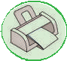
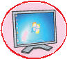
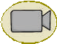

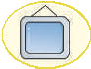
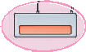

TYPES OF COMPUTER NETWORKS
Internet
Fig. 1.1 PAN
The following are the types of networks based on the geographical area covered or scale of the network.
 Personal Area Network (PAN): A PAN is a computer network organised around a person. It is used for communication between devices such as phones, personal digital assistants,
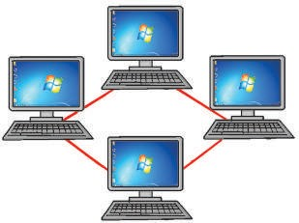
printers and laptops that are in close proximity. We can use these networks to transfer files and photos between the various devices.
LAN
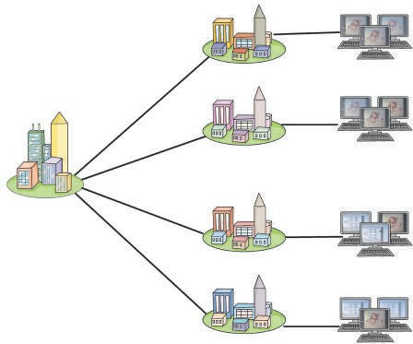
 Local Area Network (LAN): A LAN is a computer network that is limited to a local area such as a laboratory, a school or an office building. Cables (wires) or low-power radiowaves (wireless) are used for the connections in a LAN. A wireless LAN (or WLAN) is also sometimes called LAWN (Local Area Wireless

Fig. 1.2 LAN
Network).


 Campus Area Network (CAN): A CAN is a computer network that connects multiple local area networks (LAN) in a limited geographical area. A CAN is smaller than a wide area network (WAN) or metropolitan area network (MAN). It can be set up by a college, company and so on.
2

University Campus

Lab

Library

Arts

Commerce
Fig. 1.3 CAN

LAN 1

LAN 2

LAN 3

LAN 4

covers a larger area than a LAN. For example, a network that connects two offices in a city, a neighbourhood area and so on.

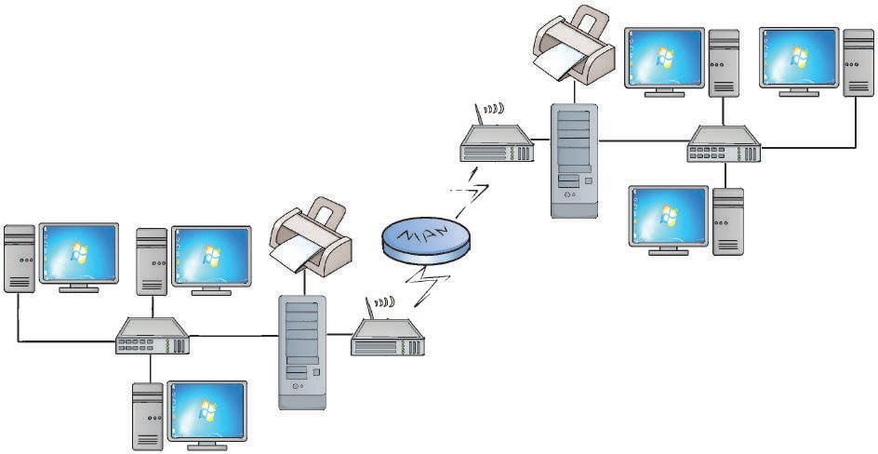
Router
Printer
Server
Switch
Office-B
Switch
Server
Router

Office-A

NeWtiwdoerAkr(eWaAN): A WAN
is a computer network that spans a wide geographical area. A WAN may be spread
1F.i4g.
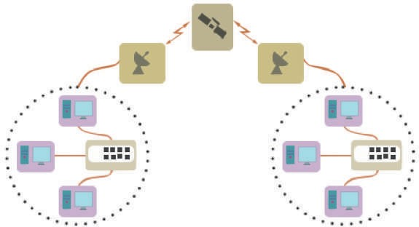
MAN

Broadcasting

Satellite

Broadcasting

across cities, countries and continents. A WAN is
Client
Client

formed by connecting LANs and MANs. Computers
Client
Wireless Switch
Client
Switch/Hub

or networks across long distances are usually
Client WLAN
1NF.i5g. WA
Client LAN

connected with optical fibre cables, satellite radio links or microwave radio links.

NETWORK TOPOLOGIES

Topology refers to the layout pattern in which various computers are connected to one another to form a network. The computers on a network are also referred to as nodes.
3

 Bus Topology: In bus topology, all the computers are connected to a single cable called the bus (Fig. 1.6). The transmission of data from any computer travels through the length of the bus in both the directions and can be received by all other computers on the network. If the address of a computer is that of the intended recipient, it accepts the data; otherwise, the data is rejected. The advantage of the bus topology is that it is quite easy to set up. However, a network cannot function if there are breaks in the bus.
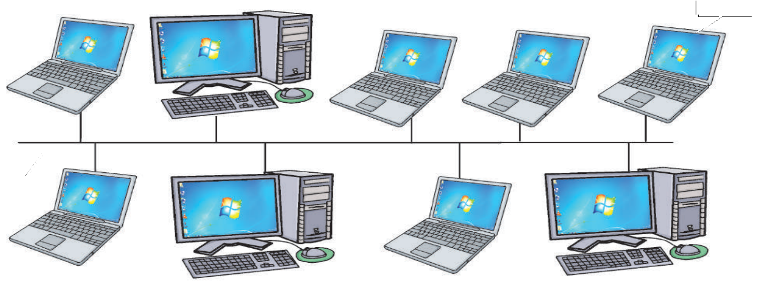



Node


Bus
Fig. 1.6 Bus topology

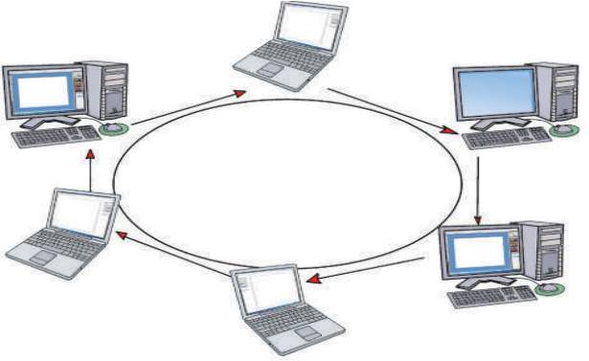

 Ring Topology: In ring topology, each computer is connected to two other computers so as to form a closed ring-like structure (Fig. 1.7). In this topology, data is transmitted in one direction only. The disadvantage of the ring network is that the breakdown of any one computer on a ring can disable the entire system or network.
Node

Fig. 1.7 Ring topology
4

 Star Topology: In star topology, all the computers are connected to a central computer or a central node (Fig. 1.8). The data to be exchanged between any two computers passes through the central node. The central node controls all the activities of the nodes. More computers can be easily added to the network. The breakdown of computers, except the central node, does not affect the functioning of the network.

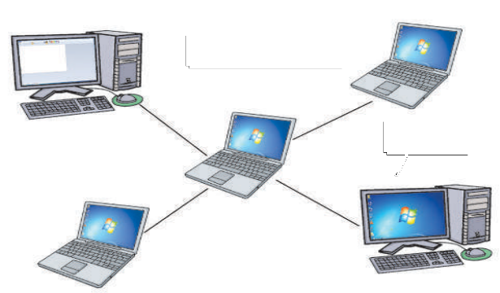
Node
Central node
Fig. 1.8 Star topology

However, the failure of the central node disables the communication across the entire network.
 Mesh Topology: In mesh topology, every computer is connected to every other computer on the network. Full mesh topology (Fig. 1.9) is very expensive to implement. Normally, partial mesh topology is implemented in which a computer is connected to a few other computers in the network (Fig. 1.10).

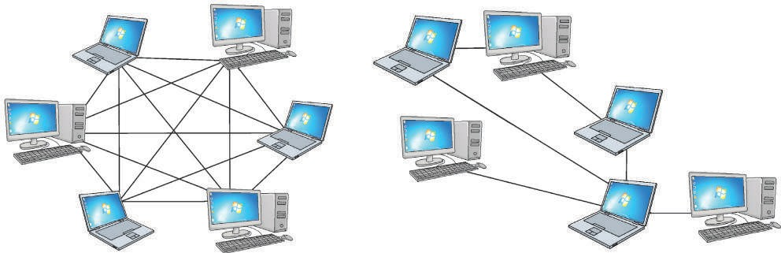
Fig. 1.9 Full mesh topology Fig. 1.10 Partial mesh topology

TRANSMISSION MEDIA

Computers must be connected to each other to form a network. Computers can be connected using wires/cables or they can be connected in a wireless manner.
5

Wired Transmission Media
There are various types of cables that can be used for setting up a network. Some of them are discussed here.
 Twisted Pair Cable: It consists of a pair of insulated wires twisted together. The use of two wires twisted around each other helps to reduce disturbances in the signals.
The twisted pair cable is often used in two or more pairs, all within a single cable. Twisted pair cabling comes in two varieties—shielded (Shielded Twisted Pair or STP) and unshielded (Unshielded Twisted Pair or UTP). UTP cable is the most commonly used cable in computer networking.
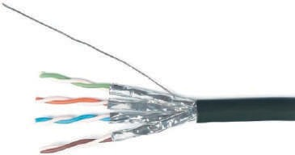
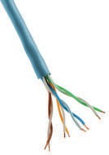
Fig. 1.11 Shielded twisted pair cable Fig. 1.12 Unshielded twisted pair cable

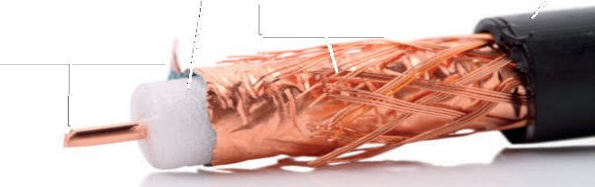





 Coaxial Cable (coax): Coaxial cable is an electrical cable with a conductor at its centre (Fig. 1.13). The inner conductor is surrounded by a tubular insulating layer. The insulating layer is surrounded by a conductive layer called the shield, which is finally covered

Insulator

Shield
Copper wire (conductor)
Outer plastic sheath (insulating layer)

with a thin insulating layer on the outside.
Fig. 1.13 Coaxial wire

 Optical Fibre Cable: Optical fibre cable consists of a central glass core surrounded by several layers of protective material (Fig. 1.14). It transmits data in the form of light rather than electronic signals, thus eliminating the problem of electrical interference. Fibre optic cable is expensive as
6

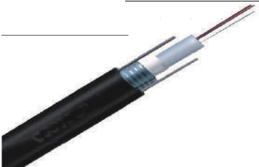

Fig. 1.14 Optical fibre cable
Glass core

compared to coaxial and twisted pair cables but can transmit signals over much longer distances. It also has the capability to carry data at a very high speed.


- Coaxial cable was invented by English engineer and mathematician Oliver Heaviside.
- Twisted pair cable was invented by Alexander Graham Bell.
- Narinder Singh Kapany, an Indian-born American Sikh physicist is known as ‘Father of Fibre Optics’.
Did You Know?

Wireless Transmission Media
In wireless networks, data is transmitted without wires. Some of the ways in which wireless networks may be set up are as follows.
 Infrared: The infrared communication range of the devices communicating through infrared waves is very limited. Infrared waves cannot penetrate walls or other obstructions and so there should be no physical barrier between the communicating devices. The communication between a TV set and a remote control happens through infrared waves. Infrared mouse and keyboard are other examples of devices that make use of infrared waves for data transmission.
 Microwave Transmission: Microwave communications are unidirectional. They can be used for terrestrial communication (on the surface of the earth) or for satellite communication.
Microwave propagation is line-of-sight communication. So, when used for terrestrial communication, the towers with antennas mounted on them need to be in direct sight of each other. The antennas are usually located at substantial heights above the ground level to extend the range between antennas and to be able to transmit over obstacles. You must have noticed high towers with microwave antennas in your city.
Microwaves can pass through the earth’s atmosphere easily and can be used
7

to transmit information between satellites and the earth’s base station (Fig. 1.15).









Fig. 1.15 Microwave transmission Fig. 1.16 Microwave antenna







 Radiowave Transmission: Radiowave communications are omnidirectional, which means that they travel in all directions
from the source, so that the transmitter and receiver do not have to be carefully aligned physically. Radio waves are easy to generate, can travel long distances and penetrate through buildings easily. So they are widely used for communication both indoors and outdoors (Fig. 1.17). However, at all frequencies, radio waves are subject to interference from motors and other electrical equipment.
Bluetooth and Wi-Fi are both wireless technologies

that use radio frequency waves to create networks.
Fig. 1.17 Radiowave antenna

 Bluetooth technology is used for exchanging data over short distances using radio waves. This technology uses low power, has a short range [30 feet (approx.)] and medium transmission speed. Bluetooth technology can be used to transfer songs or pictures between two mobile phones or a Bluetooth headset can be used with a mobile phone.

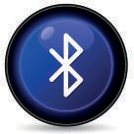
Fig. 1.18 Bluetooth
technology

8

teWchiFniology also makes use of radio waves to transmit and receive data. This technology requires more energy but enables the signal to go farther (300 feet approx.) with a faster rate of transmission. This technology is used to set up networks in which a computer’s wireless adapter translates the data into a radio signal and

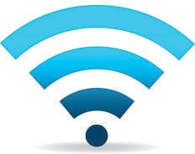
1iFF.i1gi 9.technoWlogy

transmits it. A wireless router receives the signal, decodes it and sends it to the Internet using a wired connection.
 WiMAX (Worldwide Interoperability for Microwave Access): Its technology is similar to WiFi, but it operates at higher speeds and can cover greater distances and greater

number of users as compared to WiFi.
1iFM.i2gA.0X W

NETWORK DEVICES
Various devices are used for setting up a computer network. Let us discuss a few devices that play a crucial role in a computer network.
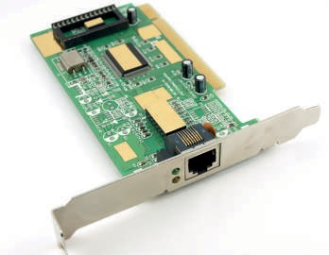
 NIC (Network Interface Card): It is a hardware device that is attached to a computer to enable it to communicate over the network (Fig.1.21). The NIC has a ROM chip that contains a unique number, which is the hardware address or the Media Access Control (MAC) address. This hardware address uniquely identifies a computer on the network.
1F.i2g1. Network Interface Card
 Modem (Modulator-demodulator): It is an electronic device that converts the digital signals of a computer into an analog form so that they can travel over a telephone line (Fig. 1.22). At the destination, the receiving modem converts the analog signals back into their digital form so that the destination computer understands them.
DIGITAL SIGNAL ANALOG SIGNAL DIGITAL SIGNAL

COMPUTER 


COMPUTER
MODEM
MODEM
TELEPHONE
9
LINE
1rFa.i2gn.2smissioTn of signals through modem

Modems are used for connecting computers to the Internet. Modems are connected to a computer and a telephone line (Fig. 1.24).
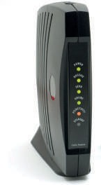
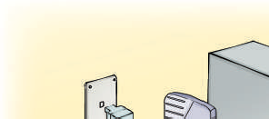

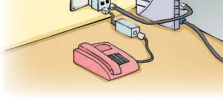
Fig. 1.23 Modem Fig. 1.24 Connection of modem
 Hub: A hub is a device that is used to connect computers in a network (Fig. 1.23). In a hub, when one computer sends data on the network, the hub simply forwards the packets to all the other computers connected to it (Fig. 1.26). Each computer is responsible for determining which packets are destined for it and which are to be ignored.
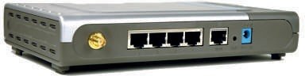
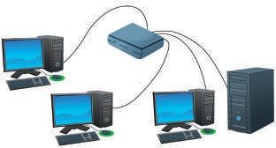
Fig. 1.25 Hub Fig. 1.26 Networking using a hub
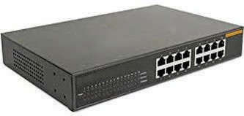
 Switch: A switch is a device that is also used to connect computers in a network (Fig. 1.27). However, a switch is a more intelligent device than a hub. Unlike a hub, the switch sends the incoming data to the desired destination only. It records the addresses of all the computers connected to it. So, when a packet is received, the switch reads the information about the destination address to determine

Fig. 1.27 Switch
if the destination device is connected to it or not. If the destination device is connected, the switch forwards the packet only to that destination device.
In this way, the other computers do not have
to read and deal with data that is not meant for them.
10

Book 8 Ch_1.indd 10 28/09/2016 11:53:12

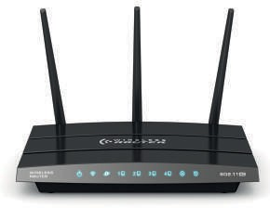
ouRter: A router is a network device that connects two or more networks. It is commonly used to connect a computer or a network to the Internet.
1F.i2g.8
Router
Lines from different networks are connected to a router. Wireless routers are also available. A router examines the address of the packet coming on the line, uses the routing information stored
in it and forwards the packet to the next network. In this way, a packet after going through multiple routers reaches its destination.

PROTOCOLS
Just the way we follow certain rules while communicating or travelling on the road, similarly rules or protocols have to be followed for effective network communication. Protocol is a set of rules used by computers on a network to communicate with each other. Some examples of protocols are:
 HTTP (Hyper Text Transfer Protocol): It is a protocol used between a web server and a web browser for transferring HTML pages.
 TCP/IP (Transmission Control Protocol/Internet Protocol): TCP is a protocol that is used along with the IP to send data over the Internet. The information is transmitted across the Internet in the form of bundles called packets. TCP is responsible for dividing the data into packets before they are sent and for reassembling the packets when they arrive at the destination. IP is a set of specifications that determines the best route for the packets across the Internet so that the packets reach their destination address.

PACKET SWITCHING IN NETWORKS
Let us explain the process of packet switching in a LAN. Suppose data has to be sent from Computer A to Computer B. The data at Computer A is split into small chunks, called packets. A header is added to every packet. The address of sender i.e. Computer A and address of receiver i.e. Computer B are put in the header. Then Computer A sends the packets to the switch. The switch has in-built software that

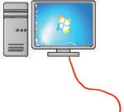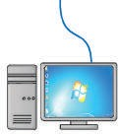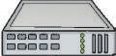
Computer-A
Switch/hub

Computer-B
1F.i2g.9 Packet switching in a LAN
11

reads the header of each packet, determines the port at which the receiver is connected and forwards the packet on the corresponding cable (Fig. 1.29). Such a type of communication in which small units of data (or packets) are routed through a network, based on the destination address contained within each packet, is called packet switching.
When packets have to be sent to a computer on a different network, they pass through a number of routers. Every packet is numbered. Packets may follow different paths to reach the destination.

Packet contains
Source  address | Destination address | Sequence  number

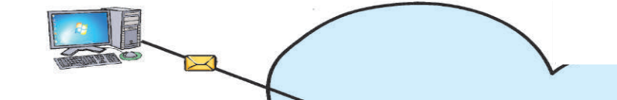

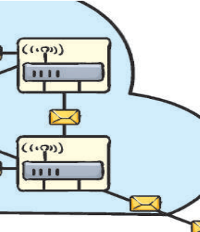
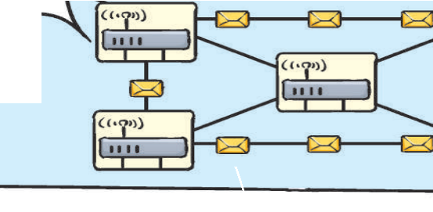
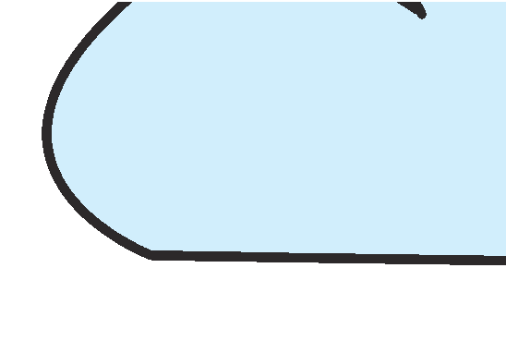


















Fig. 1.30 Packet switching through different network
Computer
Router
Router
Router
Router
Router
Before the transmission starts, each communication is divided into packets. These packets have certain headers and data.
Server
Header
Data
At the destination, the packets are received and reassembled in order, as per their sequence number.
Packets may follow different paths to reach to the destination computer
No path is fixed. The packet may be routed on the path that is available at that particular time.

12


Practice Zone

Fill in the blanks.
- A network that is limited to a small geographical area such as a laboratory is known as a
.
- The Internet is an example of .
- Central node dependency problem arises in networks with topology.
- A device that can convert digital signals into analog form and vice versa is known as a
.
- A device that is used to connect computers in a network is called .
- A transmission medium that transmits data in the form of light signals is referred to as
.
- The data that is transmitted across the Internet in the form of little bundles is called .
- WLAN stands for .

NETWORK SECURITY
A computer on a network can be accessed by many users. Security measures have to be taken to protect networks from unauthorised access and to prevent data or information theft.


Threats to Computer
Files can be shared between the computers on a network. This makes a computer vulnerable to attacks by viruses, worms, Trojan horses and so on that can easily spread because of the underlying network. Let us discuss some of the common threats to computers.
 Virus: A computer virus spreads itself from one computer to another and interferes with the normal operations of a computer. Viruses attach themselves to any type of file and spread when these infected files are copied to other computers. People unknowingly spread a computer virus by sharing infected files or sending emails with viruses as attachments.
 Worm: A worm is a computer program that uses computer networks to send copies of itself to other computers on a network. A virus requires
13

human action such as transferring of an infected file to spread itself. A worm can spread without any human action too. It replicates itself without the knowledge of the user. Worms can cause severe harm to a computer network such as blocking the network and reducing the speed of the network.
 Trojan Horse: A computer program that appears to be a useful software but actually causes damage once installed or executed onto your computer system is known as a Trojan horse or a Trojan. After getting installed, it allows unauthorised access to the computer. Trojan horses are very dangerous as they allow your computer to be remotely controlled by someone else and can cause loss of personal and confidential information (Fig. 1.31).
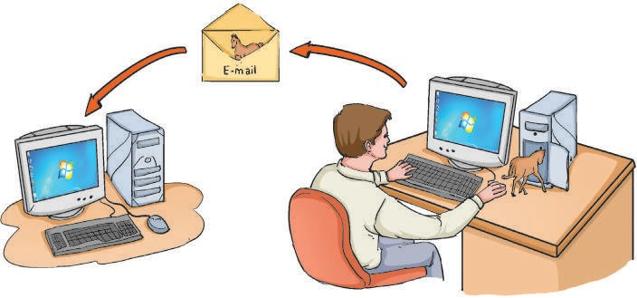
1F.i3g1. People can install Trojans onto your computer or send it via email attachments

Viruses, worms and Trojan horses may harm the data or affect the performance and the speed of a computer.

 Data Theft: It is a very serious problem for computer networks. People break into computer networks to either disrupt their functioning or to steal confidential information. Hackers

Did You Know?
Malware (malicious software) is a term used to describe all types of
unwanted software such as computer viruses, worms, Trojan horses and spyware.
are the computer experts who can break into computer systems and networks. There are two types of hackers—white hackers and black hackers.
White hackers study and break into networks to find and fix security loopholes. They offer their services
14

to corporations, public organisations and educational institutions to make their networks more secure.
Black hackers or crackers have a criminal intention. Some examples are cracking bank accounts in order to transfer money to their own accounts, stealing confidential information and attacking the computer network of an organisation for money.


Computer Securit�
 Antivirus Software: Every computer on a computer network must have an antivirus software installed in it and it should be updated on a regular basis. Antivirus software can be used to protect the computer from various types of malware. Antivirus software can detect viruses, worms and so on, and warn you of their presence in your computer. It can also deactivate and clean up the computer of malicious software.
There are various types of antivirus software such as AVG, Avira, Norton and McAfee (Fig. 1.32).





AFirewall:
Fig 1.32 Logos of some antivirus software

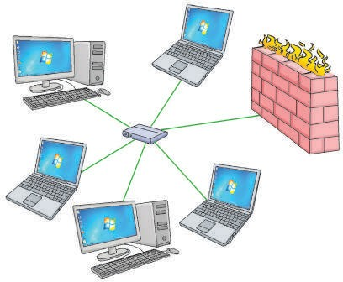

firewall is used to
Undesirable data
Internet

prevent unauthorised access to a computer network. A firewall can be implemented as a software, a hardware or a combination of both. All data or messages entering or leaving a computer network pass through a firewall (Fig. 1.33). A firewall examines each message and blocks those that do not meet the specified security criteria.

Fig. 1.33 Firewall (visual representation)
15



Words to Know
- Computer network: When two or more computers that are connected in order to share
resources, exchange files and allow electronic communication.
    - Topology: The manner in which computers are connected to one another to form a network.
    - Twisted Pair Cable: A cable that consists of a pair of insulated wires twisted together.
    - Coaxial Cable: An electrical cable with a conductor at its centre. The inner conductor is surrounded by a tubular insulating layer. The insulating layer is surrounded by a conductive layer called the shield which is finally covered with a thin insulating layer on the outside.
    - Optical Fibre Cable: A cable that consists of a centre glass core surrounded by several layers of protective material. It transmits data in the form of light rather than electronic signals.
    - Infrared Communication: Infrared waves cannot penetrate walls or other obstructions and so the communication range of the devices communicating through infrared waves is very limited.
    - Microwave Communications: Microwaves are unidirectional and they can be used for terrestrial
communication (on the surface of earth) or for satellite communication.
    - WiMAX: WiMAX (Worldwide Interoperability for Microwave Access) technology makes use of radio waves but covers a greater distance than Wi-Fi.
    - Radiowave Communications: Radio waves are omnidirectional and are widely used for communication both indoors and outdoors.
    - Network Interface Card (NIC): A hardware device that stores the hardware address and enables a computer to communicate over the network.
    - Protocol: A set of rules used by computers on the network to communicate with each other.
    - Firewall: It can be implemented as hardware device or software that prevents unauthorised access to the network.

    - Antivirus software: A software used to protect the computer from different types of malware such as viruses and worms.
- A computer network consists of two or more computers that are linked in order to share resources such as printers and exchange files and allow electronic communication.
- Based on the geographical area covered, computer networks can be of five types—PAN, LAN, CAN, MAN and WAN.
- There are various types of topologies such as bus, star, ring and mesh topology.
- There are many important protocols such as HTTP and TCP/IP which play an important role in
communication.
16
RECAP ZONE

- Cables such as twisted pair, coaxial and fibre optic cable are examples of wired network
transmission media.
- Radio waves, microwaves and infrared waves are examples of wireless network transmission media.
- Bluetooth, WiFi and WiMAX technologies make use of radio waves.
- Network devices such as Network Interface Card, modem, switch, hub, router play an important
role in setting up a network.
- It is important to be aware and take measures to avoid threats to computers from viruses, worms, Trojan horses, data theft and hackers.
- Measures of using antivirus software and firewall must be adopted to ensure network security.


ASSESSMENT ZONE
- Choose the correct answer.
  - What is the importance of a computer network?
    - It allows sharing of resources.
    - It is an effective communication medium.
    - It lets users share files.
    - All of the above
  - A network that spans countries and continents is known as
    - LAN. b) MAN. c) WAN. d) PAN.
  - A device used to connect computers in a network is referred to as
    - a firewall. b) CPU. c) HTTP. d) a switch.
  - A topology in which every computer is connected to every other computer is called
    - ring topology. b) mesh topology.
c) star topology. d) bus topology.
  - It transmits data in the form of light rather than electronic signals.
    - Coaxial cable b) Bluetooth
c) Optical fibre cable d) Twisted pair cable
  - A computer network organised around a person for communication between devices such as phones and personal digital assistants is called
    - PAN. b) LAN. c) MAN. d) WAN.
  - A device used to connect two or more networks.
17
    - NIC b) Modem c) Router d) None of these

- Fill in the blanks using the words given in the box.

MAN | TCP/IP | Topology Bluetooth | Firewall | Infrared
 | Wi-Fi Ring | modulator-demodulator | Protocol | CAN
- refers to the layout pattern in which the computers are connected to each other in a network.
- A is formed when the computers are connected in a neighbourhood area.
- A is used to prevent unauthorised access to a network.
- Modem stands for .
- is a set of rules used by computers on the network to communicate with each other.
- and technologies make use of radio waves.
- waves are used for communication between a TV set and its remote control.
- protocol is used to send data in the form of packets on the Internet.
- In topology, each computer is connected to two other computers so as to form a closed structure and the breakdown of any one computer can disable the entire system.
- A is a computer network that connects two or more LANs but is not as large as a MAN or WAN.

- Answer the following questions.
- Define the term ‘computer network’. What are its advantages?
- State the types of computer networks based on the geographical area covered by them.
- Write a note on twisted pair and coaxial cables.
- Give the advantages of optical fibre cables.
- What is a bus topology?
- How is a hub different from a switch?
- Discuss some common threats to network security.
- What is a firewall?
- How is microwave transmission different from radiowave transmission?
A
E
I
V
N
T
Y
I
O
T
Z
C


Book 8 Ch_1.indd 18 28/09/2016 11:45:47
Find out the names of two companies that manufacture switches and
modems.
18


HOTS

- Explain how a packet of data travels from one computer to the other over the Internet.
- A company has two offices in adjacent buildings. The computers in the two offices need to be connected to one another for a very high speed connectivity.
  - What cable should be used to connect the computers in these two offices?
  - What type of network is formed when the computers in the two offices are connected to form a network?

Project Zone
- A computer network has to be setup for a school lab with 20 computers.
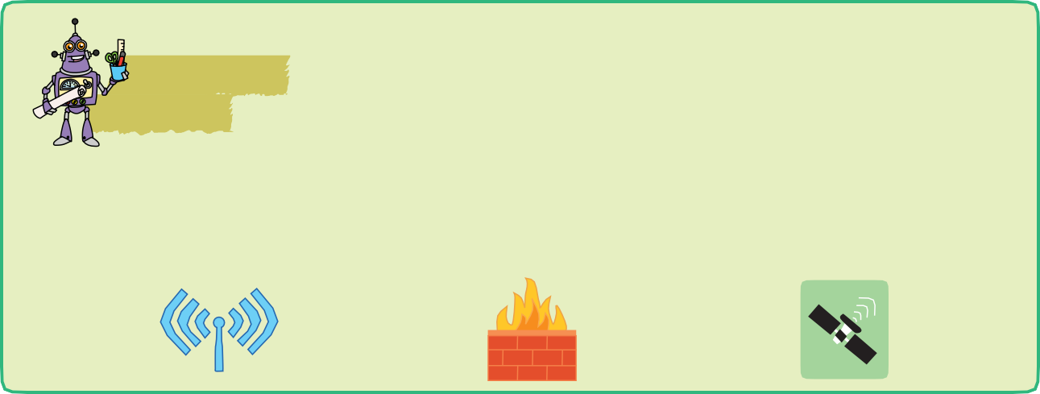
  - What hardware (devices and cables) would you require to set up the network?

  - What type of network would be formed?
  - How would data travel from one computer to the other in this network?
- What do the following pictures indicate? Can you identify them?


Lab Zone

Study the computer network used in your school computer lab and find information about the following.
- The cable used for setting up the network
- The topology of the network
- The hub or the switch used in the network

