CHAPTER:2-NUTRITION IN ANIMALS
QUESTIONS FROM NUTRITION IN AMOEBA AND DIGESTION IN GRASS EATING ANIMALS
1.What is the role of PSEUDOPODIA in nutrition of amoeba?
Ans.Pseudopodia plays an important role in the intaking of food.It engulfs the food and then the food is diffused into the cytoplasm.So,this pseudopodia helps to begin the digestion process.Pseudopodia also helps to capture food.
2.Drawa diagram to show the different steps involved in the process of nutrition in amoeba.
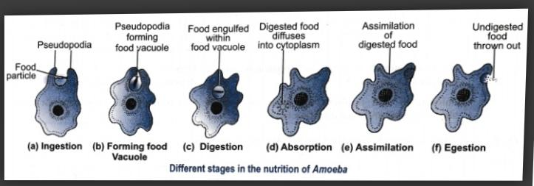
Ans.

3.What is the partially digested cellulose in the rumen of a cow called?
Ans.The partially digested cellulose in the rumen of a cow is called cud and thus, the process of rumination is commonly known as chewing of cuds.
4.What are ruminants?
Ans.Ruminants are the mammals that can digest cellulose from plants and chew the cud.e.g. cow,goat etc.
5. Which is the largest chamber of the ruminant stomach?What is its role?
Ans.Rumen is the largest chamber of the ruminant stomach.
The cow swallows the grass quickly with little chewing and stores it in the rumen.The rumen contains cellulose digesting bacteria .The bacteria present in the rumen of a cow start to digest cellulose carbohydrate present in grass food.
6.How does digestion occur in grass eating animals (ruminants)? Explain with the help of a well-labelled diagram.
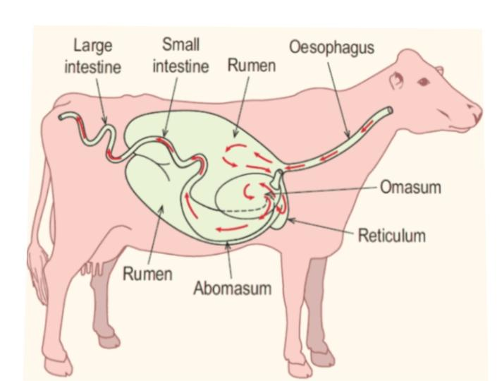
Ans.

Ruminants such as cow,goat etc eat mainly grass and other plant leaves as food.Grass is rich in carbohydrate called cellulose, which is difficult to digest.These animals have cellulose digesting bacteria present in the stomach, which helps to digest cellulose.They swallow the grass and store in the rumen,where the food gets partially digested and is called as cud.The cud returns to the mouth in small lumps and the animals chew it.This process is termed as rumination,and the animals are called ruminants.
During cud chewing,cud mixes with saliva and gets converted into a semi-solid form.This semi -solid food is swallowed back into the stomach.It doesn’t go back to rumen but to the next chambers of the stomach for further digestion.From the stomach food passes into to small intestine for complete digestion and absorption of digested food.The undigested waste then pass on to the large intestine for egestion.

