CIVIC CH- I
ON EQUALITY
HOME WORK SOLUTION

Answer the following questions:

- Who was Kanta? What are the main aspects of Kanta’s story? (1+4)
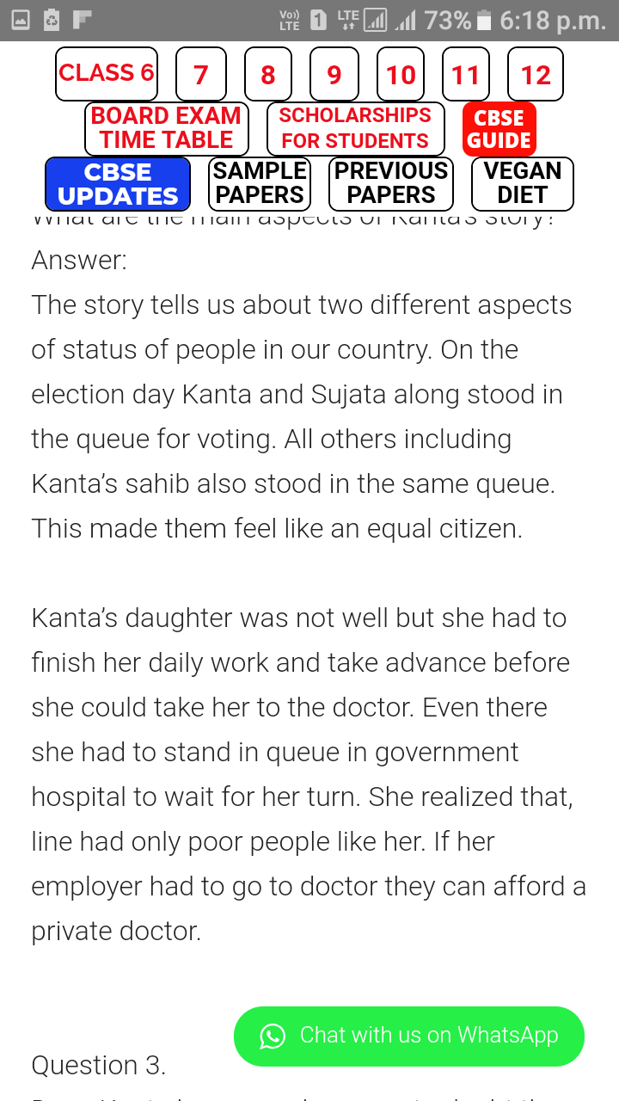
Ans. Kanta was a house hold worker.

- What do you mean by Universal Adult Franchise? (2)
Ans. This is a very important aspect of democratic societies. It means that all adult (those who are 18 and above) citizens have the right to vote irrespective of their social or economic backgrounds.

- What are the key elements of a democracy? (2)
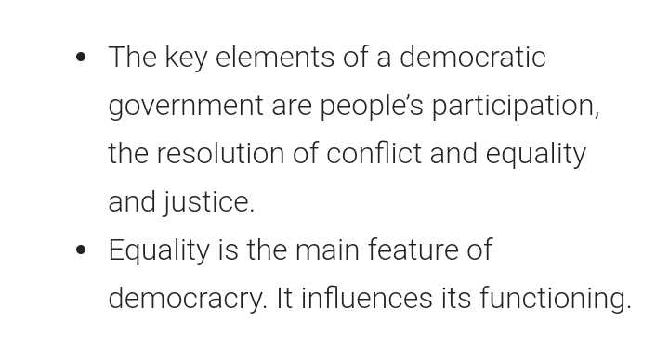

- Does Kanta have enough reason to doubt the equality level of citizens? Explain. (3)
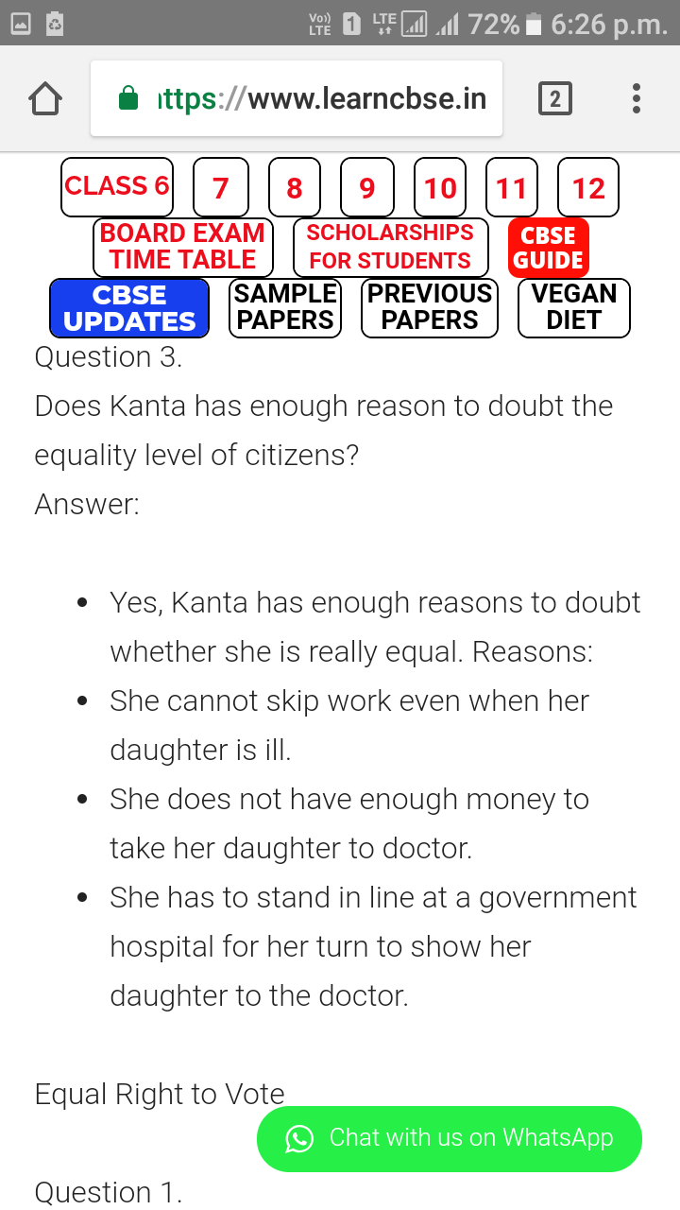

- What are the basis on which we are treated unequally? (2)
Ans. We are treated unequally on the basis of our class , caste , gender, place of birth ,race ,economic background etc.
- “When persons are treated unequally their dignity is violated” How? (3)
Ans. When persons are treated unequally their dignity is violated because they feel humiliated. In the chapter “On Equality” we have seen the dignity of both Om Prakash Valmiki and the Ansari’s was violated because of the way in which they were treated.Om Prakash and the Ansari’s do not deserve to be treated like this just for their caste and different religion. They deserve the same respect and dignity as others.
- What are the provisions in the constitution of India in respect of recognition of equality? (3)
Ans. first - every person is equal before the law. means is that every person, from the President of the country to a domestic worker, has to obey the same laws.
Second, no person can be discriminated against on the basis of their religion, race, caste, place of birth or whether they are female or male.
Third, every person has access to all public places including playgrounds, hotels, shops and markets. All persons can use publicly available wells, roads and bathing ghats.
Fourth, untouchability has been abolished.
- What are the steps Government has taken to end inequality? ( 3)
Ans. First : through laws
Second : Through government programmes or schemes to help disadvantaged communities. There are several laws in India that protect every person’s right to be treated equally.
- Who was Omprakash Valmiki? What did he face in his childhood? (1+3)
Ans. Omprakash Valmiki was a very famous Dalit writer.
In his autobiography, Joothan, he writes, “I had to sit away from the others in the class, and that too on the floor. The mat ran out before reaching the spot I sat on. Sometimes I would have to sit way behind everybody, right near the door…sometimes they would beat me without any reason.” When he was in Class IV, the headmaster asked Omprakash to sweep the school and the playground. He writes, “The playground was way larger than my small physique could handle and in cleaning it, my back began to ache. My face was covered with dust. Dust had gone inside my mouth. The other children in my class were studying and I was sweeping. Headmaster was sitting in his room and watching me. I was not even allowed to get a drink of water. I swept the whole day,…From the doors and windows of the school rooms, the eyes of the teachers and the boys saw this spectacle.”

- What is Article 15? (2)
Ans. Article 15 is a fundamental right which prohibits discrimination by the state against any citizen on grounds only of religion ,caste ,gender , race and place of birth.

