WORKSHEET-2
CLASS-IX, SUB-MATHEMATICS
CHAPTER-LINES & ANGLES
- Find the value of ‘X’
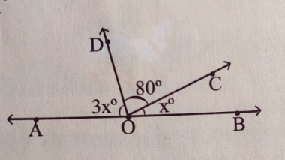
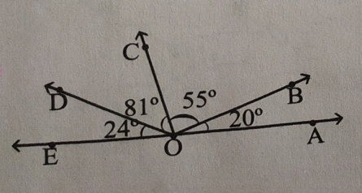
- What is the position of OA with respect to OE in the following figure:

- If $<$AOP=140⁰ then find $<$BOP
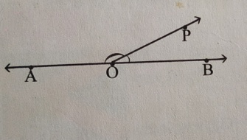

- If value two adjacent angles are 64⁰ and 26⁰, what is position of two non common side?

- If value two adjacent angles are 70⁰ and 110⁰, what is position of two non common side?

- Two lines AB and CD intersect each other at the point O. If <AOC= 65⁰,then find <BOD and <AOD.

- In the following figure if <AOC= 120⁰, find <COB, <BOD, <AOD 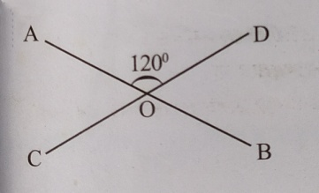

SOLUTION OF WORKSHEET-1
CLASS-IX, SUB-MATHEMATICS
CHAPTER-LINES & ANGLES
- Identify which of the followings are acute angle, obtuse angle, reflex angle, right angle, straight angle, complete angle:-
169⁰, 275⁰, 180⁰, 129⁰, 360⁰, 90⁰,75⁰, 99⁰, 20⁰, 155⁰, 348⁰, 126⁰, 220⁰

Solution-
169⁰- Obtuse angle
275⁰- Reflex angle
180⁰- Straight angle
129⁰- Obtuse angle
360⁰- Complete angle
90⁰- Right angle
75⁰- Acute angle
99⁰- Obtuse angle
20⁰- Acute angle
155⁰- Obtuse angle
348⁰- Reflex angle
126⁰- Obtuse angle
220⁰ - Reflex angle

- Identify which of the following pair of angles are complementary, supplementary to each other or none of these:-

Solution-
120⁰,60⁰ are supplementary angles to each other as 120⁰+60⁰=180⁰
42⁰,48⁰ are complementary angles to each other as 42⁰+48⁰ =90⁰
33⁰,47⁰ neither complementary or supplementary.
45⁰,45⁰ are complementary angles to each other as 45⁰+45⁰=90⁰
85⁰,95⁰ neither complementary or supplementary.
60⁰, 130⁰ neither complementary or supplementary.
70⁰,111⁰ neither complementary or supplementary

- Write the measurement of value of complementary angle for the followings:-
25⁰, 44⁰, 89⁰, 64⁰, 72⁰, 45⁰, 12⁰

Solution-
Complementary angle of 25⁰ is 90⁰-25⁰=65⁰
Complementary angle of 44⁰ is 90⁰-44⁰=46⁰
Complementary angle of 64⁰ is 90⁰-64⁰=26⁰
Complementary angle of 72⁰ is 90⁰-72⁰=18⁰
Complementary angle of 45⁰ is 90⁰-45⁰=45⁰
Complementary angle of 12⁰ is 90⁰-12⁰=68⁰
- Write the measurement of value of supplementary angle for the followings:-
125⁰, 84⁰, 29⁰, 164⁰, 102⁰, 65⁰, 90⁰

Solution-
Supplementary angle of 125⁰ is 180⁰-125⁰=55⁰
Supplementary angle of 84⁰ is 180⁰-84⁰=96⁰
Supplementary angle of 29⁰ is 180⁰-29⁰=151⁰
Supplementary angle of 164⁰ is 180⁰-164⁰=16⁰
Supplementary angle of 102⁰ is 180⁰-102⁰=78⁰
Supplementary angle of 65⁰ is 180⁰-65⁰=105⁰
Supplementary angle of 90⁰ is 180⁰-90⁰=90⁰

- Is it possible sum of two acute angles are complementary to each other? Explain.

Solution-
Yes possible, because many examples are there as 42⁰+48⁰ =90⁰, 30⁰+60⁰ =90⁰

- Is it possible sum of two obtuse angles are supplementary to each other? Explain.
Solution-
Not possible because sum of two obtuse angle is always greater than 180⁰. As 91⁰+91⁰=182⁰

- Which angle is complementary angle of itself?
Solution- 45⁰ is complementary angle of itself.

- Which angle is supplementary angle of itself?
Solution- 45⁰ is complementary angle of itself.

