Chapter : II
Forest and Wildlife Resource
Home work 2 solution

Answer the following short questions:
- When was first Indian Wild Life Act implemented?
Ans.: The Indian Wildlife (Protection) Act was implemented in 1972,

- Name two Government project for protecting specific animals.
Ans.: The central government also announced several projects for protecting specific animals, which were gravely threatened, including the tiger, the one-horned rhinoceros,

- Name three types of crocodiles under Government project.
Ans.: three types of crocodiles – fresh water crocodile, saltwater crocodile and the Gharial, the Asiatic lion, and others.

- Under which wild life act butterflies, moths, etc have been added to the list of protected species?
Ans.: In the notification under Wildlife Act of 1980 and 1986, several hundred butterflies, moths, beetles, and one dragonfly have been added to the list of protected species.

- What are the three types of forest? Write the difference between reserve forest and protected forest?
Ans.: Reserved Forest, Protected Forest and Un-classed Forest
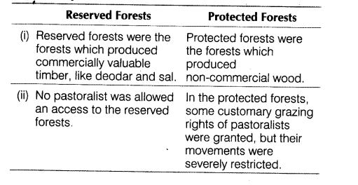

- What is un-classed forest? Where can we see un-classed forest in India?
Ans.: These are other forests and wastelands belonging to both government and private individuals and communities.

All North-eastern states and parts of Gujarat have a very high percentage of their forests as un-classed forests managed by local communities.

- Give some examples of protected and reserve forests.
Ans.:
- Reserved and protected forests are also referred to as permanent forest estates maintained for the purpose of producing timber and other forest produce, and for protective reasons.
- Madhya Pradesh has the largest area under permanent forests, constituting 75 per cent of its total forest area. Jammu and Kashmir, Andhra Pradesh, Uttaranchal, Kerala, Tamil Nadu, West Bengal, and Maharashtra have large percentages of reserved forests of its total forest area.
- Whereas Bihar, Haryana, Punjab, Himachal Pradesh, Orissa and Rajasthan have a bulk of it under protected forests.

- Why does the Himalayan Yew in trouble?
Ans.: The Himalayan Yew (Taxus wallachiana) is a medicinal plant found in various parts of Himachal Pradesh and Arunachal Pradesh. A chemical compound called ‘taxol’ is extracted from the bark, needles, twigs and roots of this tree, and it has been successfully used to treat some cancers – the drug is now the biggest selling anti-cancer drug in the world.

The species is under great threat due to over-exploitation. In the last one decade, thousands of yew trees have dried up in various parts of Himachal Pradesh and Arunachal Pradesh.

- In which year the Asiatic Cheetah was declared as extinct species in India?
Ans.: The species was declared extinct in India long back in 1952.

- What are the causes behind the vanishing of forests?
Ans.: Hints:
- Resources obtaining directly and indirectly from forest
- Large-scale development projects.
- Mining
NEED EXPLANATION
- Fuel-wood collection.
- Industrialization and urbanization.
- Hunting, Poaching
- Over-exploitation
- Environmental pollution.
- .Poisoning and forest fires
- Unequal access
- Over- population

