Electricity
Worksheet-1
- A wire of length l, made of material resistivity r is cut into two equal parts. The resistivity of the two parts are equal to
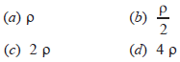
- The temperature of a conductor is increased. The graph best showing the variation of its resistance is 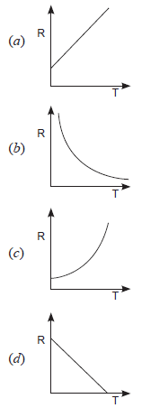
- A battery of 10 volt carries 20,000 C of charge through a resistance of 20 Ω. The work done in 10 seconds is
(a) 2 × 10³ joule (b) 2 × 10⁵ joule
(c) 2 × 10⁴ joule (d) 2 × 10² joule
- A boy records that 4000 joule of work is required to transfer 10 coulomb of charge between two points of a resistor of 50 Ω. The current passing through it is
(a) 2 A (b) 4 A
(c) 8 A (d) 16 A

- The resistance whose V – I graph is given below is
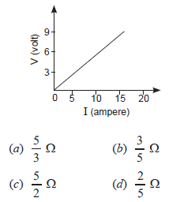
- To get 2 Ω resistance using only 6 Ω resistors, the number of them required is
(a) 2 (b) 3
(c) 4 (d) 6
- Two wires of same length and area made of two materials of resistivity and are connected in series to a source of potential V. The equivalent resistivity for the same area is
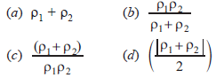
- Two devices are connected between two points say A and B in parallel. The physical quantity that will remain the same between the two points is
(a) current (b) voltage
(c) resistance (d) None of these
- The least resistance obtained by using 2 Ω, 4 Ω, 1 Ω and 100 Ω is
(a) < 100 Ω (b) < 4 Ω
(c) < 1 Ω (d) > 2 Ω
- Two wires of same length and area, made of two materials of resistivity and are connected in parallel V to a source of potential. The equivalent resistivity for the same length and area is 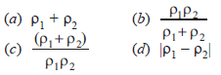
- Connecting many resistors in parallel, will __________ the resistance of the circuit.
- Current is a __________ quantity.
- Work done on unit charge is called as __________.
(a) Identify the various elements of the circuit shown below:
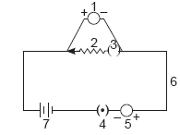
(b) What does the bigger line of element 7 represent?
- Define 1 volt. Express it in terms of SI unit of work and charge. Calculate the amount of energy consumed in carrying a charge of 1 coulomb through a battery of 3 V.
- Study the circuit shown:
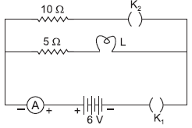 A current of 0.6 A is shown by ammeter in the circuit when the key K₁ is closed. Find the resistance of the lamp L. What change in current flowing through the 5 Ω resistor and potential difference across the lamp will take place, if the key K₂ is also closed. Give reason for your answer.

