ANSWER OF WORKSHEET 1
- ANS: (a) Resistivity of the material depends only on the nature of material not dimensions.
- ANS: (a) Resistance is directly proportional to temperature of the conductor.
- ANS: (b) W = qV = 20000 × 10 = 2,00, 000 = 2 × 10⁵ J
- ANS: (c) Work done in transferring the charge W = qV = qIR ..... (V = IR) 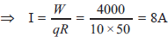
- ANS: (b) Resistance = slope line of V-I graph = 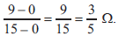
- ANS: (b) Three resistors of 2 Ω is required to get 6 Ω because resultant is more than individual so they all must be connected in series.
- ANS.
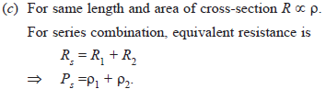
- ANS: (b) In parallel combination voltage remains same across two points.
- ANS: (c) In parallel combination, the equivalent resistance is smaller than the least resistance used in the circuit.
- ANS: (b) Equivalent resistance in parallel combination is 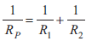 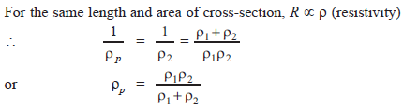
- ANS: (a) Equivalent resistance in parallel combination will be smaller than the lest resistance used in circuit.
- ANS: (b) Current is a scalar quantity as it has no particular direction of flow.
- ANS: Potential difference

- ANS: (a) Various element of the circuit are
1 – Voltmeter
2 – Resistance
3 – Open key
4 – Closed key
5 – Ammeter
6 – Connecting wire
7 – Cell
(b) Bigger line of element 7 represents positive terminal of the cell.
- ANS: When 1 joule of work is done in carrying 1 coulomb of charge, from infinity to a point in the electric field, then potential at that point is called 1 volt.
Potential difference between two points is
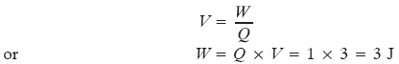
- ANS: (a) 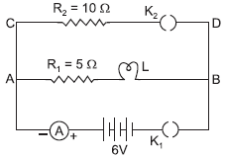 When K₁ is closed and K₂ is open
I₁ = 0.6 A, R₁ = 5 Ω, R_{L} = ?
Using Ohm’s law V = IR_{S}
⇒ 6 = 0.6 × (5 + R_{L}) …R_{S} = R₁ + R_{L}
⇒ 10 = 5 + R_{L}
⇒ R_{L} = 5 Ω
(b) Potential difference across lamp
V_{L1} = IR_{L} = 0.6 × 5 = 3.0 V
Now key K₂ is also closed.
10 Ω resistor is now connected in parallel with series combination of R₁ and R_{L}, potential remains same across them. 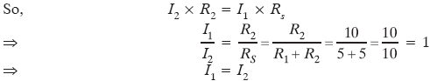 Equivalent resistance of the circuit 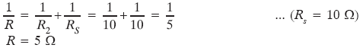 So, total current drawn from the battery 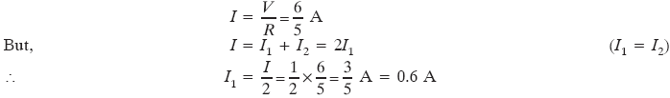 So, there will be no change in the current flowing through 5 Ω conductor and potential difference across the lamp will also remain same in both the cases.

