GK
CLASS III
PARTS OF PLANTS
National tree of India: Banyan Tree. Largest canopy recorded for a banyan tree is Thimmamma Marrimanu
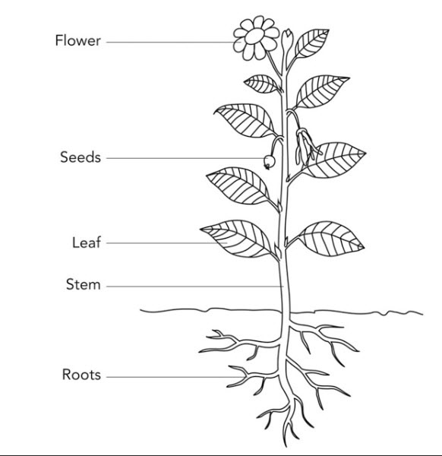
Draw this picture in your copy and memories the different parts of plant

