SATISH CHANDRA MEMORIAL SCHOOL
MATHS WORKSHEET
Name : _________________________________ Sec : ______ Roll no. : ______
1. Draw and colour a BIG land animal and a SMALL land animal.

2. Can you help them in dressing ????
Make her wear a LONG frock : Make her wear a SHORT frock :
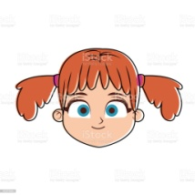

3. FULL the glass no. 1 , 3 and 5 with the orange juice from the jug and leave the glass no. 2 and 4 EMPTY.

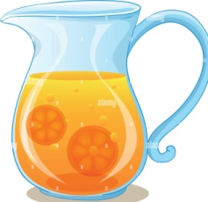
1 2 3 4 5

