ELECTRICITY
WORKSHEET-2
- Two resistors are connected in series gives an equivalent resistance of 10 Ω. When connected in parallel, gives 2.4 Ω. Then the individual resistance are
(a) each of 5 Ω (b) 6 Ω and 4 Ω
(c) 7 Ω and 4 Ω (d) 8 Ω and 2 Ω

- The effective resistance between A and B is 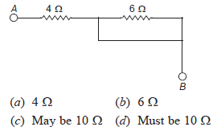

- A current of 1 A is drawn by a filament of an electric bulb. Number of electrons passing through a cross-section of the filament in 16 seconds would be roughly
(a) 10²⁰ (b) 10¹⁶
(c) 10¹⁸ (d) 10²³

- What is the maximum resistance which can be made using five resistors each of 1/5 W?
(a) 1/5 Ω (b) 10 Ω
(c) 5 Ω (d) 1 Ω

- A cylindrical conductor of length l and uniform area of cross-section A has resistance R. Another conductor of length 2l and resistance R of the same material has area of cross-section
(a) A/2 (b) 3A/2
(c) 2A (d) 3A

- Two resistors are in parallel when they have ___________ common points.

- One common point and no sharing devices for that point are the conditions to be satisfied for two resistors to be in series.

- Define resistance. Write the SI unit of resistance and define it. Match the correct range of resistivity with the materials given.
(a) Conductors (i) 10^{–6} Ωm
(b) Alloys (ii) 10¹² to 10¹⁷ Ωm
(c) Insulators (iii) 10^{–6} to 10^{–8} Ωm

- The figure below shows three cylindrical copper conductors along with their face areas and lengths. Discuss in which geometrical shape the resistance will be highest. 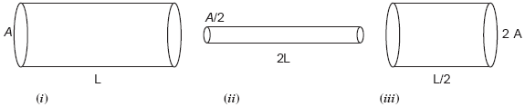
- V-I graph for two wires A and B are shown in the figure. If both wires are of same length and same thickness, which of the two is made of a material of high resistivity? Give justification for your answer.
