Types of Plants: PART II
There are three types of plants namely shrubs, trees and clmbers.
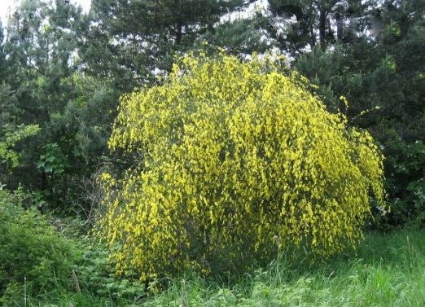
The plants which are small and have short lifespan are called shrubs.
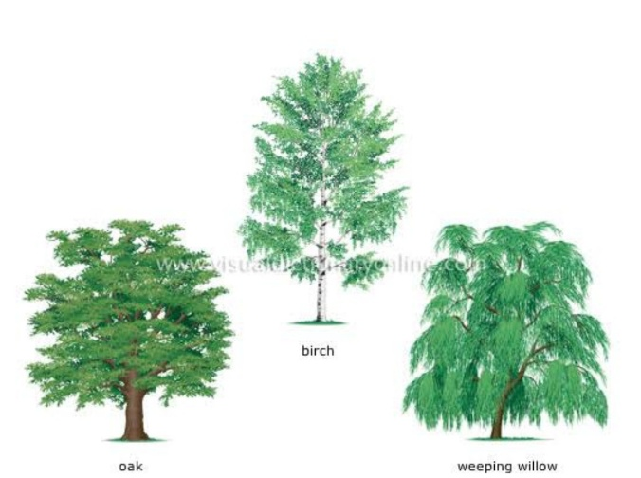
The plants which are very big and have longer lifespan are called trees.

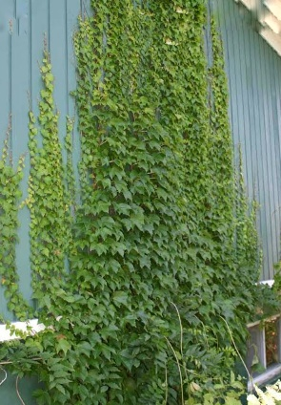
The plants which creep on land or need support of others to climb are called climbers.

