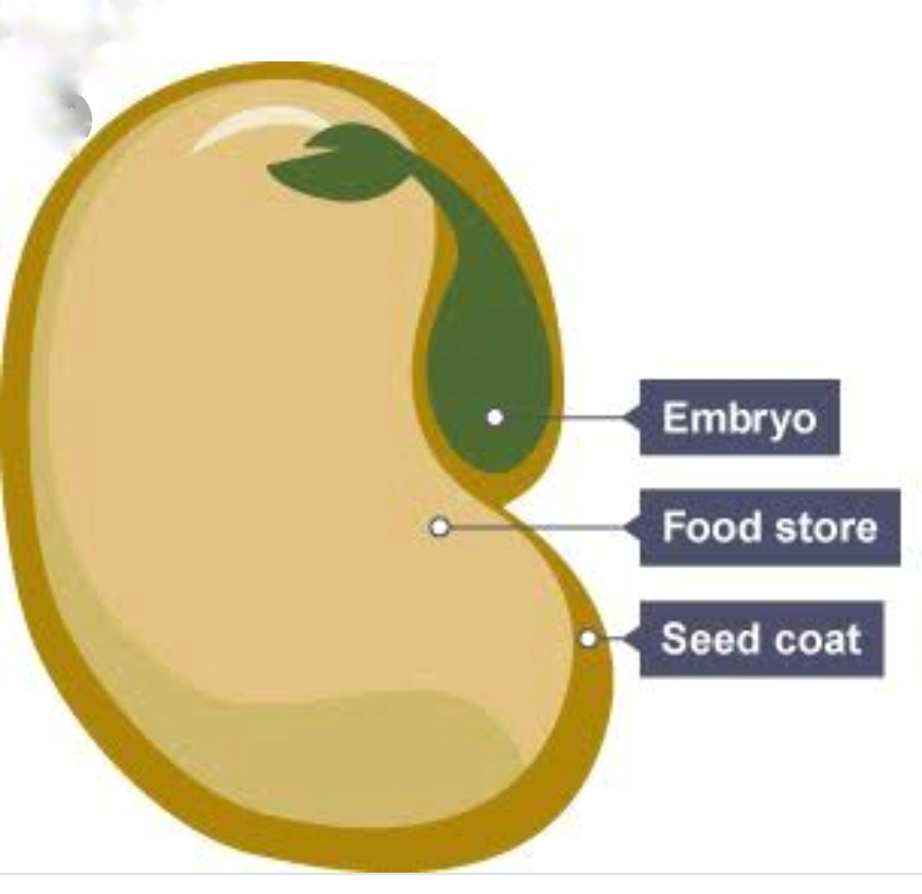
CLASS III PARTS OF PLATS P3

Simple diagram of seed. Where embryo is the small future plant. Seed coat protect the seed and large portion is for food storage.
The largest seed in the world is the coco de mer, the seed of a palm tree. It can reach about 12 inches (30 cm) long, and weigh up to 40 pounds (18 kg).

