Worksheet 3
Electricity

1. Find the current flowing through the following electric circuit.
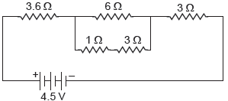
2. Find the equivalent resistance across the two ends A and B of the following circuits.
(i) 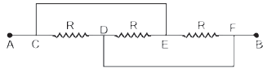
(ii) Assume that P and Q are at the same potential.
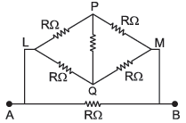

3.Two identical wires one of nichrome and other of copper are connected in series and a current (I) is passed through them. State the change observed in the temperatures of the two wires. Justify your answer. State the law which explains the above observation.

4.A student boils the water in an electric kettle for 20 minutes after being switched on. Using the same mains supply, he wants to reduce the boiling time of water. To do so, should he increase or decrease the length of the heating element? Justify your answer.

5.An electric bulb of resistance 200 Ω draws a current of 1 Ampere. Calculate the power of the bulb, the potential difference at its ends and the energy in kWh consumed in burning it for 5h.

6.Two lamps, one rated 60 W at 220 V and the other 40 W at 220 V, are connected in parallel to the electric supply at 220 V.
(a) Draw a circuit diagram to show the connections.
(b) Calculate the current drawn from the electric supply.
(c) Calculate the total energy consumed by the two lamps together when they operate for one hour.

7.Three bulbs each having power P are connected in series in an electric circuit. In another circuit, another set of three bulbs of same power are connected in parallel to the same source.
(i) Will the bulbs in both the circuits glow with the same brightness? Justify your answer.
(ii) Now let one bulb in each circuit get fused. Will the rest of the bulbs continue to glow in each circuit? Give reason.
(iii) Representing each bulb by a resistor, draw circuit diagram for each case.

8.(a) Though same current flows through the electric line wires and the filament of bulb, yet only the filament glows. Why?
(b) The temperature of the filament of bulb is 2700 °C when it glows. Why does it not get burnt up at such high temperature?
(c) The filament of an electric lamp, which draws a current of 0.25 A is used for four hours.
Calculate the amount of charge flowing through the circuit.
(d) An electric iron is rated 2 kW at 220 V. Calculate the capacity of the fuse that should be used for the electric iron.

9.(a) Define electric power. Express it in terms of potential difference V and resistance R.
(b) An electrical fuse is rated at 2A. What is meant by this statement?
(c) An electric iron of 1 kW is operated at 220 V. Find which of the following fuses that respectively rated at 1 A, 3 A and 5 A can be used in it.

10.(a) Write two point of difference between electric energy and electric power.
(b) Out of 60 W and 40 W lamps, which one has higher electrical resistance when in use.
(c) What is the commercial unit of electric energy? Convert it into joules.
11.An electric geyser consumes 2.2 ‘units’ of electrical energy per hour of its use. It is designed to work on the mains voltage of 220 V.
(a) What is the ‘power-rating’ of this device?
(b) What is the current flowing through this device when it is connected across the ‘mains’?
(c) What is the ‘resistance’ of this device?
(d) Does the resistance of this device remain constant during its operation/working?
(e) Cost of energy consumed if each unit cost 6.00.

