Class -7. Science. REVISION OF CHAP.1,2,3,4
Answer the following questions on the basis of your understanding of the following paragraph and the related studied concepts

1) Heterotrophic nutrition is a type of nutrition in which organisms depend upon other organisms for food to survive.All heterotrophs depends upon autotrophs for food to survive.All heterotrophs depends on autotrophs for their nutrition..All fungi are heterotrophic.Fungi are mostly saprophytes.Like animals, they can not ingest the food.They secrete some enzymes into the environment,where the enzymes digest dead organisms or waste materials, which is then absorbed by the fungi.Then they act as decomposers and maintain the balance in nature.Some fungi live in symbiotic association with plants.Some fungus species are pathogenic and cause harmful plant diseases such as powdery mildew,rust,root rot ,leaf spot and blights.The conditions which encourage many of these fungal diseases are excessive moisture, improper watering,over fertilizing etc.

a) Saprophytic fungi are
i) autotrophs ii) heterotrophs
iii) Insectivorous. iv) omnivores

b) Complete the web chart

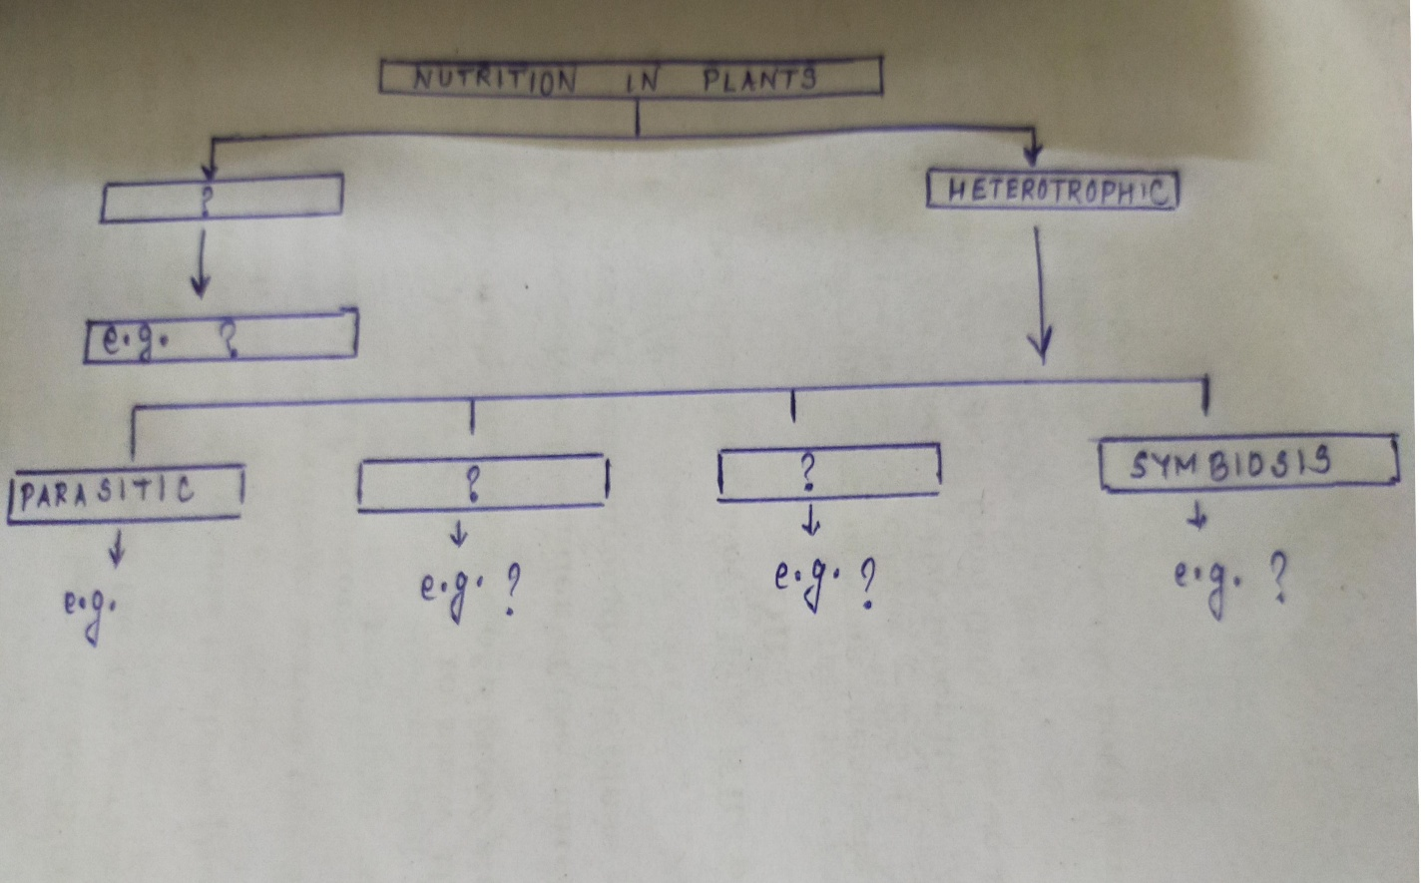

c)Why are fungi important decomposers?
d) What are the uses and harmful effects of fungi?
e)How do you prevent fungus in soil?
3. Heat conduction is the transfer of internal energy by microscopic collision of particles and movement of electrons within a body.Conduction takes place in all phases - Solid, liquid and gas .Heat spontaneously flows from a hotter to a colder body.e.g.heat is conducted from the hotplate of an electric stove to the bottom of a saucepan in contact with it.
Heat conduction varies with the type of material.e.g.greatest for metallic solids, lower for non metallic solids,very low for liquids and extremely low for gases.Metals like iron, aluminum, copper,silver, stainless steel etc. and stones are considered good conductors whereas air is an awesome insulator when locked in an enclosed space.
a)What does heat conduction mean?
b)Give two examples from everyday life where heat is transmitted by conduction.
c)With the help of an experiment ,show conduction of heat in solids.
d)Is paper a bad conductor of heat?How?
e)A wooden spoon is used to make vegetable in a metal frying pan.Its other end
i) becomes hot because of conduction
ii) becomes hot because of convection
iii) becomes hot because of radiation
iv)does not become hot
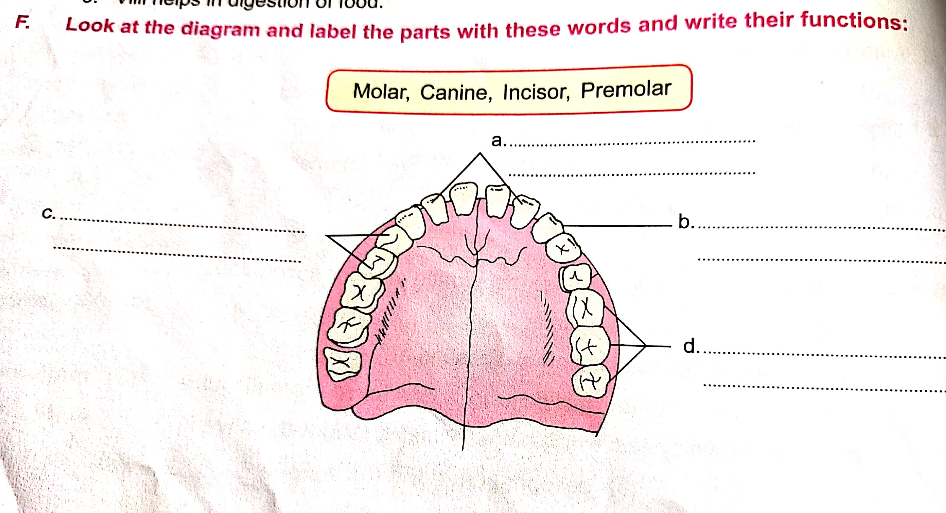
3
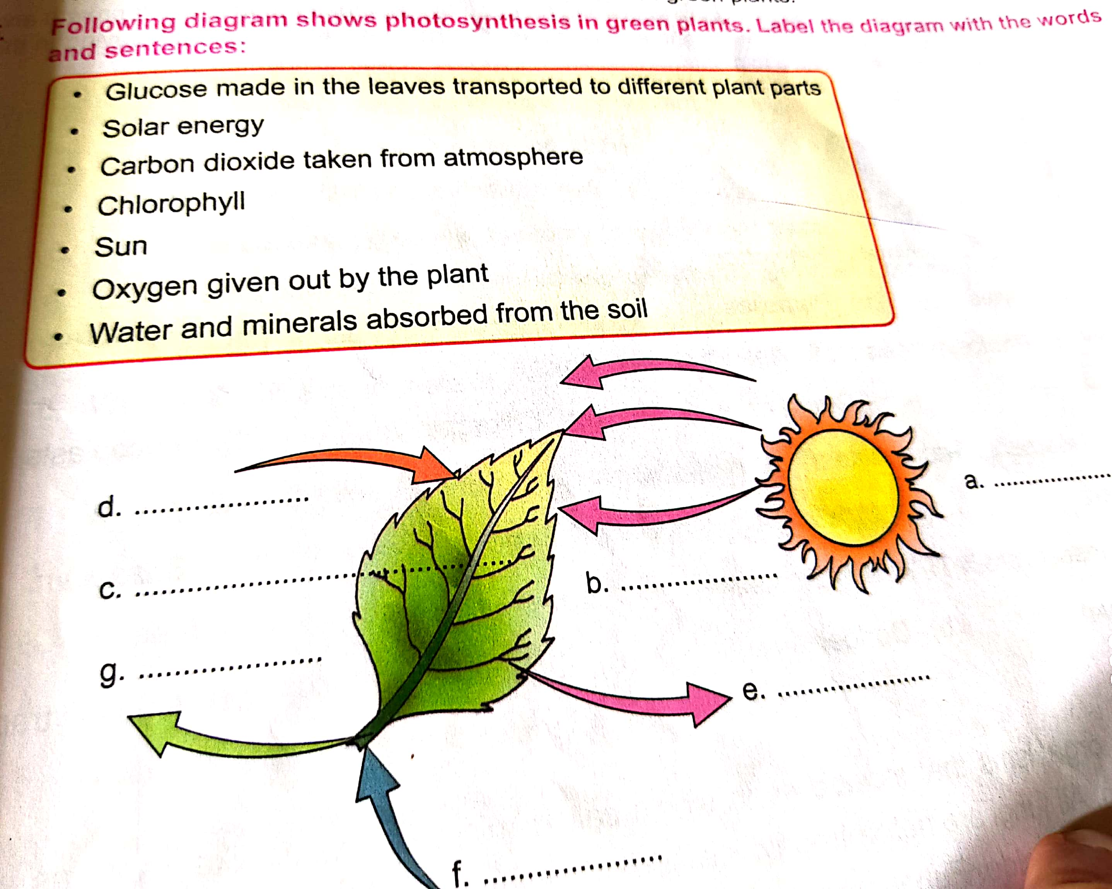
4.

