Worksheet 3
answer

1.Find the current flowing through the following electric circuit.
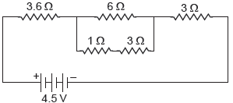
Ans :
Series combination of 1 Ω and 3 Ω resistance is in parallel combination with 6 Ω. Their equivalent resistance is
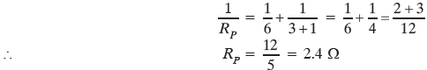
Now, 3.6 Ω, 2.4 Ω and 3 Ω are in series, their equivalent resistance be
R_{S} = R₁ + R₂ + R₃ = 3.6 + 2.4 + 3 = 9 Ω
Hence, the current flowing through the circuit is
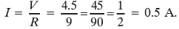
2.Find the equivalent resistance across the two ends A and B of the following circuits.
(i) 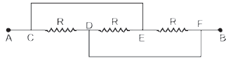
(ii) Assume that P and Q are at the same potential.
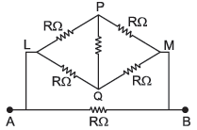
Ans :
(i) The equivalent circuit is shown in figure below. Here all the three resistances are in parallel combination between point A and B
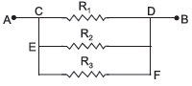
Therefore, equivalent resistance of the circuit is
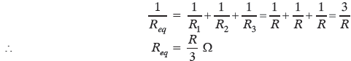
Given : P and Q are at the same potential. It means, no current will flow through the resistance between P and Q. Therefore, the resistance between P and Q is ineffective.
The circuit can be redrawn as
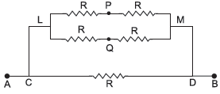
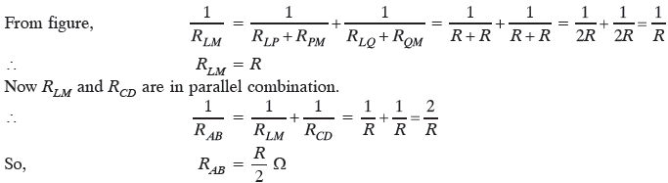

3.Two identical wires one of nichrome and other of copper are connected in series and a current (I) is passed through them. State the change observed in the temperatures of the two wires. Justify your answer. State the law which explains the above observation.

Ans :
The resistivity of nichrome is more than that of copper so its resistance is also high. Therefore, large amount of heat is produced in the nichrome wire for the same current as compared to that of copper wire. Accordingly, more change in temperature is observed in the nichrome wire. This is explained by Joule’s law of heating.
Joule’s law of heating : It states that the amount of heat produced in a conductor is
(i) directly proportional to the square of current flowing through it i.e. H ∝ I².
(ii) directly proportional to the resistance of the conductor for a given current and time i.e.
H ∝ R
(iii) directly proportional to the time for which current is flowing through it, i.e.,
H ∝ t
Combining these, we get
H ∝ I²Rt
or H = KI²Rt
where K is proportionality constant and in SI system, it is equal to one.

4.A student boils the water in an electric kettle for 20 minutes after being switched on. Using the same mains supply, he wants to reduce the boiling time of water. To do so, should he increase or decrease the length of the heating element? Justify your answer.

Ans :
To reduce the boiling time of water, using the same mains supply, the rate of heat production should be large. We know that P = clearly R should be decreased. Since R ∝ l, therefore, the length of heating element should be decreased.

5.An electric bulb of resistance 200 Ω draws a current of 1 Ampere. Calculate the power of the bulb, the potential difference at its ends and the energy in kWh consumed in burning it for 5h.
Ans :
Power of the bulb,
P = I²R = (1)² × 200
⇒ P = 200 W
Energy consumed by bulb in 5h in burning = Power × Time = 200 × 5 = 1000 Wh = 1 kWh

6. Two lamps, one rated 60 W at 220 V and the other 40 W at 220 V, are connected in parallel to the electric supply at 220 V.
(a) Draw a circuit diagram to show the connections.
(b) Calculate the current drawn from the electric supply.
(c) Calculate the total energy consumed by the two lamps together when they operate for one hour.
Ans :
(a) 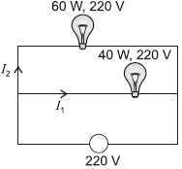
(b) Current drawn by 40 W lamp:
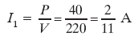
Current drawn by 60 W lamp:
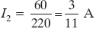
Total current drawn from the electric supply
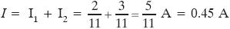
(c) Total energy consumed in one hour = 60 × 1 + 40 × 1 = 100 Wh = 0.1 kWh

7.Three bulbs each having power P are connected in series in an electric circuit. In another circuit, another set of three bulbs of same power are connected in parallel to the same source.
(i) Will the bulbs in both the circuits glow with the same brightness? Justify your answer.
(ii) Now let one bulb in each circuit get fused. Will the rest of the bulbs continue to glow in each circuit? Give reason.
(iii) Representing each bulb by a resistor, draw circuit diagram for each case.
Ans :
(i) Bulbs in parallel provide more illumination. This is because in parallel combination.
(a) each bulb gets same voltage and is equal to the applied voltage.
(b) each bulb draws required current from the mains. Hence, they work properly.
Mathematical justification:
For three identical bulbs,
In series, R_{S} = 3R
In parallel, R_{P} =
The bulbs in the two circuits will not glow equally bright as the current through them is not the same.
In series, I_{S} = 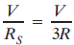
In parallel, I_{P} = 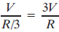
So, I_{P} > I_{S}.
(ii) When one bulb in each circuit get fused,
In series: Rest of the bulbs will not glow as circuit becomes an open circuit. This is because in series arrangement, there is only a single path for the flow of current.
In parallel: Rest of the bulbs will continue to glow as in parallel
(a) individual branch in the circuit completes its own circuit. or
(b) different paths are available for the flow of current.
(iii) Circuit diagram
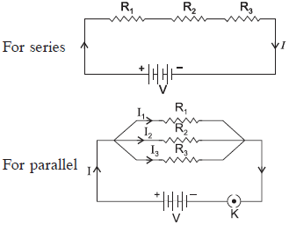

8.(a) Though same current flows through the electric line wires and the filament of bulb, yet only the filament glows. Why?
(b) The temperature of the filament of bulb is 2700 °C when it glows. Why does it not get burnt up at such high temperature?
(c) The filament of an electric lamp, which draws a current of 0.25 A is used for four hours.
Calculate the amount of charge flowing through the circuit.
(d) An electric iron is rated 2 kW at 220 V. Calculate the capacity of the fuse that should be used for the electric iron.
Ans :
(a) Electric line wires offer extremely low resistance to the flow of current, so they do not glow because negligible heat is produced in it.
The filament of bulb glows because it becomes red hot due to large amount of heat produced, as it offers high resistance to the flow of current through it.
(b) The filament of bulb when it glows at 2700 °C does not gets burnt because the tungsten metal of filament has
(i) a very high melting point (of 3380 °C) and
(ii) a high resistivity.
(c) Given: I = 0.25 A, t = 4 h = 4 × 60 × 60 sec.
So, amount of charge flowing the filament of electric lamp
q = It = 0.25 × 4 × 60 × 60 = 3600 C
(d) Given P = 2 kW = 2000 W
V = 220 V
Using, P = VI
2000 = 220 × I
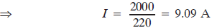
So, the capacity of the fuse that should be used for the electric iron is 10 A.

9. (a) Define electric power. Express it in terms of potential difference V and resistance R.
(b) An electrical fuse is rated at 2A. What is meant by this statement?
(c) An electric iron of 1 kW is operated at 220 V. Find which of the following fuses that respectively rated at 1 A, 3 A and 5 A can be used in it.
Ans :
(a) Electric power: It is the rate of doing work by an energy source or the rate at which the electrical energy is dissipated or consumed per unit time in the electric circuit is called electric power.
(b) It means, the maximum current will flow through it is only 2 A. Fuse wire will melt if the current exceeds 2 A value through it.
(c) Given: P = 1 kW = 1000 W, V = 220 V
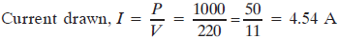
To run electric iron of 1 kW, rated fuse of 5 A should be used.

10.(a) Write two point of difference between electric energy and electric power.
(b) Out of 60 W and 40 W lamps, which one has higher electrical resistance when in use.
(c) What is the commercial unit of electric energy? Convert it into joules.
Ans :
(a) Difference between electric energy and electric power:
Electrical energy | Electric power
(i) The work done or energy supplied by the  source in maintaining the flow of electric  current is called electrical energy. It appears  in the form of heat given by  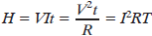  (ii) It is equal to the product of power and time  E = P × t  (iii) Its SI unit is joule (J)  1 J = 1 W × 1s | (i) The time rate at which electric energy is  consumed or dissipated by an electrical device is called electric power and is given by  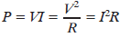  (ii) It equal to the rate of doing work by an energy source.  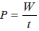  (iii) Its SI unit is watt (W)  1 W = 1 J s^{–1}
(b) For the same applied voltage, 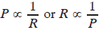
i.e. less the power of electrical device, higher is its electrical resistance.
Therefore, a 40 W lamp has higher electrical resistance when in use.
(c) Kilowatt hour – Commercial unit of electrical energy

11.An electric geyser consumes 2.2 ‘units’ of electrical energy per hour of its use. It is designed to work on the mains voltage of 220 V.
(a) What is the ‘power-rating’ of this device?
(b) What is the current flowing through this device when it is connected across the ‘mains’?
(c) What is the ‘resistance’ of this device?
(d) Does the resistance of this device remain constant during its operation/working?
(e) Cost of energy consumed if each unit cost 6.00.
Ans :
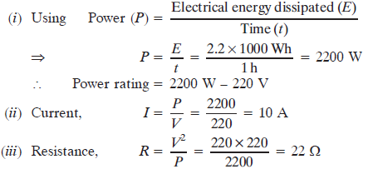
(iv) No, Resistance increases with the increase in temperature.
(v) Cost of energy consumed per hour = Number of electrical unit × Cost per unit = 2.2 × 6 = 13.2

