SCIENCE ACTIVITIES
CLASS-7
- CHICKEN BONES CONTAIN CALCIUM JUST LIKE OUR TEETH AND BONES DO.NOW, EXPERIMENT WITH DIFFERENT LIQUIDS TO SEE THE EFFECTS OF DIFFERENT LIQUIDS ON BONES.DROP CHICKEN BONES (NOT COOKED)IN ANY TRANSPARENT GLASS CONTAINING VINEGAR ,LEMON JUICE .OBSERVE IT AFTER A FEW HOURS . WHAT EFFECT DOES THE ACID HAVE ON THE BONES?

NOW,PLACE SOME CHICKEN BONES IN TEST TUBES CONTAINING BAKING SODA,A COLD DRINK,TEA AND WATER FOR A WEEK EACH .OBSERVE WHAT HAPPENS TO THE BONES.COMPARE IT WITH THE EFFECT OF ACID.WHAT ARE YOUR CONCLUSIONS?

2)A SMALL BOTTLE IS FILLED WITH A TWO- HOLED RUBBER CORK.TWO THIN RUBBER TUBES OR PLASTIC STRAWS,EACH AROUND 5cmLONG ,ARE INSERTED INTO THE CORK AS SHOWN IN THE FIGURE.THE SMALL BOTTLE IS FILLED WITH COLOURFUL WATER AND PLACED INSIDE A BIGGER GLASS CONTAINER FILLED WITH COLD WATER.AND THEN FILLED WITH HOT WATER.
a) WHAT WILL HAPPEN IF THE GLASS CONTAINER IS FILLED WITH COLD WATER?
b) WHAT WILL HAPPEN IF THE GLASS CONTAINER IS FILLED WITH HOT WATER?
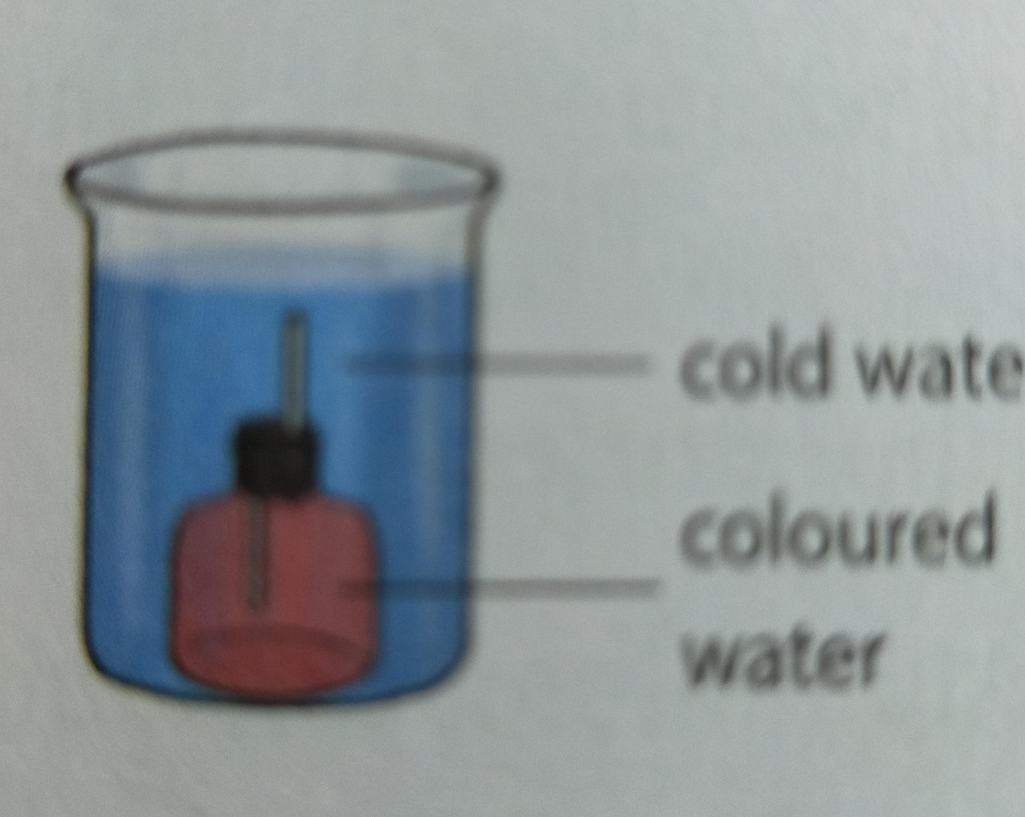

3)WRITE IN 100 WORDS ABOUT 'IMPORTANCE OF PLANT LIFE ON PLANET EARTH '.

4)DRAW AN OUTLINE MAP OF INDIA .MARK THE PLACES WHERE WOOL YIELDING ANIMALS ARE FOUND.WRITE THE NAMES OF THOSE ANIMALS.

NOTE: You all are requested to buy an activity copy (practical copy) and write all these over there.Complete it by the end of june.

