Class III
INDIAN FORTS PART ONE
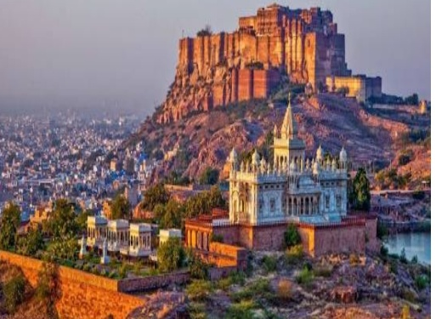
●Mehrangarh Fort, located in Jodhpur, Rajasthan, is one of the largest forts in India. It is believed to have been Built around 1460 by Rao Jodha, the chief of the Rathore clan.

●The Red Fort is a historical fort in the city of Delhi in India, constructed in 1639 by the fifth Mughal Emperor Shah Jahan as the palace of his fortified capital Shahjahanabad and is named for its massive enclosing walls of red sandstone.
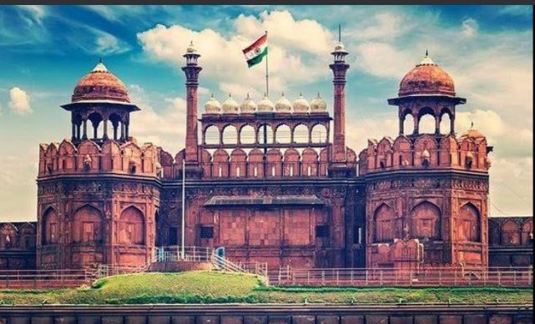

●Gwalior Fort is an 8th-century hill fort near Gwalior, Madhya Pradesh, central India. The fort consists of a defensive structure and two main palaces, Gujari Mahal and Man Mandir.
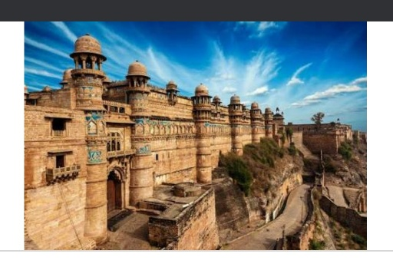

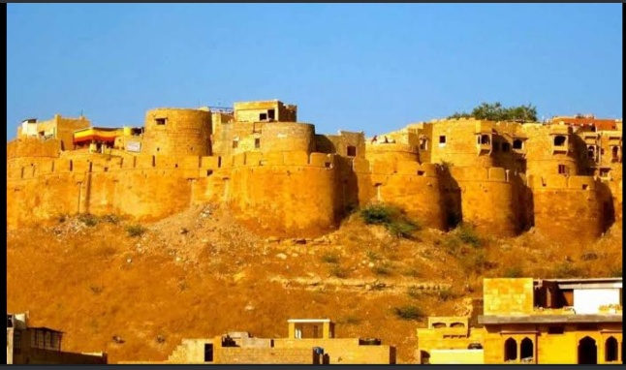
●Jaisalmer Fort is situated in the city of Jaisalmer, in the Indian state of Rajasthan. It was built in 1156 AD by the Rajput ruler Rawal Jaisal, from whom it derives its name. The fort stands amidst the sandy expanse of the great Thar Desert, on Trikuta Hill.

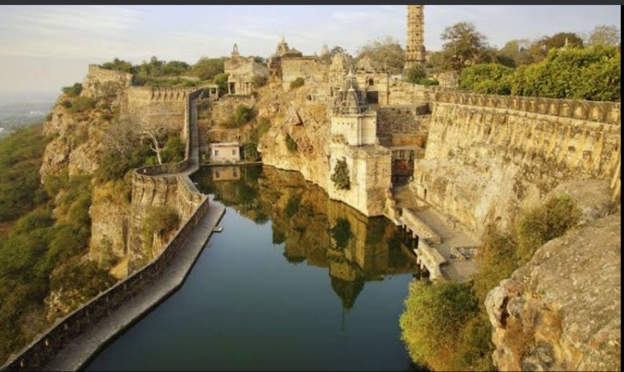
● The Chittor Fort or Chittorgarh is one of the largest forts in India. It is a World Heritage Site. The fort was the capital of Mewar and is today situated in the Chittorgarh town.

