|| Question answer of chapter 5 ||

- How do seeds spread to far of places write in your own words.
Ans. Seeds spread to far places as they are carried away by birds, animals, air and water from one place to another place. Birds and animals after eating the fruits throw away the seeds. Also some seeds stick to the body of animals and carried to different places by those animals. Some light weight seeds are carried by the blowing winds. Some seeds are carried by flowing water. To be very precise seeds disperse
By wind
By water
By birds and animals.

- What do you think the seeds need for sprouting ?
Ans. We have read the case study of Gopal. From the given case study basic requirements are air, water. Soil and sunlight for further development.
- Check the following short type questions and answer the following
(i) Seeds that are used as spices in your home.
(ii) Seeds of vegetables.
(iii) Seeds of fruits.
(iv) Light seeds (check by blowing them).
(v) Seeds which are flat.
(vi) Make more groups. How many groups of seeds did you make?
(vii) Do you know any games that you can play with seeds?

Answer.
(i) Seeds used as spices in our home: mustard and cumin
(ii) Seeds of vegetables: lady finger, tomato, cucumber
(iii) Seeds of fruits: guava, mango, apple, papaya
(iv) Light seeds: mustard, cumin, aniseed
(v) Seeds which are flat: sesame, seeds of water melon, musk melon and cucumber
(vi) I can make the following five more groups of seeds:
(a) Edible seeds
(b) Seeds from which oil is extracted
(c) Seeds which are round in shape
(d) Seeds with rough coating
(e) Seeds with smooth coating
(vii) I only know that children play with mango seeds by making a flute out of them.

- Look at the pictures and find out different types of dispersal
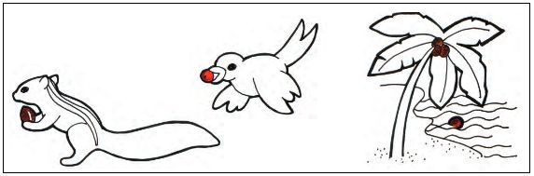
Ans. First one is squirrel. It holds a seed in its forelimbs and helping for seed dispersal. Next one is a bird flying away with the seed. Third one is water dispersal, where light weight seeds are carried by water.
- What is the biggest seed on planet?
Ans. The largest seed in the world is Coco de Mar. One seed can weigh upto 18kg!
- What is velcro ? What are the applications of velcro ?
Ans. George De Mestral gave the name Velcro, French words velour ("velvet") and crochet ("hook"), to his invention as well as to the company he founded. The company continues to manufacture and market the fastening(to hold something) system.
Application of it:
It closes backpacks, briefcases and notebooks, secures pockets, and holds diaper covers for cloth diapers, on babies.
- What is biomimicry ? Write two examples of it .
Ans. Biomimicry is the imitation of the models, systems, and elements of nature for the purpose of solving complex human problems.
Aero plane inspired from Birds.
Automobiles inspired from fishes.
- What are the advantages of wandering seeds?
Ans. If the seeds did not spread out and remained at one place then all of them would have competed for water and minerals from that small area of earth. As a result, none of the seeds would have got enough nutrition to grow properly.8. If you take the Mango seed what is its colour, shape, texture
- What is the other name of Pitcher plant? Why is this plant got such name write down in your own words.
Ans. Other name of pitcher plant is Nepenthes. This carnivorous insect eating plant looks like a pitcher with lead on it. It has digestive juices within its pitcher like structure. These plants get nutrition from the insects.
- Draw a simple seed germination diagram in your school copy. Write down the name of seed, it’s colour and texture.
Ans.

