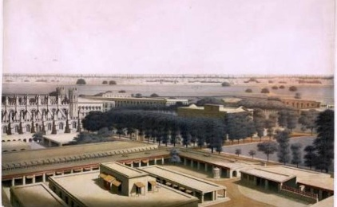
Fort William is a fort in Calcutta (Kolkata), built during the early years of the Bengal Presidency of British India. It sits on the eastern banks of the River Hooghly, the major distributary of the River Ganges.
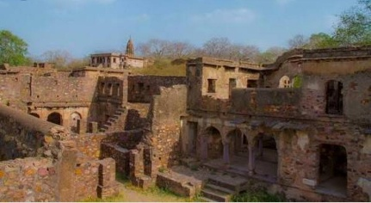
Ranthambore Fort lies within the Ranthambore National Park, near the town of Sawai Madhopur, the park being the former hunting grounds of the Maharajahs of Jaipur until the time of India's Independence.
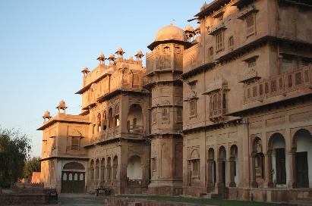
Junagarh Fort is a fort in the city of Bikaner, Rajasthan, India. The fort was originally called Chintamani and was renamed Junagarh or "Old Fort" in the early 20th century.
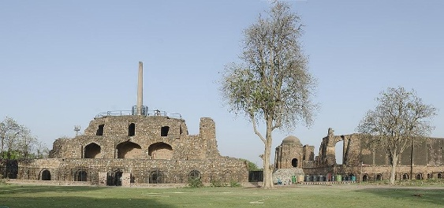
The Feroz Shah Kotla or Kotla was a fortress built by Sultan Feroz Shah Tughlaq to house his version of Delhi city called Ferozabad.
Warangal Fort is located in Warangal District, Telangana, India. It was the capital city of Kakatiyas and Musunuri Kamma Nayakas.
