Computer - Components
All types of computers follow the same basic logical structure and perform the following five basic operations for converting raw input data into information useful to their users.
S.No. | Operation | Description
1 | Take Input | The process of entering data and instructions into the computer system.
2 | Store Data | Saving data and instructions so that they are available for processing as and when required.
3 | Processing Data | Performing arithmetic, and logical operations on data in order to convert them into useful information.
4 | Output Information | The process of producing useful information or results for the user, such as a printed report or visual display.
5 | Control the workflow | Directs the manner and sequence in which all of the above operations are performed.

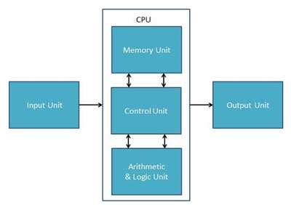
(JHON VON NEUMANN created this basic diagram of Computer first time, called Von Neumann Architecture)

Input Unit
This unit contains devices with the help of which we enter data into the computer. This unit creates a link between the user and the computer. The input devices translate the information into a form understandable by the computer.

CPU (Central Processing Unit)
CPU is considered as the brain of the computer. CPU performs all types of data processing operations. It stores data, intermediate results, and instructions (program). It controls the operation of all parts of the computer.
CPU itself has the following three components −
- ALU (Arithmetic Logic Unit)
- Memory Unit
- Control Unit

Output Unit
The output unit consists of devices with the help of which we get the information from the computer. This unit is a link between the computer and the users. Output devices translate the computer's output into a form understandable by the users.

Computer - CPU(Central Processing Unit)
Central Processing Unit (CPU) consists of the following features −
- CPU is considered as the brain of the computer.
- CPU performs all types of data processing operations.
- It stores data, intermediate results, and instructions (program).
- It controls the operation of all parts of the computer.
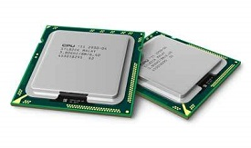
CPU itself has following three components.
- Memory or Storage Unit
- Control Unit
- ALU(Arithmetic Logic Unit)

Memory or Storage Unit
This unit can store instructions, data, and intermediate results. This unit supplies information to other units of the computer when needed. It is also known as internal storage unit or the main memory or the primary storage or Random Access Memory (RAM).
Its size affects speed, power, and capability. Primary memory and secondary memory are two types of memories in the computer. Functions of the memory unit are −
- It stores all the data and the instructions required for processing.
- It stores intermediate results of processing.
- It stores the final results of processing before these results are released to an output device.
- All inputs and outputs are transmitted through the main memory.

Control Unit
This unit controls the operations of all parts of the computer but does not carry out any actual data processing operations.
Functions of this unit are −
- It is responsible for controlling the transfer of data and instructions among other units of a computer.
- It manages and coordinates all the units of the computer.
- It obtains the instructions from the memory, interprets them, and directs the operation of the computer.
- It communicates with Input/Output devices for transfer of data or results from storage.
- It does not process or store data.

ALU (Arithmetic Logic Unit)
This unit consists of two subsections namely,
- Arithmetic Section
- Logic Section

Arithmetic Section
Function of arithmetic section is to perform arithmetic operations like addition, subtraction, multiplication, and division. All complex operations are done by making repetitive use of the above operations.

Logic Section
Function of logic section is to perform logic operations such as comparing, selecting, matching, and merging of data.

Computer - Input Devices

Following are some of the important input devices which are used in a computer −
- Keyboard
- Mouse
- Joy Stick
- Light pen
- Track Ball
- Scanner
- Graphic Tablet
- Microphone
- Magnetic Ink Card Reader(MICR)
- Optical Character Reader(OCR)
- Bar Code Reader
- Optical Mark Reader(OMR)

Keyboard
Keyboard is the most common and very popular input device which helps to input data to the computer. The layout of the keyboard is like that of traditional typewriter, although there are some additional keys provided for performing additional functions.
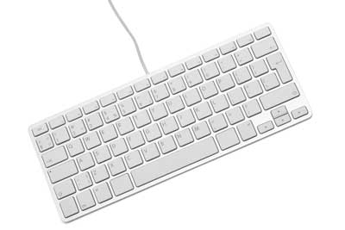
Keyboards are of two sizes 84 keys or 101/102 keys, but now keyboards with 104 keys or 108 keys are also available for Windows and Internet.
The keys on the keyboard are as follows −
S.No | Keys & Description
1 | Typing Keys  These keys include the letter keys (A-Z) and digit keys (09) which generally give the same layout as that of typewriters.
2 | Numeric Keypad  It is used to enter the numeric data or cursor movement. Generally, it consists of a set of 17 keys that are laid out in the same configuration used by most adding machines and calculators.
3 | Function Keys  The twelve function keys are present on the keyboard which are arranged in a row at the top of the keyboard. Each function key has a unique meaning and is used for some specific purpose.
4 | Control keys  These keys provide cursor and screen control. It includes four directional arrow keys. Control keys also include Home, End, Insert, Delete, Page Up, Page Down, Control(Ctrl), Alternate(Alt), Escape(Esc).
5 | Special Purpose Keys  Keyboard also contains some special purpose keys such as Enter, Shift, Caps Lock, Num Lock, Space bar, Tab, and Print Screen.

Mouse
Mouse is the most popular pointing device. It is a very famous cursor-control device having a small palm size box with a round ball at its base, which senses the movement of the mouse and sends corresponding signals to the CPU when the mouse buttons are pressed.
Generally, it has two buttons called the left and the right button and a wheel is present between the buttons. A mouse can be used to control the position of the cursor on the screen, but it cannot be used to enter text into the computer.
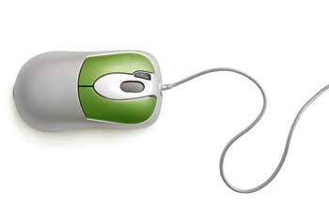

Advantages
- Easy to use
- Not very expensive
- Moves the cursor faster than the arrow keys of the keyboard.

Joystick
Joystick is also a pointing device, which is used to move the cursor position on a monitor screen. It is a stick having a spherical ball at its both lower and upper ends. The lower spherical ball moves in a socket. The joystick can be moved in all four directions.
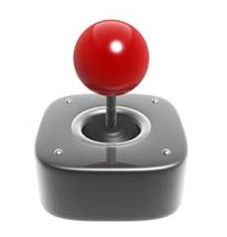
The function of the joystick is similar to that of a mouse. It is mainly used in Computer Aided Designing (CAD) and playing computer games.

Light Pen
Light pen is a pointing device similar to a pen. It is used to select a displayed menu item or draw pictures on the monitor screen. It consists of a photocell and an optical system placed in a small tube.
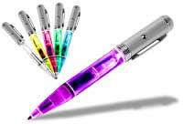
When the tip of a light pen is moved over the monitor screen and the pen button is pressed, its photocell sensing element detects the screen location and sends the corresponding signal to the CPU.

Track Ball
Track ball is an input device that is mostly used in notebook or laptop computer, instead of a mouse. This is a ball which is half inserted and by moving fingers on the ball, the pointer can be moved.
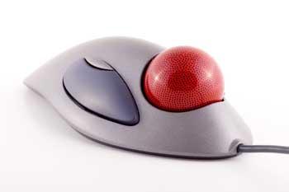
Since the whole device is not moved, a track ball requires less space than a mouse. A track ball comes in various shapes like a ball, a button, or a square.

Scanner
Scanner is an input device, which works more like a photocopy machine. It is used when some information is available on paper and it is to be transferred to the hard disk of the computer for further manipulation.
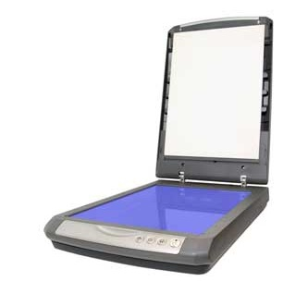
Scanner captures images from the source which are then converted into a digital form that can be stored on the disk. These images can be edited before they are printed.

Digitizer
Digitizer is an input device which converts analog information into digital form. Digitizer can convert a signal from the television or camera into a series of numbers that could be stored in a computer. They can be used by the computer to create a picture of whatever the camera had been pointed at.
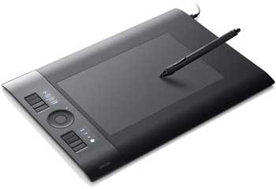
Digitizer is also known as Tablet or Graphics Tablet as it converts graphics and pictorial data into binary inputs. A graphic tablet as digitizer is used for fine works of drawing and image manipulation applications.

Microphone
Microphone is an input device to input sound that is then stored in a digital form.
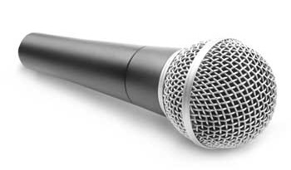
The microphone is used for various applications such as adding sound to a multimedia presentation or for mixing music.

Magnetic Ink Card Reader (MICR)
MICR input device is generally used in banks as there are large number of cheques to be processed every day. The bank's code number and cheque number are printed on the cheques with a special type of ink that contains particles of magnetic material that are machine readable.
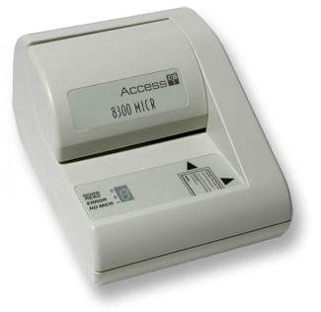
This reading process is called Magnetic Ink Character Recognition (MICR). The main advantages of MICR is that it is fast and less error prone.

Optical Character Reader (OCR)
OCR is an input device used to read a printed text.
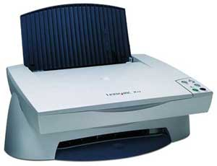
OCR scans the text optically, character by character, converts them into a machine readable code, and stores the text on the system memory.

Bar Code Readers
Bar Code Reader is a device used for reading bar coded data (data in the form of light and dark lines). Bar coded data is generally used in labelling goods, numbering the books, etc. It may be a handheld scanner or may be embedded in a stationary scanner.
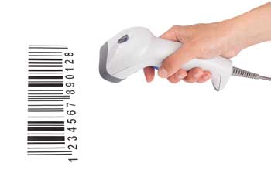
Bar Code Reader scans a bar code image, converts it into an alphanumeric value, which is then fed to the computer that the bar code reader is connected to.

Optical Mark Reader (OMR)
OMR is a special type of optical scanner used to recognize the type of mark made by pen or pencil. It is used where one out of a few alternatives is to be selected and marked.
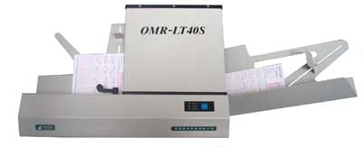
It is specially used for checking the answer sheets of examinations having multiple choice questions.

Computer - Output Devices

Following are some of the important output devices used in a computer.
- Monitors
- Graphic Plotter
- Printer

Monitors
Monitors, commonly called as Visual Display Unit (VDU), are the main output device of a computer. It forms images from tiny dots, called pixels that are arranged in a rectangular form. The sharpness of the image depends upon the number of pixels.
There are two kinds of viewing screen used for monitors.
- Cathode-Ray Tube (CRT)
- Flat-Panel Display

Cathode-Ray Tube (CRT) Monitor
The CRT display is made up of small picture elements called pixels. The smaller the pixels, the better the image clarity or resolution. It takes more than one illuminated pixel to form a whole character, such as the letter ‘e’ in the word help.
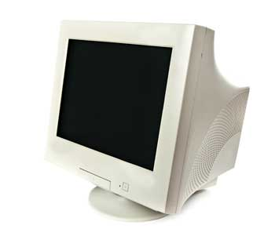
A finite number of characters can be displayed on a screen at once. The screen can be divided into a series of character boxes - fixed location on the screen where a standard character can be placed. Most screens are capable of displaying 80 characters of data horizontally and 25 lines vertically.
There are some disadvantages of CRT −
- Large in Size
- High power consumption

Flat-Panel Display Monitor
The flat-panel display refers to a class of video devices that have reduced volume, weight and power requirement in comparison to the CRT. You can hang them on walls or wear them on your wrists. Current uses of flat-panel displays include calculators, video games, monitors, laptop computer, and graphics display.
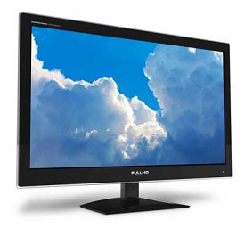
The flat-panel display is divided into two categories −
- Emissive Displays − Emissive displays are devices that convert electrical energy into light. For example, plasma panel and LED (Light-Emitting Diodes).
- Non-Emissive Displays − Non-emissive displays use optical effects to convert sunlight or light from some other source into graphics patterns. For example, LCD (Liquid-Crystal Device).

Printers
Printer is an output device, which is used to print information on paper.
There are two types of printers −
- Impact Printers
- Non-Impact Printers

Impact Printers
Impact printers print the characters by striking them on the ribbon, which is then pressed on the paper.
Characteristics of Impact Printers are the following −
- Very low consumable costs
- Very noisy
- Useful for bulk printing due to low cost
- There is physical contact with the paper to produce an image
These printers are of two types −
- Character printers
- Line printers
Character Printers
Character printers are the printers which print one character at a time.
These are further divided into two types:
- Dot Matrix Printer(DMP)
- Daisy Wheel
Dot Matrix Printer
In the market, one of the most popular printers is Dot Matrix Printer. These printers are popular because of their ease of printing and economical price. Each character printed is in the form of pattern of dots and head consists of a Matrix of Pins of size (5*7, 7*9, 9*7 or 9*9) which come out to form a character which is why it is called Dot Matrix Printer.
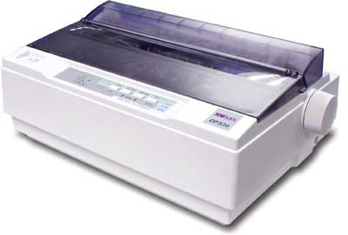
Advantages
- Inexpensive
- Widely Used
- Other language characters can be printed
Disadvantages
- Slow Speed
- Poor Quality
Daisy Wheel
Head is lying on a wheel and pins corresponding to characters are like petals of Daisy (flower) which is why it is called Daisy Wheel Printer. These printers are generally used for word-processing in offices that require a few letters to be sent here and there with very nice quality.
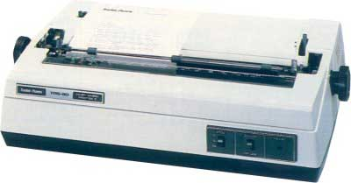
Advantages
- More reliable than DMP
- Better quality
- Fonts of character can be easily changed
Disadvantages
- Slower than DMP
- Noisy
- More expensive than DMP
Line Printers
Line printers are the printers which print one line at a time.
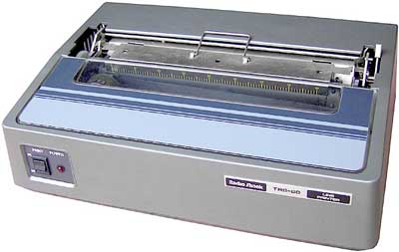
These are of two types −
- Drum Printer
- Chain Printer
Drum Printer
This printer is like a drum in shape hence it is called drum printer. The surface of the drum is divided into a number of tracks. Total tracks are equal to the size of the paper, i.e. for a paper width of 132 characters, drum will have 132 tracks. A character set is embossed on the track. Different character sets available in the market are 48 character set, 64 and 96 characters set. One rotation of drum prints one line. Drum printers are fast in speed and can print 300 to 2000 lines per minute.
Advantages
- Very high speed
Disadvantages
- Very expensive
- Characters fonts cannot be changed
Chain Printer
In this printer, a chain of character sets is used, hence it is called Chain Printer. A standard character set may have 48, 64, or 96 characters.
Advantages
- Character fonts can easily be changed.
- Different languages can be used with the same printer.
Disadvantages
- Noisy

Non-impact Printers
Non-impact printers print the characters without using the ribbon. These printers print a complete page at a time, thus they are also called as Page Printers.
These printers are of two types −
- Laser Printers
- Inkjet Printers
Characteristics of Non-impact Printers
- Faster than impact printers
- They are not noisy
- High quality
- Supports many fonts and different character size
Laser Printers
These are non-impact page printers. They use laser lights to produce the dots needed to form the characters to be printed on a page.
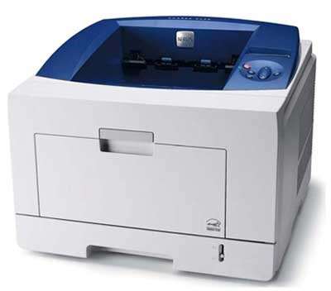
Advantages
- Very high speed
- Very high quality output
- Good graphics quality
- Supports many fonts and different character size
Disadvantages
- Expensive
- Cannot be used to produce multiple copies of a document in a single printing
Inkjet Printers
Inkjet printers are non-impact character printers based on a relatively new technology. They print characters by spraying small drops of ink onto paper. Inkjet printers produce high quality output with presentable features.
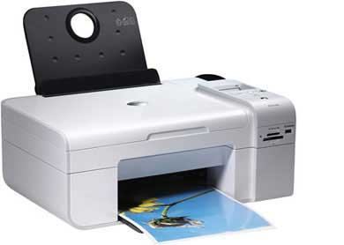
They make less noise because no hammering is done and these have many styles of printing modes available. Color printing is also possible. Some models of Inkjet printers can produce multiple copies of printing also.
Advantages
- High quality printing
- More reliable
Disadvantages
- Expensive as the cost per page is high
- Slow as compared to laser printer

Computer – Memory
A memory is just like a human brain. It is used to store data and instructions. Computer memory is the storage space in the computer, where data is to be processed and instructions required for processing are stored. The memory is divided into large number of small parts called cells. Each location or cell has a unique address, which varies from zero to memory size minus one. For example, if the computer has 64k words, then this memory unit has 64 * 1024 = 65536 memory locations. The address of these locations varies from 0 to 65535.
Memory is primarily of three types −
- Cache Memory
- Primary Memory/Main Memory
- Secondary Memory

Cache Memory
Cache memory is a very high speed semiconductor memory which can speed up the CPU. It acts as a buffer between the CPU and the main memory. It is used to hold those parts of data and program which are most frequently used by the CPU. The parts of data and programs are transferred from the disk to cache memory by the operating system, from where the CPU can access them.
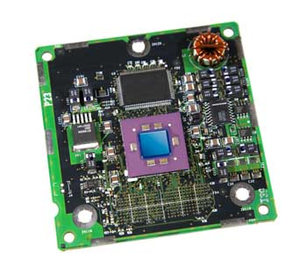

Advantages
The advantages of cache memory are as follows −
- Cache memory is faster than main memory.
- It consumes less access time as compared to main memory.
- It stores the program that can be executed within a short period of time.
- It stores data for temporary use.

Disadvantages
The disadvantages of cache memory are as follows −
- Cache memory has limited capacity.
- It is very expensive.

Primary Memory (Main Memory)
Primary memory holds only those data and instructions on which the computer is currently working. It has a limited capacity and data is lost when power is switched off. It is generally made up of semiconductor device. These memories are not as fast as registers. The data and instruction required to be processed resides in the main memory. It is divided into two subcategories RAM and ROM.
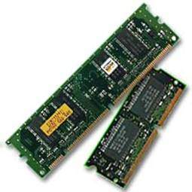

Characteristics of Main Memory
- These are semiconductor memories.
- It is known as the main memory.
- Usually volatile memory.
- Data is lost in case power is switched off.
- It is the working memory of the computer.
- Faster than secondary memories.
- A computer cannot run without the primary memory.

Secondary Memory
This type of memory is also known as external memory or non-volatile. It is slower than the main memory. These are used for storing data/information permanently. CPU directly does not access these memories, instead they are accessed via input-output routines. The contents of secondary memories are first transferred to the main memory, and then the CPU can access it. For example, disk, CD-ROM, DVD, etc.
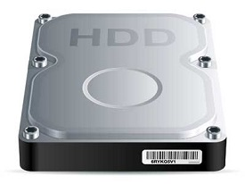

Characteristics of Secondary Memory
- These are magnetic and optical memories.
- It is known as the backup memory.
- It is a non-volatile memory.
- Data is permanently stored even if power is switched off.
- It is used for storage of data in a computer.
- Computer may run without the secondary memory.
- Slower than primary memories.

Random Access Memory

RAM (Random Access Memory) is the internal memory of the CPU for storing data, program, and program result. It is a read/write memory which stores data until the machine is working. As soon as the machine is switched off, data is erased.
Access time in RAM is independent of the address, that is, each storage location inside the memory is as easy to reach as other locations and takes the same amount of time. Data in the RAM can be accessed randomly but it is very expensive.
RAM is volatile, i.e. data stored in it is lost when we switch off the computer or if there is a power failure. Hence, a backup Uninterruptible Power System (UPS) is often used with computers. RAM is small, both in terms of its physical size and in the amount of data it can hold.
RAM is of two types −
- Static RAM (SRAM)
- Dynamic RAM (DRAM)

Static RAM (SRAM)
The word static indicates that the memory retains its contents as long as power is being supplied. However, data is lost when the power gets down due to volatile nature. SRAM chips use a matrix of 6-transistors and no capacitors. Transistors do not require power to prevent leakage, so SRAM need not be refreshed on a regular basis.
There is extra space in the matrix, hence SRAM uses more chips than DRAM for the same amount of storage space, making the manufacturing costs higher. SRAM is thus used as cache memory and has very fast access.

Characteristic of Static RAM
- Long life
- No need to refresh
- Faster
- Used as cache memory
- Large size
- Expensive
- High power consumption

Dynamic RAM (DRAM)
DRAM, unlike SRAM, must be continually refreshed in order to maintain the data. This is done by placing the memory on a refresh circuit that rewrites the data several hundred times per second. DRAM is used for most system memory as it is cheap and small. All DRAMs are made up of memory cells, which are composed of one capacitor and one transistor.

Characteristics of Dynamic RAM
- Short data lifetime
- Needs to be refreshed continuously
- Slower as compared to SRAM
- Used as RAM
- Smaller in size
- Less expensive
- Less power consumption

Computer - Read Only Memory

ROM stands for Read Only Memory. The memory from which we can only read but cannot write on it. This type of memory is non-volatile. The information is stored permanently in such memories during manufacture. A ROM stores such instructions that are required to start a computer. This operation is referred to as bootstrap. ROM chips are not only used in the computer but also in other electronic items like washing machine and microwave oven.
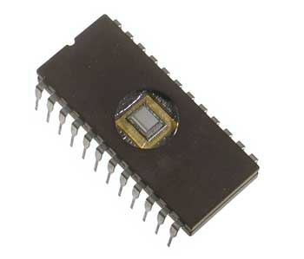
Let us now discuss the various types of ROMs and their characteristics.

MROM (Masked ROM)
The very first ROMs were hard-wired devices that contained a pre-programmed set of data or instructions. These kind of ROMs are known as masked ROMs, which are inexpensive.

PROM (Programmable Read Only Memory)
PROM is read-only memory that can be modified only once by a user. The user buys a blank PROM and enters the desired contents using a PROM program. Inside the PROM chip, there are small fuses which are burnt open during programming. It can be programmed only once and is not erasable.

EPROM (Erasable and Programmable Read Only Memory)
EPROM can be erased by exposing it to ultra-violet light for a duration of up to 40 minutes. Usually, an EPROM eraser achieves this function. During programming, an electrical charge is trapped in an insulated gate region. The charge is retained for more than 10 years because the charge has no leakage path. For erasing this charge, ultra-violet light is passed through a quartz crystal window (lid). This exposure to ultra-violet light dissipates the charge. During normal use, the quartz lid is sealed with a sticker.

EEPROM (Electrically Erasable and Programmable Read Only Memory)
EEPROM is programmed and erased electrically. It can be erased and reprogrammed about ten thousand times. Both erasing and programming take about 4 to 10 ms (millisecond). In EEPROM, any location can be selectively erased and programmed. EEPROMs can be erased one byte at a time, rather than erasing the entire chip. Hence, the process of reprogramming is flexible but slow.

Advantages of ROM
The advantages of ROM are as follows −
- Non-volatile in nature
- Cannot be accidentally changed
- Cheaper than RAMs
- Easy to test
- More reliable than RAMs
- Static and do not require refreshing
- Contents are always known and can be verified

Computer - Software

Software is a set of programs, which is designed to perform a well-defined function. A program is a sequence of instructions written to solve a particular problem.
There are two types of software −
- System Software
- Application Software

System Software
The system software is a collection of programs designed to operate, control, and extend the processing capabilities of the computer itself. System software is generally prepared by the computer manufacturers. These software products comprise of programs written in low-level languages, which interact with the hardware at a very basic level. System software serves as the interface between the hardware and the end users.
Some examples of system software are Operating System, Compilers, Interpreter, Assemblers, etc.
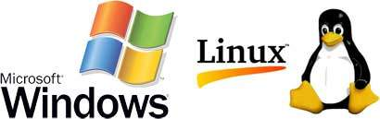
Here is a list of some of the most prominent features of a system software −
- Close to the system
- Fast in speed
- Difficult to design
- Difficult to understand
- Less interactive
- Smaller in size
- Difficult to manipulate
- Generally written in low-level language

Application Software
Application software products are designed to satisfy a particular need of a particular environment. All software applications prepared in the computer lab can come under the category of Application software.
Application software may consist of a single program, such as Microsoft's notepad for writing and editing a simple text. It may also consist of a collection of programs, often called a software package, which work together to accomplish a task, such as a spreadsheet package.
Examples of Application software are the following −
- Payroll Software
- Student Record Software
- Inventory Management Software
- Income Tax Software
- Railways Reservation Software
- Microsoft Office Suite Software
- Microsoft Word
- Microsoft Excel
- Microsoft PowerPoint

Features of application software are as follows −
- Close to the user
- Easy to design
- More interactive
- Slow in speed
- Generally written in high-level language
- Easy to understand
- Easy to manipulate and use
- Bigger in size and requires large storage space

Computer - Data and Information

Data can be defined as a representation of facts, concepts, or instructions in a formalized manner, which should be suitable for communication, interpretation, or processing by human or electronic machine.
Data is represented with the help of characters such as alphabets (A-Z, a-z), digits (0-9) or special characters (+,-,/,*,<,>,= etc.)

What is Information?
Information is organized or classified data, which has some meaningful values for the receiver. Information is the processed data on which decisions and actions are based.
For the decision to be meaningful, the processed data must qualify for the following characteristics −
- Timely − Information should be available when required.
- Accuracy − Information should be accurate.
- Completeness − Information should be complete.
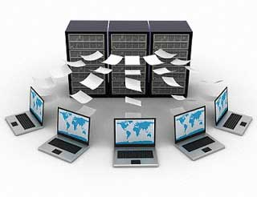

Data Processing Cycle
Data processing is the re-structuring or re-ordering of data by people or machine to increase their usefulness and add values for a particular purpose. Data processing consists of the following basic steps - input, processing, and output. These three steps constitute the data processing cycle.
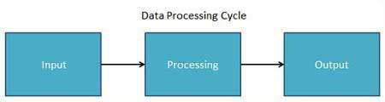
- Input − In this step, the input data is prepared in some convenient form for processing. The form will depend on the processing machine. For example, when electronic computers are used, the input data can be recorded on any one of the several types of input medium, such as magnetic disks, tapes, and so on.
- Processing − In this step, the input data is changed to produce data in a more useful form. For example, pay-checks can be calculated from the time cards, or a summary of sales for the month can be calculated from the sales orders.
- Output − At this stage, the result of the proceeding processing step is collected. The particular form of the output data depends on the use of the data. For example, output data may be pay-checks for employees.

Computer - Operating System

The Operating System is a program with the following features −
- An operating system is a program that acts as an interface between the software and the computer hardware.
- It is an integrated set of specialized programs used to manage overall resources and operations of the computer.
- It is a specialized software that controls and monitors the execution of all other programs that reside in the computer, including application programs and other system software.
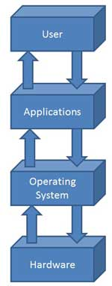

Objectives of Operating System
The objectives of the operating system are −
- To make the computer system convenient to use in an efficient manner.
- To hide the details of the hardware resources from the users.
- To provide users a convenient interface to use the computer system.
- To act as an intermediary between the hardware and its users, making it easier for the users to access and use other resources.
- To manage the resources of a computer system.
- To keep track of who is using which resource, granting resource requests, and mediating conflicting requests from different programs and users.
- To provide efficient and fair sharing of resources among users and programs.

Characteristics of Operating System
Here is a list of some of the most prominent characteristic features of Operating Systems −
- Memory Management − Keeps track of the primary memory, i.e. what part of it is in use by whom, what part is not in use, etc. and allocates the memory when a process or program requests it.
- Processor Management − Allocates the processor (CPU) to a process and deallocates the processor when it is no longer required.
- Device Management − Keeps track of all the devices. This is also called I/O controller that decides which process gets the device, when, and for how much time.
- File Management − Allocates and de-allocates the resources and decides who gets the resources.
- Security − Prevents unauthorized access to programs and data by means of passwords and other similar techniques.
- Job Accounting − Keeps track of time and resources used by various jobs and/or users.
- Control Over System Performance − Records delays between the request for a service and from the system.
- Interaction with the Operators − Interaction may take place via the console of the computer in the form of instructions. The Operating System acknowledges the same, does the corresponding action, and informs the operation by a display screen.
- Error-detecting Aids − Production of dumps, traces, error messages, and other debugging and error-detecting methods.
- Coordination Between Other Software and Users − Coordination and assignment of compilers, interpreters, assemblers, and other software to the various users of the computer systems.

