Revision exercise
Science, chapter-1to 5
Very short answer questions
1)Name two acids and bases.
2)Which acid is produced in our stomach?
3)How does Litmus Indicator work?
4)What is the usual temperature range of a laboratory Thermometer?
5)What are the two conditions necessary for the Conduction of heat?
6)Name the steps involved in the production of Wool from sheep.
7)Name the process of rearing of silkworms for obtaining silk.
8)Name the four different tastes that can be detected by our tongue.
9) Name the various steps in animal nutrition.
10)Why do some plants eat insects?

MCQ
TICK THE CORRECT OPTION
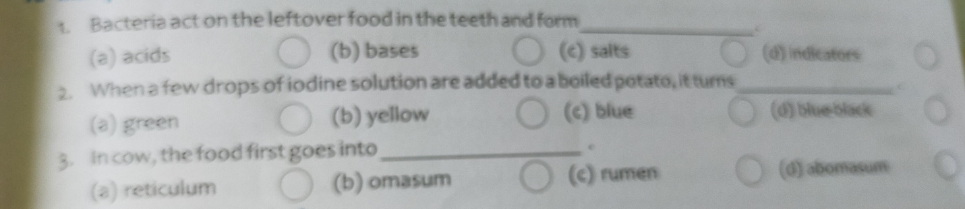
A.
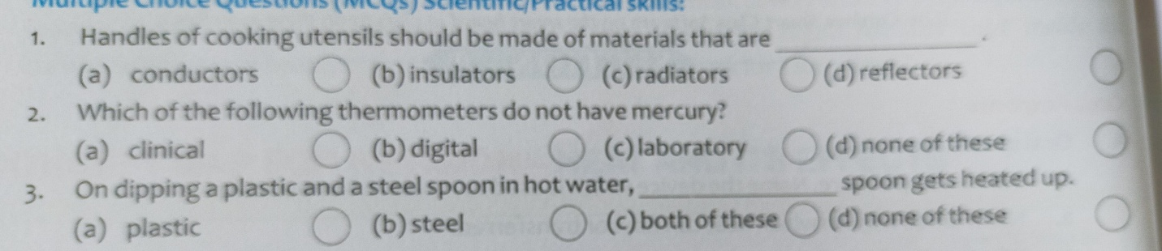
B.
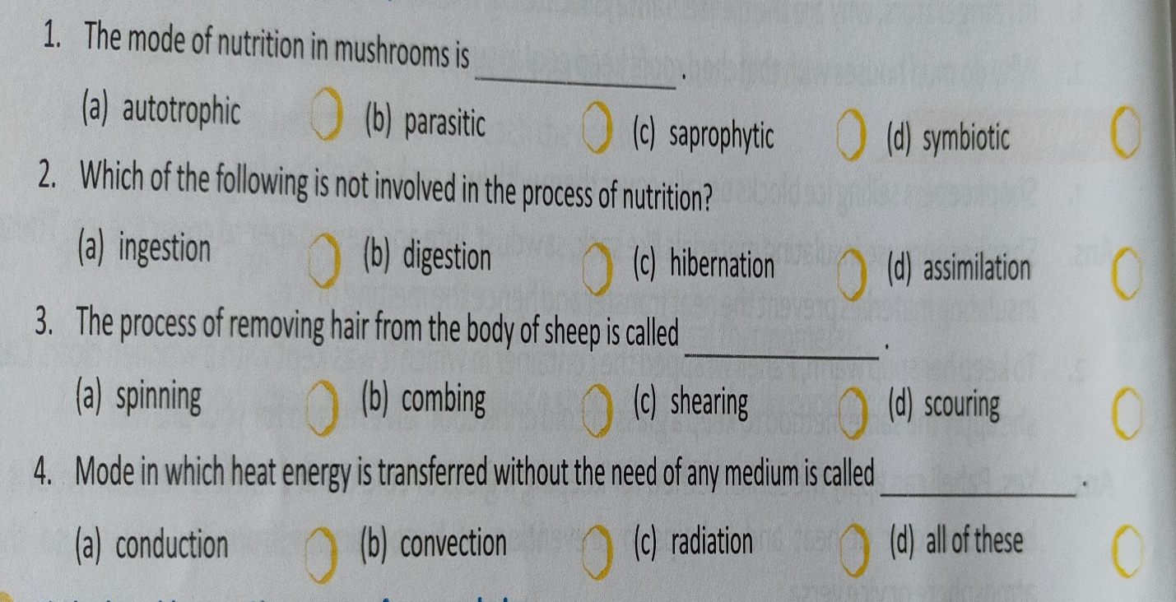
C.

D.
