REVISION ON MCQ FOR ONLINE TEST
CLASS:7, SUBJECT: SCIENCE

REMEMBER THIS TABLE
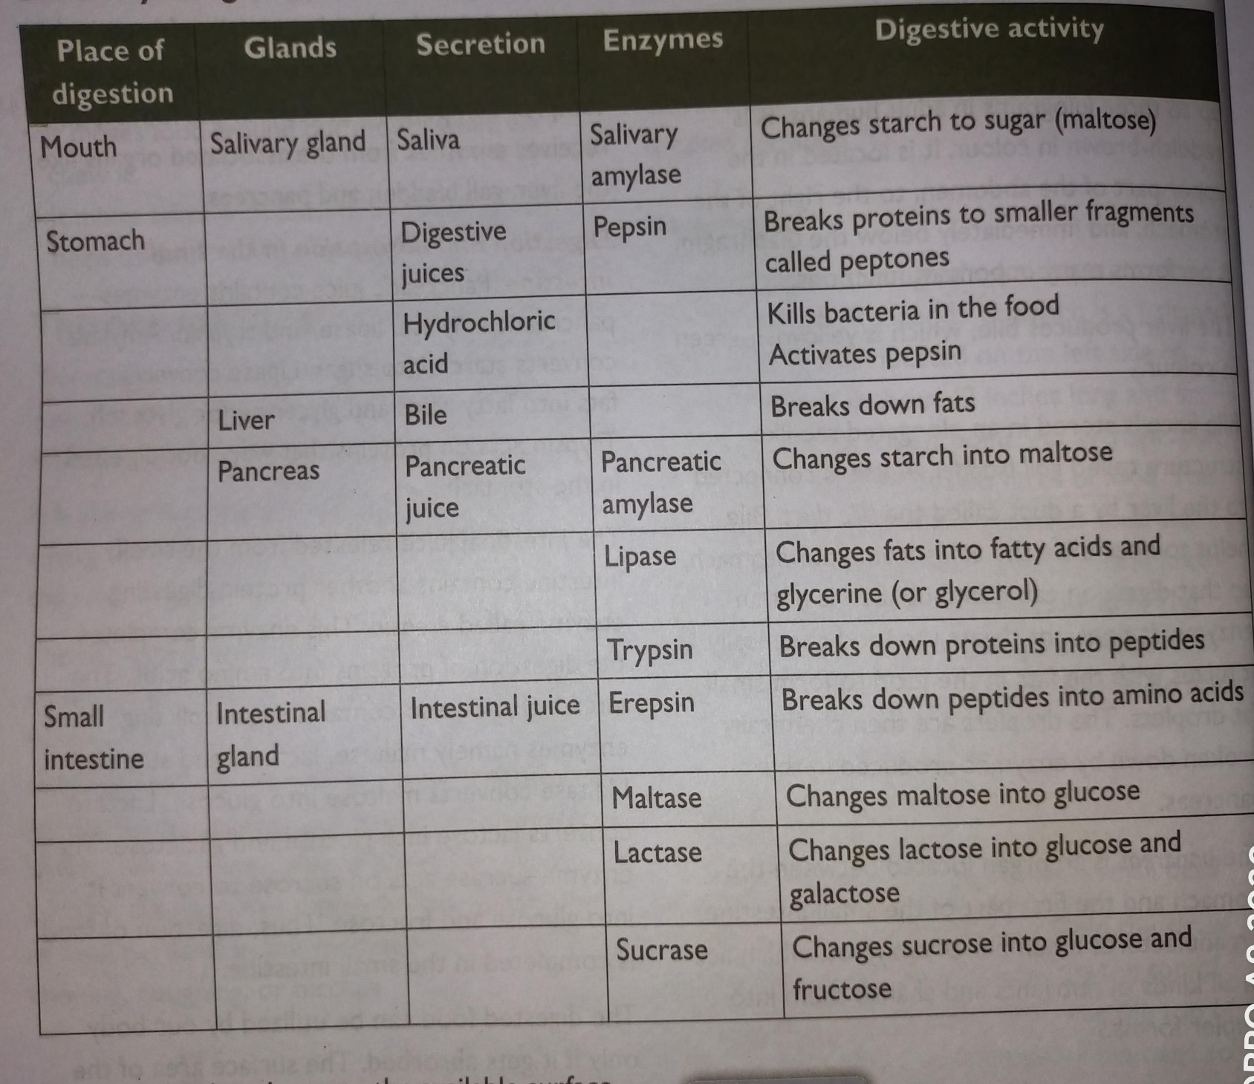

MULTIPLE CHOICE QUESTIONS
CHOOSE THE CORRECT OPTION OF THE FOUR PROVIDED TO YOU:

A.

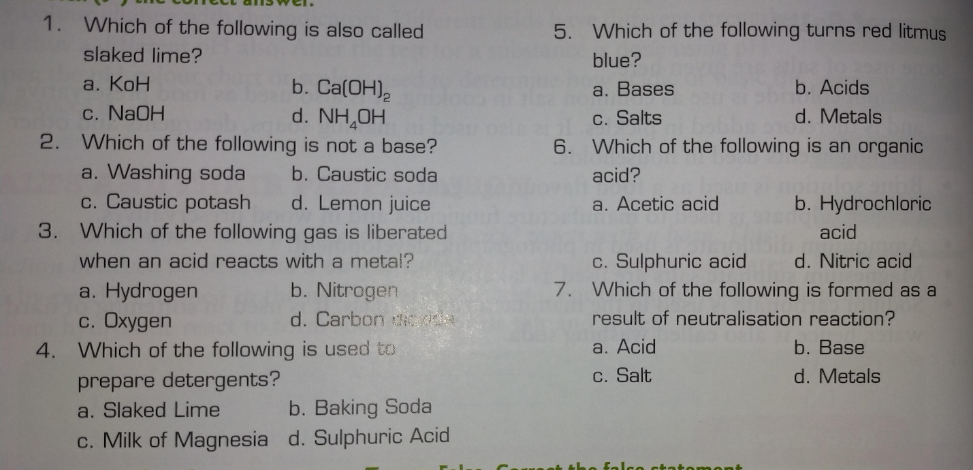
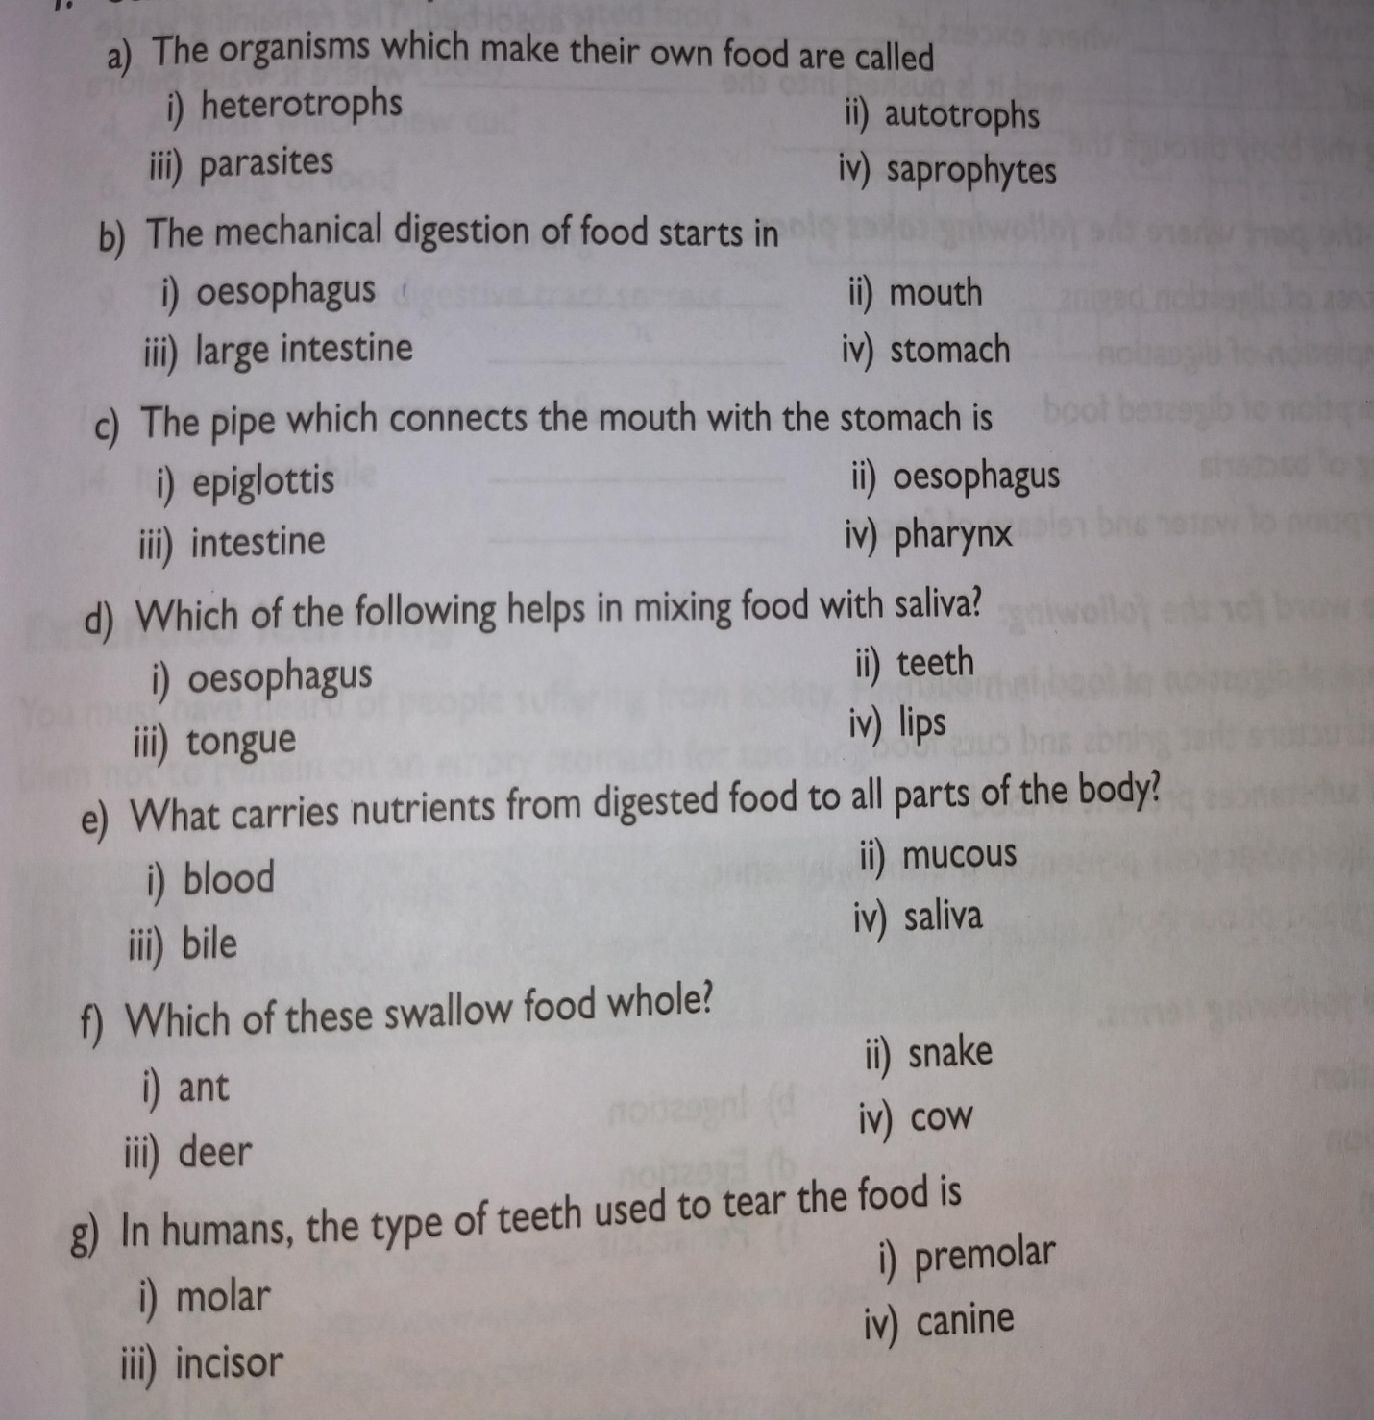
B.

