SATISH CHANDRA MEMORIAL SCHOOL
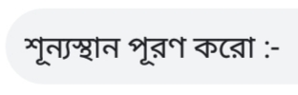
BENGALI WORKSHEET FOR L.K.G.

 |  |  |  |  | 
 |  |  |  |  | 

