- What is the rate of flow of electric charges called?
  - Electric potential
  - electric conductance
  - Electric current
  - none of these
- Which of the following is the SI Unit of Electric Current?
  - ohm
  - ampere
  - volt
  - faraday
- Which instrument is used for measuring electric potential?
  - Ammeter
  - galvanometer
  - voltmeter
  - potentiometer
- When one unit electric charge moves from one point to another point in an electric circuit, then the amount of work done in joules is known as?
  - Electric current
  - electric resistance
  - electric conductance
  - potential difference
- The hindrance presented by material of conductor to the smooth passing of electric current is known as:
  - Resistance
  - Conductance
  - Inductance
  - None of these
- The resistance of a conductor is directly proportional to:
  - Its area of cross-section
  - density
  - melting point
  - length
- The purpose of a rheostat is:
  - Increase the magnitude of current only
  - Decrease the magnitude of current only
  - Increase or decrease the magnitude of current
  - None of these
- Point to be kept in mind for verification of Ohm’s Law is:
  - Ammeter and voltmeter should be connected in series
  - Ammeter should be connected in series and voltmeter in parallel
  - Ammeter should be connected in parallel and voltmeter in series
  - Ammeter and voltmeter should be connected in parallel
- When a 40V battery is connected across an unknown resistor there is a current of 100 mA in the circuit. Find the value of the resistance of the resister:
  - 5000 Ω
  - 800 Ω
  - 0.8 Ω
  - none of these
- A battery of 6V is connected in series with resisters of 0.1 ohm , 0.15 ohm,0.2 ohm,0.25 ohm and 6 ohm. How much current would flow through the 0.3 ohm resistor?
  - 0.895A
  - 2.22A
  - 1A
  - none of these
- A fuse wire is inserted in a?
  - . Live wire
  - . In the neutral wire
  - . In the earth wire
  - . May be connected in any line.
- A battery of 10 volt carries 20,000 C of charge through a resistance of 20 Ω. The work done in 10 seconds is
(a) 2 × 10₃ joule
(b) 2 × 10⁵joule
(c) 2 × 10⁴ joule
(d) 2 × 10² joule

- . A boy records that 4000 joule of work is required to transfer 10 coulomb of charge between two points of a resistor of 50 Ω. The current passing through it is
(a) 2 A
(b) 4 A
(c) 8 A
(d) 16 A

- . The resistance whose V-I graph is given below is
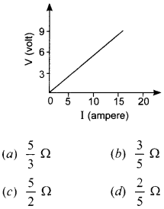

- 6. To get 2 Ω resistance using only 6 Ω resistors, the number of them required is
(a) 2
(b) 3
(c) 4
(d) 6

- Electricity MCQ Question 7. Two wires of same length and area made of two materials of resistivity ρ₁ and ρ₂ are connected in series to a source of potential V. The equivalent resistivity for the same area is
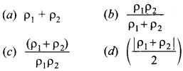

- Two devices are connected between two points say A and B in parallel. The physical quantity that will remain the same between the two points is
(a) current
(b) voltage
(c) resistance
(d) None of these

- . The least resistance obtained by using 2 Ω, 4 Ω, 1 Ω and 100 Ω is
a) < 100 Ω
(b) < 4 Ω
(c) < 1 Ω (d) > 2 Ω

- Two wires of same length and area, made of two materials of resistivity ρ₁ and ρ₂ are connected in parallel V to a source of potential. The equivalent resistivity for the same length and area is
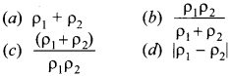

- Electricity Class 10 MCQ With Answers Pdf Question 11. Calculate the current flows through the 10 Ω resistor in the following circuit.
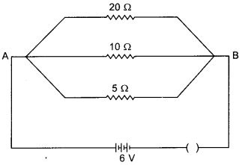
(a) 1.2 A
(b) 0.6 A
(c) 0.2 A
(d) 2.0 A

- Two resistors are connected in series gives an equivalent resistance of 10 Ω. When connected in parallel, gives 2.4 Ω. Then the individual resistance are
(a) each of 5 Ω
(b) 6 Ω and 4 Ω
(c) 7 Ω and 4 Ω
(d) 8 Ω and 2 Ω

- If R₁ and R₂ be the resistance of the filament of 40 W and 60 W respectively operating 220 V, then
(a) R₁ < R₂
(b) R₂ < R₁
(c) R₁ = R₂
(d) R₁ ≥ R₂

- Electricity MCQ Class 10 Question 14. The resistance of hot filament of the bulb is about 10 times the cold resistance. What will be the resistance of 100 W-220 V lamp, when not in use?
(a) 48 Ω
(b) 400 Ω
(c) 484 Ω
(d) 48.4 Ω

- If P and V are the power and potential of device, the power consumed with a supply potential V₁ is
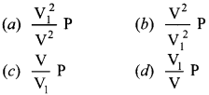

- MCQ Questions for Class 10 Science Electricity Question 16. A coil in the heater consume power P on passing current. If it is cut into halves and joined in parallel, it will consume power
(a) P
(b) P2
(c) 2P
(d) 4P

- A fuse wire repeatedly gets burnt when used with a good heater. It is advised to use a fuse wire of
(a) more length
(b) less radius
(c) less length
(d) more radius

- A cooler of 1500 W, 200 volt and a fan of 500 W, 200 volt are to be used from a household supply. The rating of fuse to be used is
(a) 2.5 A
(b) 5.0 A
(c) 7.5 A
(d) 10 A

- The effective resistance between A and B is
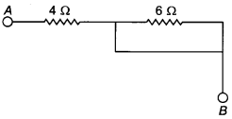
(a) 4Ω
(b) 6Ω
(c) May be 10 Ω
(d) Must be 10 Ω

- MCQ Electricity Class 10 Question 20. A cell, a resistor, a key, and an ammeter are arranged as shown in the circuit diagrams. The current recorded in the ammeter will be [NCERT Exemplar Problems]
(a) maximum in (i)
(b) maximum in (ii)
(c) maximum in (iii)
(d) same in all the cases
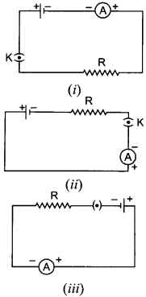

- . A current of 1 A is drawn by a filament of an electric bulb. Number of electrons passing through a cross-section of the filament in 16 seconds would be roughly [NCERT Exemplar Problems]
(a) 10²⁰
(b) 10¹⁶
(c) 10¹⁸
(d) 10²³

- What is the maximum resistance which can be made using five resistors each of 1/5 W? [NCERT Exemplar Problems]
(a) 1/5 Ω
(b) 10 Ω
(c) 5 Ω
(d) 1 Ω

- A cylindrical conductor of length l and uniform area of cross-section A has resistance R. Another conductor of length 2l and resistance R of the same material has area of cross-section [NCERT Exemplar Problems]
(a) A/2
(b) 3A/2
(c) 2A
(d) 3A

- A student carries out an experiment and plots the V-I graph of three samples of nichrome wire with resistances R₁ R₂ and R₃ respectively. Which of the following is hue? [NCERT Exemplar Problems]
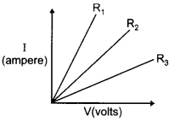
(a) R₁ = R₂ = R₃
(b) R₁ > R₂ > R₃
(c) R₃ > R₂ > R₁
(d) R₂ > R₃ > R₁

- If the current I through a resistor is increased by 100 % (assume that temperature remains unchanged), the increase in power dissipated will be [NCERT Exemplar Problems]
(a) 100%
(b) 200%
(c) 300 %
(d) 400 %

- The resistivity does not change if [NCERT Exemplar Problems]
(a) the material is changed
(b) the temperature is changed
(c) the shape of the resistor is changed
(d) both material and temperature are changed

- In an electrical circuit two resistors of 2 Ω and 4 Ω respectively are connected in series to a 6 V battery. The heat dissipated by the 4 Ω resistor in 5 s will be [NCERT Exemplar Problems]
(a) 5 J
(b) 10 J
(c) 20 J
(d) 30 J

- Electric potential is a:
(a) scalar quantity
(b) vector quantity
(c) neither scalar nor vector
(d) sometimes scalar and sometimes vector

- Electricity Question 29. 1 mV is equal to:
(a) 10 volt
(b) 1000 volt
(c) 10⁻³ volt
(d) 10⁻⁶ volt

- Electricity MCQ Question 30. Coulomb is the SI unit of:
(a) charge
(b) current
(c) potential difference
(d) resistance

- When electric current is passed, electrons move from:
(a) high potential to low potential.
(b) low potential to high potential.
(c) in the direction of the current.
(d) against the direction of the current.

- The heating element of an electric iron is made up of:
(a) copper
(b) nichrome
(c) aluminium
(d) iron

- The electrical resistance of insulators is
(a) high
(b) low
(c) zero
(d) infinitely high

- Electrical resistivity of any given metallic wire depends upon
(a) its thickness
(b) its shape
(c) nature of the material
(d) its length

