|| 21st June 2020 Solar Eclipse ||
Be ready!!!

This year will witness its first Solar Eclipse on June 21. When it's a total eclipse, the disk of the Sun is fully obscured by the Moon, however, in partial and annular eclipses, only part of the Sun is obscured. This one is going to be an annular eclipse. It will be visible in parts of Africa including the Central African Republic, Congo, Ethiopia, Pakistan, India, and China.
A solar eclipse occurs when a portion of the Earth is engulfed in a shadow cast by the Moon which fully or partially blocks sunlight. This occurs when the Sun, Moon and Earth are aligned.
Total solar eclipse
A total solar eclipse occurs when the Moon completely covers the Sun's disk
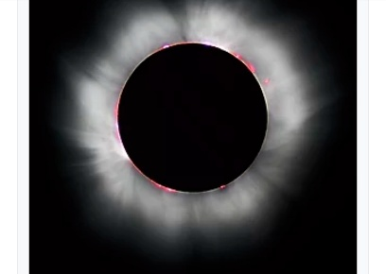

Annular eclipse
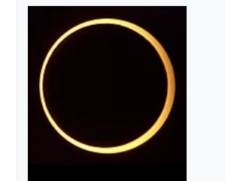
An annular solar eclipse (left) occurs when the Moon is too far away from earth to completely cover the Sun's disk

|| Time of Solar Eclipse ||
According to timeanddate.com, the annular solar eclipse of June 2020 will start at 9:15 am on June 21 as per Indian Standard Timing (IST). The full eclipse will start from 10:17 am with the maximum eclipse occurring at 12:10 pm. The full eclipse will be visible until 2:02 pm. By 3:04 pm, the eclipse will end.
