CLASS-9 SUB-MATHEMATICS
POLYNOMIAL CROSSWORD PUZZLE
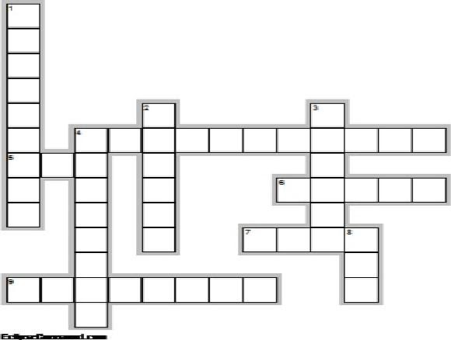

Across
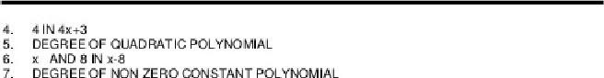
9.Polynomial having two terms.
Down
