SATISH CHANDRA MEMORIAL SCHOOL
CLASS-III SUBJECT: MATHEMATICS
WORKSHEET: 23

COUNT THE NUMBER OF TRIANGLES IN THE FIGURE
- 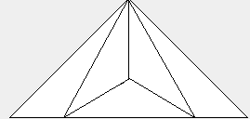 B) 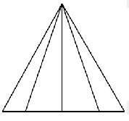
C)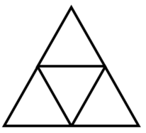 D)
IDENTIFY THE TYPES OF SHAPES AND COUNT THE NUMBER OF TYPES THE SHAPES APPEAR IN THE FOLLOWING FIGURES GIVEN BELOW:
A)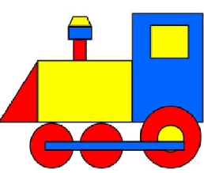 B) C) 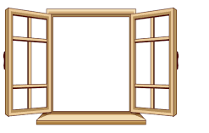
D) 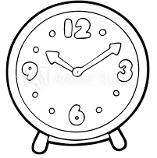 E) 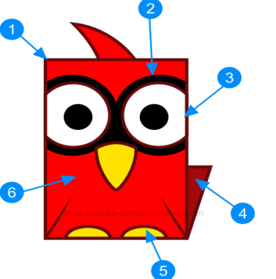F)