GLOBE-LATITUDES AND LONGITUDES.

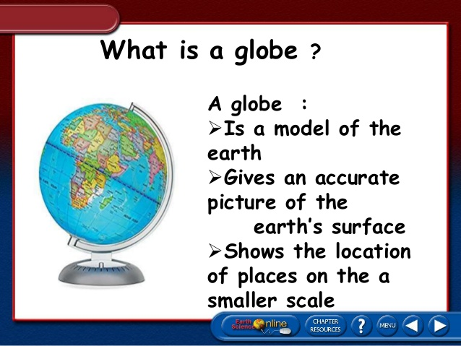

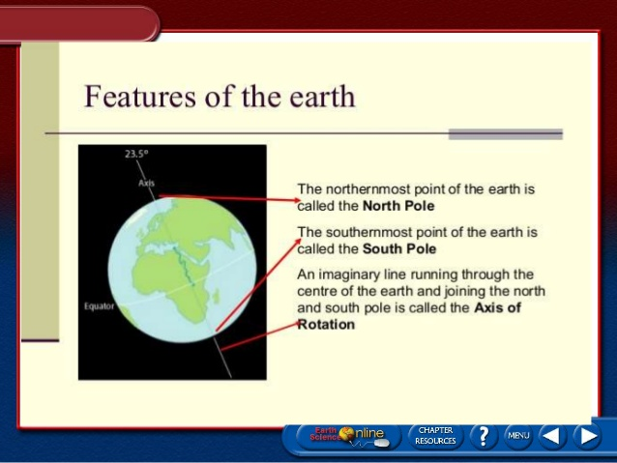

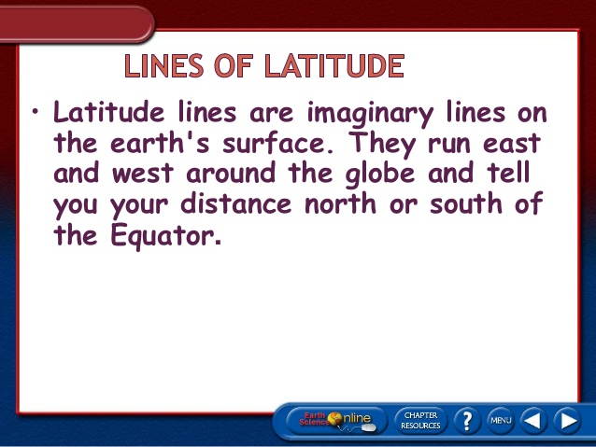

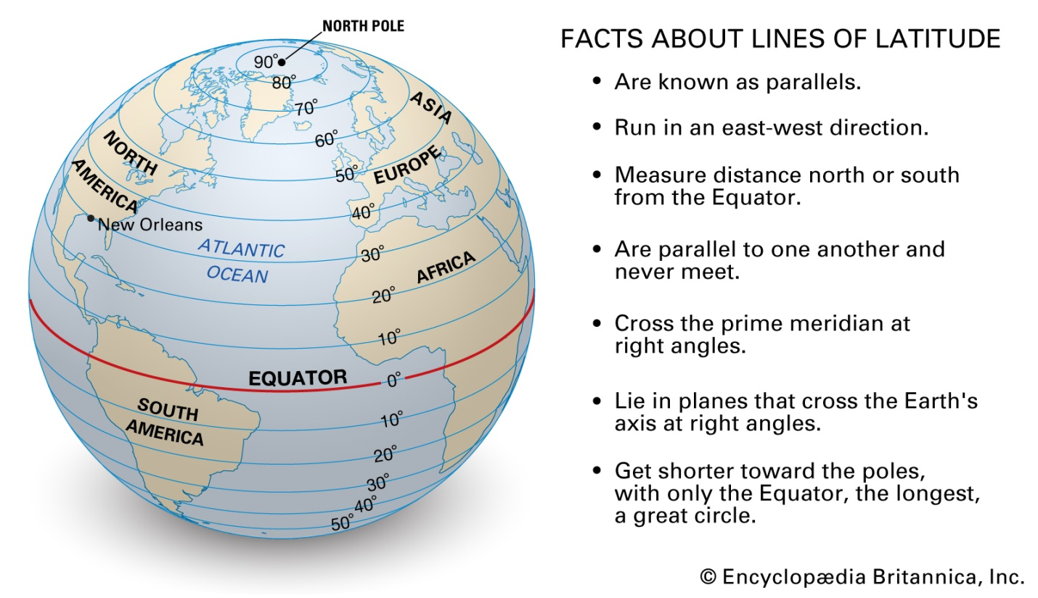
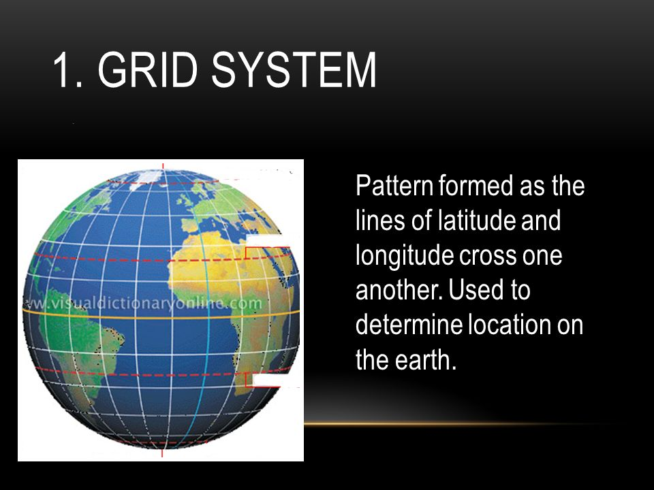

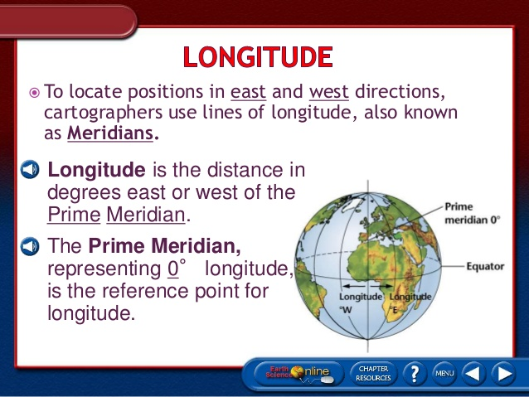

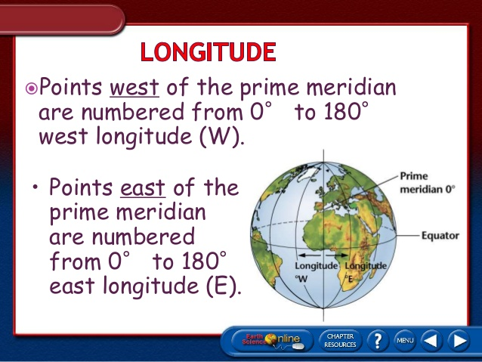

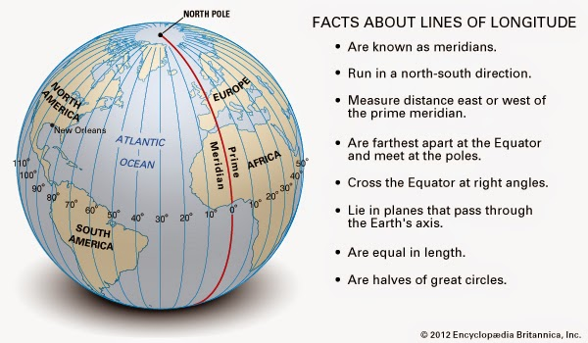

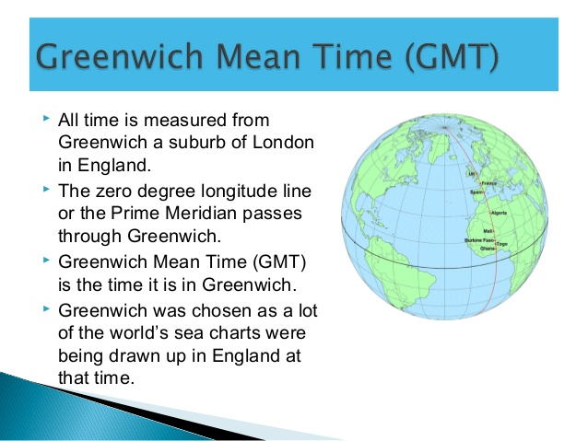

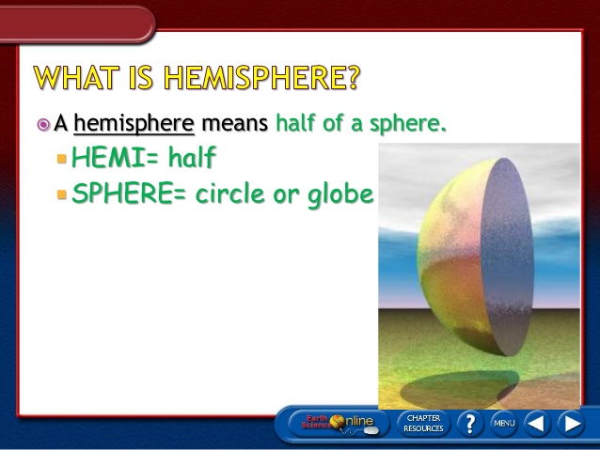
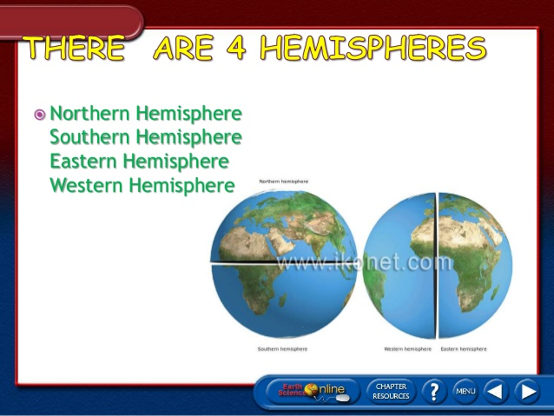

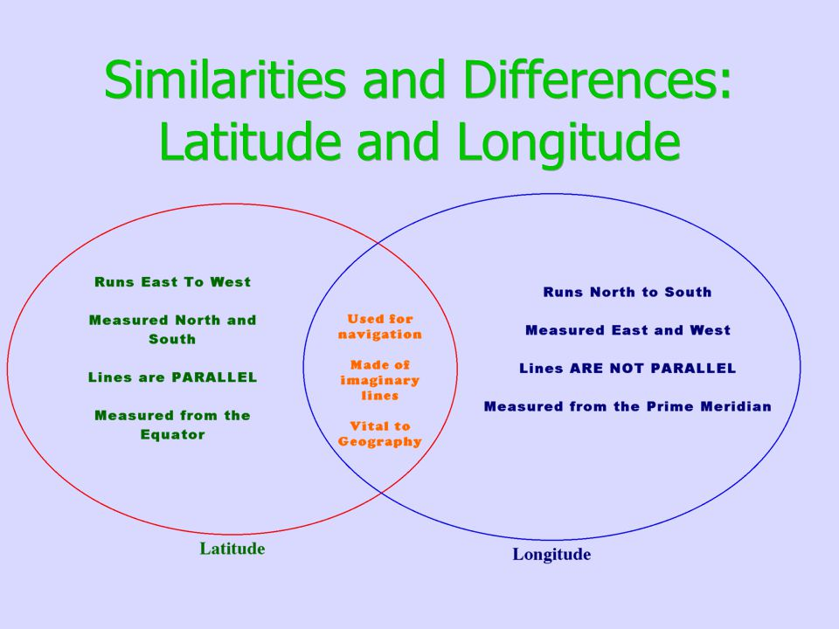
DIFFERENCE BETWEEN LATITUDES AND LONGITUDES.
The Parallels of Latitude.
- They run from East to West.
- These lines are parallel to each other.
- These lines decreases in length while moving towards to the Poles.
- They never meet or intersect each other.
- The Equator is the biggest latitude.
The Meridians of longitude.
- They run from North to South.
- These lines are not parallel to each other.
- The distance between two longitudes decreases while moving towards the poles from the Equator.
- They meet each other at the Poles.
- The Prime Meridian is the mid longitude.
THE THREE HEAT ZONES OF THE EARTH.

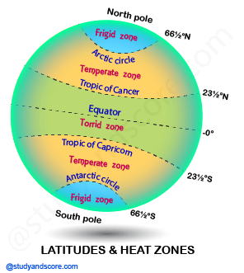
Description of Three Heat Zones.
- The fact that the Earth is spherical in shape results in different parts of the Earth getting heated differently. Based on the heat received from the Sun, the Earth is divided into three heat zones. They are:
- Torrid Zone: It is a region between the Tropic of Cancer and the Tropic of Capricorn. This region receives the direct vertical rays of the Sun for almost the whole year. Therefore, this zone gets the maximum heat from the Sun. This zone is known as the torrid or the tropical zone.
- Temperate Zone: This zone lie between the Tropic of Cancer and the Arctic Circle in the Northern Hemisphere and between the Tropic of Capricorn and the Antarctic Circle in the southern hemisphere. This zone gets the slanting rays of the Sun as the angle of the Sun’s rays goes on decreasing towards the Poles. Thus this zone experiences moderate temperature.
- Frigid Zone: The Frigid Zone lies between the Arctic Circle and the North Pole and between the Antarctic Circle and the South Pole. This zone is also known as the Polar region. Since it receives the extreme slanting rays of the Sun, the temperature is extremely low throughout the year. This is the reason why the Polar Regions are generally covered with ice.
QUESTIONS AND ANSWERS.
- What is the true shape of the Earth?
Answer:- The true shape of the Earth is Geoid-the Earth like shape.
2. Why does the Torrid Zone receive maximum amount of heat?
Answer:- The Torrid zone receives maximum amount of heat because –
- The Sun shines perpendicular between the Tropic of Cancer and Tropic of Capricorn.
Perpendicular Sun rays give more heat than slanting Sun rays.
Mention two differences between the Equator and the Prime Meridian.
The Equator.
- The Equator is the biggest latitude.
It divides the Earth into two Hemispheres – The North and The South
The Prime Meridian.
- The Prime Meridian is the Mid longitude.
- It divides the Earth into two Hemispheres – The East and the West.

What is the difference between GMT and IST?
- IST stands for Indian Standard Time and GMT stands for Greenwich Mean Time.
- IST- Indian Standard time is the time observed throughout India and GMT or Greenwich Mean Time is the clock time at the Royal Observatory in Greenwich, London.
- Indian Standard Time is 5 hours and 30 minutes ahead of Greenwich Mean Time.

