COORDINATE SYSTEM
COORDINATE AXES :The position of a point in a plane is determined with reference to two fixed mutually perpendicular lines, called the coordinate axes.
Two lines X'OX and YOY', which are perpendicular to each other and intersect at the point O.
These lines are called the coordinate axes or the axes of reference.
The horizontal line X'OX is called the x-axis.
The vertical line YOY' is called the y-axis.
The point O is called the origin.
COORDINATES OF A POINT IN A PLANE
Let P be a point in a plane. Let the distance of P from the y-axis = a units. And, the distance of P from x-axis =b units.
we say that the coordinates of P are (a,b). a is called the x-coordinate, or abscissa of P. b is called the y-coordinate, or ordinate of P.
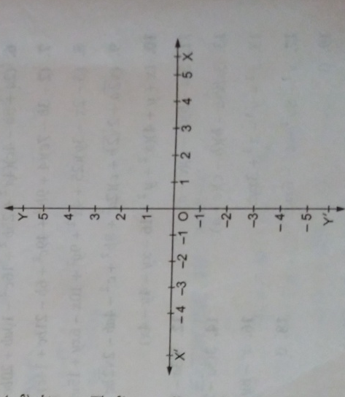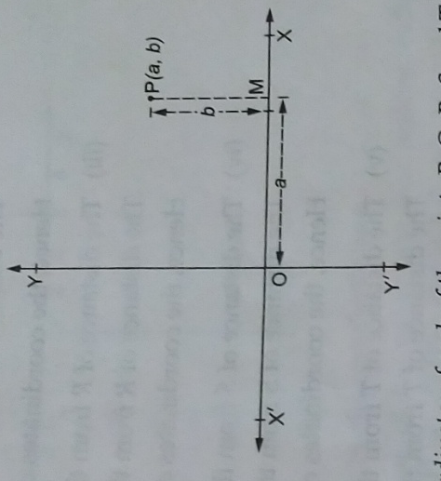
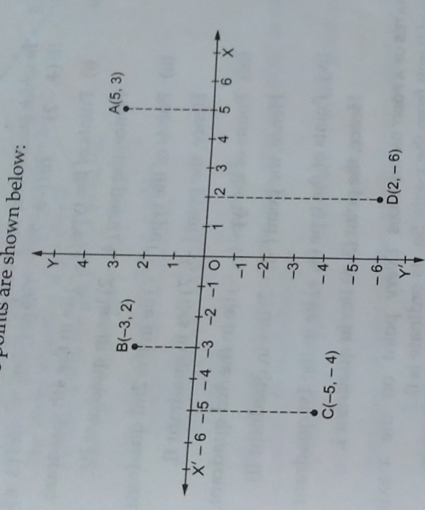
QUADRANTS
Let X'OX and YOY' be the coordinate axes.
These axes divide the plane of the paper into four regions, called quadrants. The regions XOY , YOX', X'OY' and Y'OX are respectively known as the first, second , third and fourth quadrants.
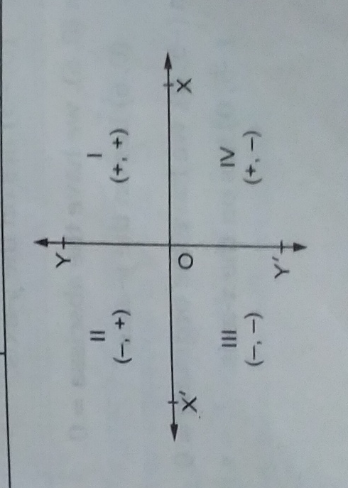
EXAMPLE 1 Write down the coordinates of each of the points P, Q, R, S and T, as shown in the following figure.
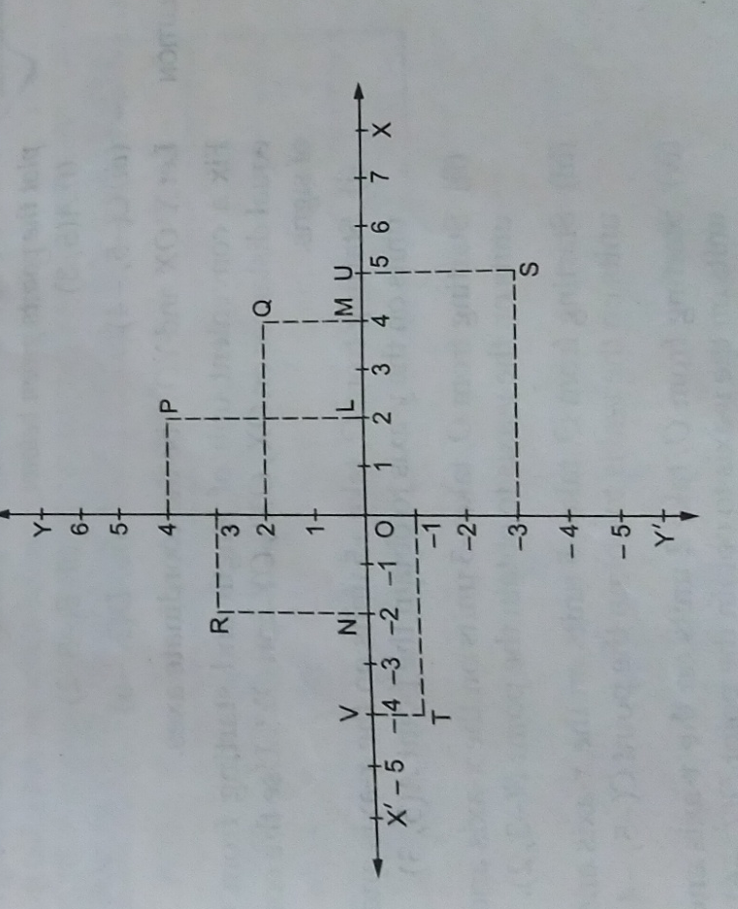P(2,4)

