.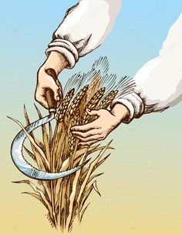
#1 Raja is very happy today. The farmland is filled with ripe crops. Raja has a sharp sickle. A sickle is a farm tool or person that reaps (cuts and often also gathers) crops at harvest when they are ripe. Usually the crop involved is a cereal grass. Raja started to harvest fast as he has to store it properly.
Raja knows hand reaping is done by various means, including plucking the ears of grains directly by hand, cutting the grain stalks with a sickle. Reaping is usually distinguished from mowing, which uses similar implements, but is the traditional term for cutting grass for hay, rather than reaping cereals. The stiffer, dryer straw of the cereal plants and the greener grasses for hay usually demand different blades on the machines. The reaped grain stalks are gathered into sheaves (bunches), tied with string or with a twist of straw. Raja is very tired to execute such process.
- Mention the type of separation technique farmer used by Raja in the above case.
- Suggest a better technique to Raja to execute such work.
- Your suggestion is cost effective or time saving?

#2 Marcello played extremely well in the first half of the interschool football match, but due to humid condition and heat he started feeling tired and fell on the ground. Immediately school medical team rushed to him and they offered him ORS. After a point of time he got his strength and become normal.
- Write the full form of ORS
- Now mix salt, sugar and water together. After preparation of this solution write the separation techniques of all the material.
- Write the concept of soluble substance. Give one example of it.

#3 in this lockdown days Pragyan has collected a jar of salt, a tumbler, a bunsen burner, a spoon. Pour half a cup of water in the beaker. He adds one teaspoonful of salt and stirs it well, until the salt dissolves completely
Again add a teaspoonful of salt and stir well. Go on adding salt, one teaspoonful at a time, and stir.
After adding a few spoons of salt, do you find that some salt remains X. Now he has started heating it. After heating for long time he left with Y.

- What is X?
- What is Y?
- When we can understand that Pragyan got saturated solution?

