- Amritsar – A Blend Of Culture, Food, & Religious Sites. Amritsar historically also known as Rāmdāspur and colloquially as Ambarsar, is a city in state of Punjab.
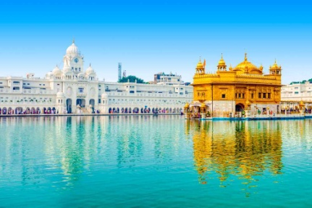
- Orissa – The Land Of Temples. Odisha (formerly Orissa), an eastern Indian state on the Bay of Bengal, is known for its tribal cultures and its many ancient Hindu temples. The capital, Bhubaneswar, is home to hundreds of temples, notably the Mukteshvara.
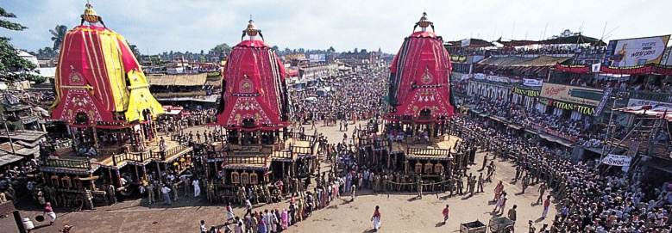
- Mahabalipuram – An Epitome Of Art & Architecture. Mamallapuram, or Mahabalipuram, is a town on a strip of land between the Bay of Bengal and the Great Salt Lake, in the south Indian state of Tamil Nadu.
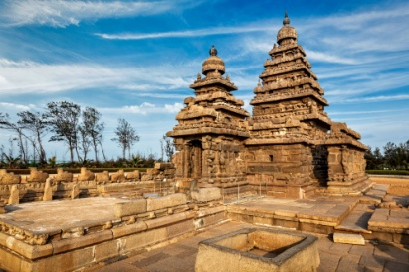
- Visakhapatnam – Revisit One Of The Best Beaches In India. Visakhapatnam is a port city and industrial center in the Indian state of Andhra Pradesh, on the Bay of Bengal. It's known for its many beaches, including Ramakrishna Beach.
