The taxi fare in a city is as follows.
For the first kilometre, the fare is Rs 8 and for the subsequent distance, it is Rs 5 per km. Taking the distance covered as x km and the total fare as Rs y, write a linear equation for this information and draw its graph.
Given, total distance covered = $x$ km =$1+ (x - 1)$ km
Fare for first kilometre = 8
Fare for subsequent distance = Rs 5 per km
Fare for next (x - 1) km= $(x - 1)×5$
= $5(x - 1)$
According to the question,
Total fare = $y$
$$∴ 8 +5(x - 1) = y$$
$$8 + 5x - 5= y$$
$$5x - y + 3 = 0$$
which is the required linear equation.
It can also be written as $y = 5x +3.$
When x = 0, then y = 3
When x = 1, then y = 5+3 = 8
When x = 2, then y = 5(2)+3 = 13
Then, we have the following table
X | 0 | 1 | 2
y | 3 | 8 | 13

We plot the points A (0,3), B (1,8) and C(2,13) on a graph paper and join them to form a line AC, which represents the required graph of linear equation.
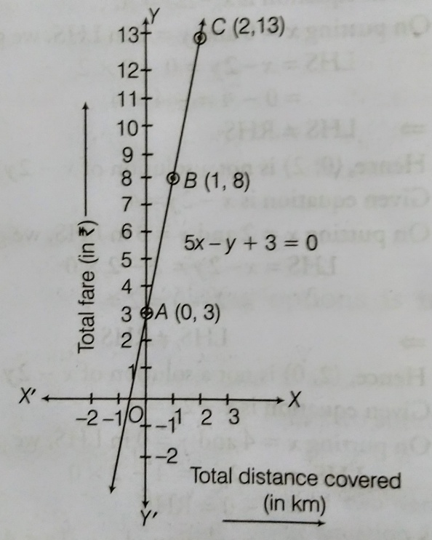
6) If the work done by a body on application of a constant force is directly proportional to the distance travelled by the body, then express this in the form of an equation in two variables and draw the graph of the same by taking the constant force as 5 units. Also, read from the graph the work done, when the distance travelled by the body is (1) 2 units. (ii) 0 unit.
SOLUTION:-
let x be the distance and y be the work done.
Then, the equation will be $y = Fx$ , where F is the constant force .
$∴y=Fx$ is the required linear equation in two variables $x and y.$

Given, $F = 5$, then equation is
$y=5x$ .............(1)
When x = 0, then y = 0.
When x = 1, then y = 5
When x = 3, then y = 15
Thus, we have the following table
X | 0 | 1 | 3
y | 0 | 5 | 15
We plot the points $O (0,0)$ , $A \left(1,5\right),B(3,15)$on graph paper and join them to get a line OB which represents the required graph.
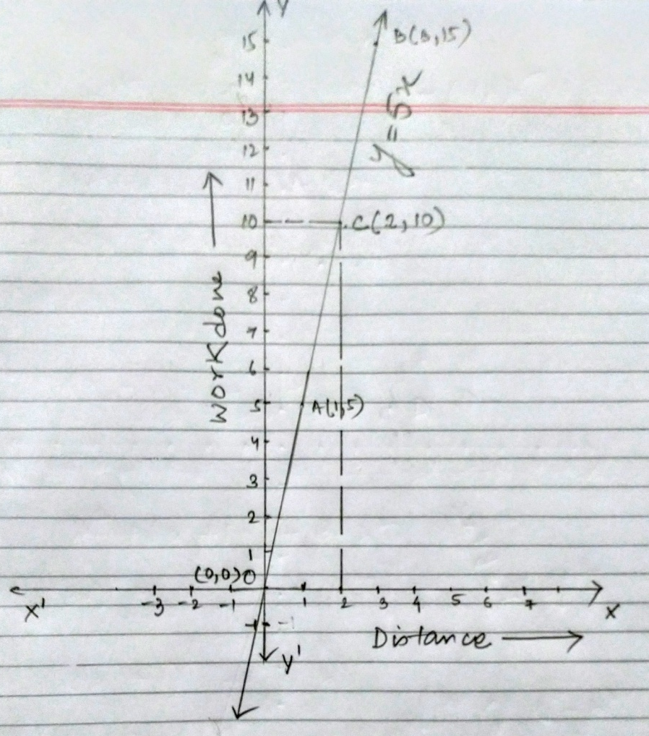
- Clearly, C represents (2,10). So, work done, when the distance travelled by the body is 2 units, is 10 units.
- Clearly, y = 0, when x = 0, so the work done when the distance travelled by the body is 0 unit, is zero unit.
QUESTION 8) In countries, like USA and Canada, temperature is measured in Fahrenheit, whereas in countries like India, it is measured in Celsius. There is a linear equation that converts Fahrenheit to Celsius.
$F=\left(\frac{9}{5}\right)C+32$
- Draw the graph of the above linear equation using Celsius for X-axis and Fahrenheit for Y-axis.
- If the temperature is 30°C, then what is the temperature in Fahrenheit?
- If the temperature is 95°F, then what is the temperature in Celsius?
- If the temperature is 0°C, then what is the temperature in Fahrenheit and if the temperature is 0°F, then what is the temperature in Celsius?
- Is there a temperature, which is numerically the same in both Fahrenheit and Celsius? If yes, find it.

Solution: (i)Let Celsius be x and Fahrenheit be y.
The required equation is :
$$y=\left(\frac{9}{5}\right)x+32$$
When x= 0 , then y=32
When x= 10, then
$$y=\left(\frac{9}{5}\right)x+32$$
$$y=\left(\frac{9}{5}×10\right)+32$$
$$y=(9×2)+32$$
$$y=50$$
When x= 20, then
$$y=\left(\frac{9}{5}\right)x+32$$
$$y=\left(\frac{9}{5}×20\right)+32$$
$$y=(9×4)+32$$
$$y=68$$

Thus, we have the following table
X | 0 | 10 | 20
y | 32 | 50 | 68
We plot the points $A (0,32)$ , $B \left(10,50\right),C(20,68)$on graph paper by taking the following scale:
Scale for x-axis is 1 unit = 5°c and for y-axis is 1 unit = 10°F
Join A ,B and C to get a line AC which represents the required graph.
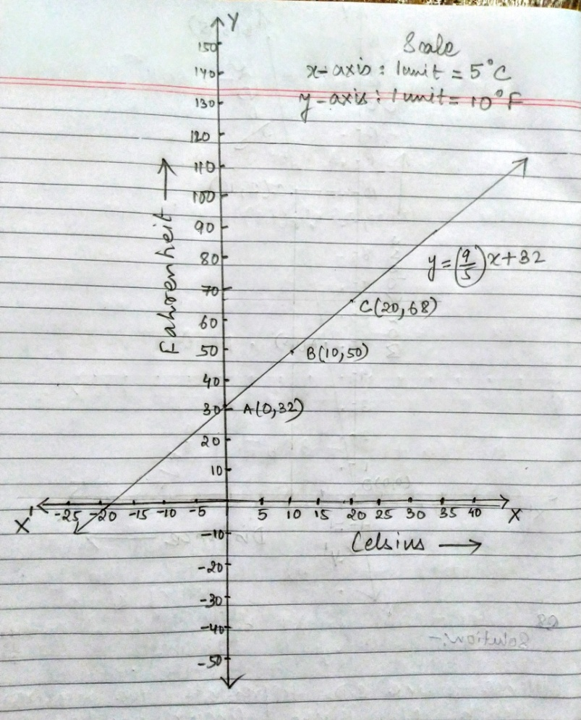
(ii)If x=30 ,then
$$y=\left(\frac{9}{5}\right)x+32$$
$$y=\left(\frac{9}{5}×30\right)+32$$
$$y=(9×6)+32$$
$$y=86$$
the temperature is 30°C, then the temperature in Fahrenheit is 86°F

