SATISH CHANDRA MEMORIAL SCHOOL, CHAKDAHA
EVS CLASS – V
CASE STUDY #4
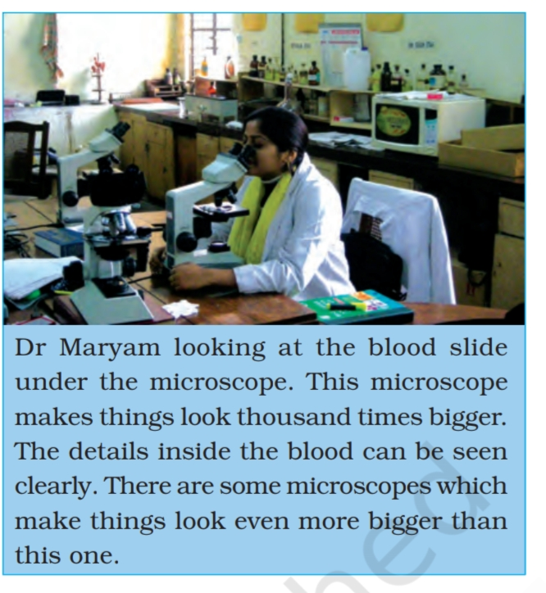
TICK ON THE RIGHT OPTION:-
Q.1) What is Dr. Maryam looking at?
a) Plant cell
b) Virus
c) Bacteria
d) Blood slide
Q.2) What instrument Dr.Maryam is using?
a) Microscope
b) Telescope
c) X-ray machine
d) Microwave oven
Q.3) This microscope make things look _________
a) Hundred times smaller
b) Thousand times bigger
c) Ten times smaller
d) As it is with no change
Q.4) Dr.Maryam is trying to see the details inside the ___________
a) Microscope
b) Plant cell
c) Blood
d) Nothing
Q.5) Microscope was invented by ___________
a) Thomas Edison
b) Albert Einstein
c) Rabindranath Tagore
d) Zacharias Janssen

