Class Work
Questions (to be solved)
Topic- Photosynthesis
Date: 6th April 2020
Instruction:
- Questions you need to copy in your c/w Biology copy and then write down the answers. Try sincerely, then if any problem contact me.
- ‘Notes’ part you can write or you can take print out and paste in your copy but make sure everything must be in one copy.

Q. 1 to 5 are MCQ types
1. Name the metal present in chlorophyll ‘a’ and ‘b’?
A. Iron
B. Copper
C. Magnesium
D. Manganese
2. Name the structural unit of photosynthesis?
A. Thylakoid
B. Grana
C. Stroma
D. Chlorophyll

3. Rate of photosynthesis does not depend upon:
A. Quality of light
B. Intensity of Light
C. Duration of Light
D. Temperature
4. Quantasomes are found in:
A. Cristae of mitochondria
B. Thylakoid membrane of chloroplasts
C. Nucleus membrane
D. Lysosome

5. Which part of the leaf reflects back excess light?
A. Stomata
B. Guard cells
C. Waxy cuticle

D. Chlorophyll

6. Explain in detail the major steps of Photosynthesis. (3 marks)

Q. 7 to 13 short answer types (2 marks)

7. Why some plants have red leaves? How do they trap sunlight with this?
8. What criteria do we use to decide whether something is alive?
9. What kind of modifications we generally found in desert plant’s photosynthesis process?
10. For iodine test why do we perform alcohol treatment?
11. Explain how stomatal aperture opening and closing are controlled.
12. What happen (to its photosynthetic activity) if we put a plant in white light?
13. Where does the oxygen during photosynthesis come from?
Assertion –Reason Based Questions
Choose any one option
- Both A and R are true and R is the correct explanation of A.
- Both A and R are true but R is not the correct explanation of A.
- A is true but R is false.
- A is false but R is true.
- Both A and R are false.
14. A: The only product of light reaction, required in dark reaction are NADPH₂ and ATP.
R: Dark reactions occur in night only.
15. A: Plant cells generally have large vacuoles
R: It helps chloroplasts to work in a better way.

NOTES

What is Photosynthesis
Photosynthesis is the process that happens in every autotrophic organisms like green plants, they use light energy from the sun to make sugar and oxygen gas from CO and water. The image below shows the basic concept of photosynthesis:
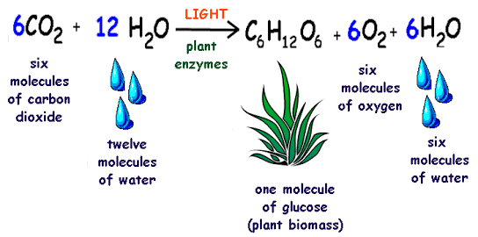

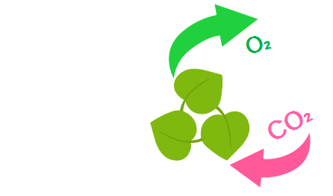
In other words, photosynthesis is the process when plants make their own food.

Process of Photosynthesis
Photosynthesis has two phases, they are commonly known as "Photosynthesis Light Reaction" and "Photosynthesis Dark Reaction". We will analyze these two phases one by one.
1. Photosynthesis Light Reaction: ADP + NADP + H2O → ATP +NADPH + H ion + O2
This reaction of photosynthesis only happens when light is available. In this reaction the light hits the reaction centers of chlorophyll in the chloroplasts. The chlorophyll will vibrate, makes water molecule (H2O) and oxygen (O) released into the air and the remaining molecules of hydrogen (H) from the water (H2O) remains in chloroplast and gets attached to NADP. In this phase of photosynthesis energy loses along the electron transport chain to recharge ATP from ADP. During this process, light energy gets converted into chemical energy and finally ATP molecules are produced. This reaction is also known as light-dependent reaction.
2. Photosynthesis Dark Reaction: ATP + NADPH + CO2 → ADP + NADP + glucose
This phase of photosynthesis does not require light and it takes place in stroma. In this reaction the carbon dioxide (CO2) in the atmosphere combines with hydrogen (H) from water molecules and forms glucose. During this process, ATP molecules will be converted to simple sugars. This reaction is also known as light-independent reaction.

Photosynthesis Flowchart
A flowchart is a way to show the steps in a process. Below is the flowchart of photosynthesis process that shows the steps involved in the Light reaction and dark reaction of photosynthesis
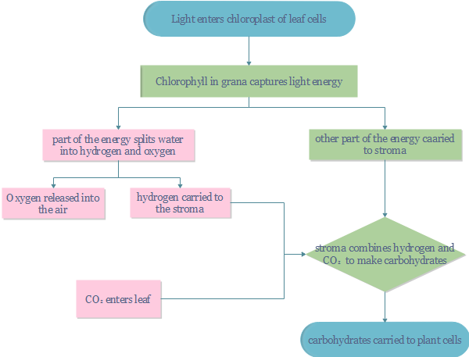
- Carbon dioxide and oxygen enter and exit the plant leaves through stomata.
- The chlorophyll in the chloroplasts of the leaf cells adsorbs energy from sunlight
- Chlorophyll and other carotenoids transfer light energy
- The light reaction produces carbohydrates by using ATP and NADPH
- The dark reaction produces sugar from carbon dioxide with the help of ATP and NADPH

Ref: https://www.edrawsoft.com/flowchart/photo-synthesis-flowchart.html

