MAP WORK PRACTICE
WORK SHEET - 1
H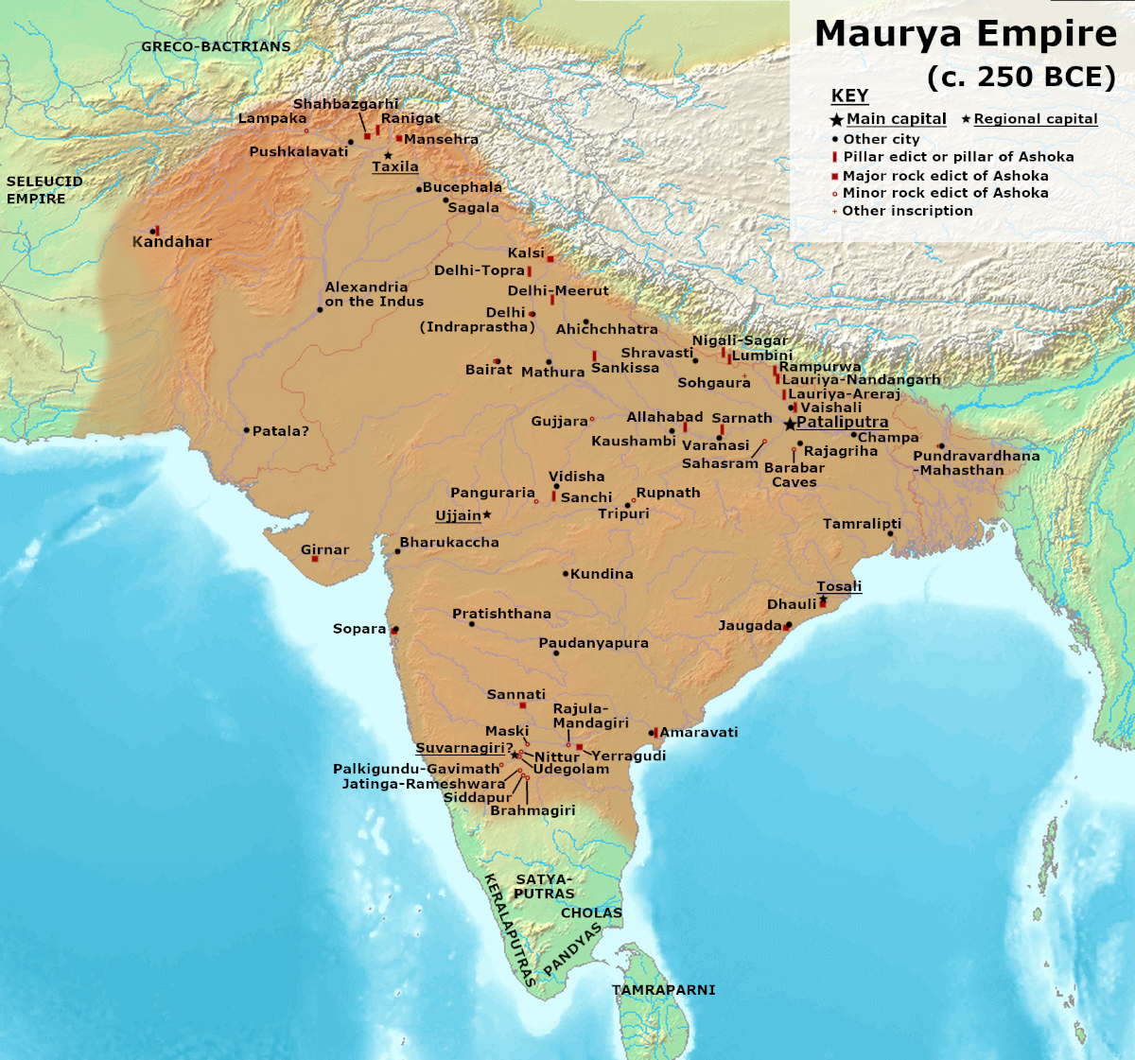
FOLLOWING THE ABOVE MAP LOCATE THE FOLLOWING:
1. CAPITAL CITY OF MAURYAN EMPIRE – PATALIPUTRA.
2. MAJOR IMPORTANT CITIES – TAXILA AND UJJAIN
3. THE PLACE WHERE THE KALINGA WAR HELD – NEAR DHAULI
4. CITIES WHERE INSCRIPTIONS WERE FOUND THROUGH PILLARS
(SARNATH, DHAULI, LUMBINI, MEERUT, SANCHI, GIRNAR,
KALSI & ALLAHABAD)
(Take the help of your History Text Book
Chapter- ASHOKA, THE EMPEROR WHO GAVE UP WAR)
DO THE MAP WORK ON AN OUTLINE MAP OF INDIA

WORK SHEET – 2
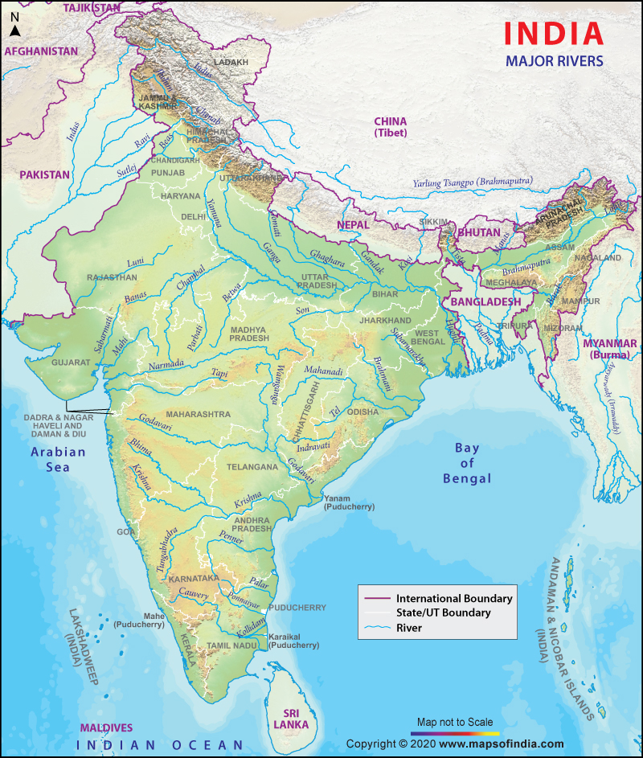
FOLLOWING THE ABOVE MAP SHOW
THE MAJOR RIVERS OF INDIA
1. THE GANGA AND ITS TRIBUTARIES 2. THE YAMUNA
3. THE INDUS AND ITS TRIBUTARIES 4. THE BRAHMAPUTRA
5. THE CHAMBAL 6. THE MAHANADI 7. THE GODAVARI
8. THE KRISHNA 9. THE KAVERI 10. THE NARMADA 11. THE TAPI
12. THE INDIAN OCEAN, THE BAY OF BENGAL AND THE ARABIAN SEA
DO THE MAP WORK ON AN OUTLINE MAP OF INDIA

